**Restrictive Party Screening – RPS**

**Instructions for processing your request in DocuSign**

Go to this link, which takes you to the Division of Finance website.

<https://www.tamuk.edu/finance/compliance/export-controls.html>

Scroll down to the **Forms** section

Click on



Scroll down and you will see this form. Enter your Name and your Email address.

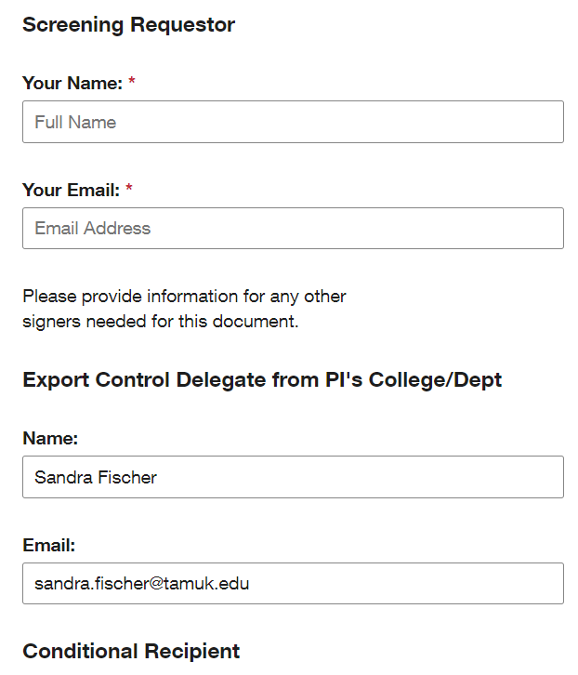Enter my name and email address here.

Scroll down and click on the “Begin Signing”

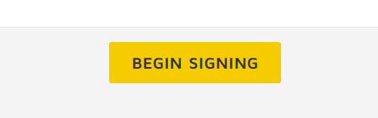

DocuSign opens up.

If you have this in your banner, then click the agreement.



Then click the “Continue” button

You will now complete the Sections 1 & 2

You must enter your email, and the “reason for the screening”

Do not enter anything in Section 3

If screening a person, then use section 2.a.

Enter the Last & First name and a middle name if available.

No need for the full address, but you MUST enter the “Country”

If screening an Entity/University, etc, then use section 2.b.

Enter the name of the Entity

No need for the full address, but you MUST enter the “Country”

You may complete both sections on one form, if you are screening a person and the Entity. I will process them separately for you. No need for two forms to be completed.

Now you will scroll to the bottom and click “Finish”



Once you have finished the electronic RPS form, it will route to Sandy Fischer (Delegate)

And she will process the screening and when it is complete, DocuSign will notify you and you can open the complete document and save/attach it where ever you need it.