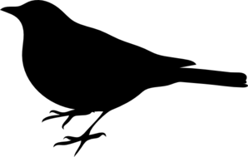


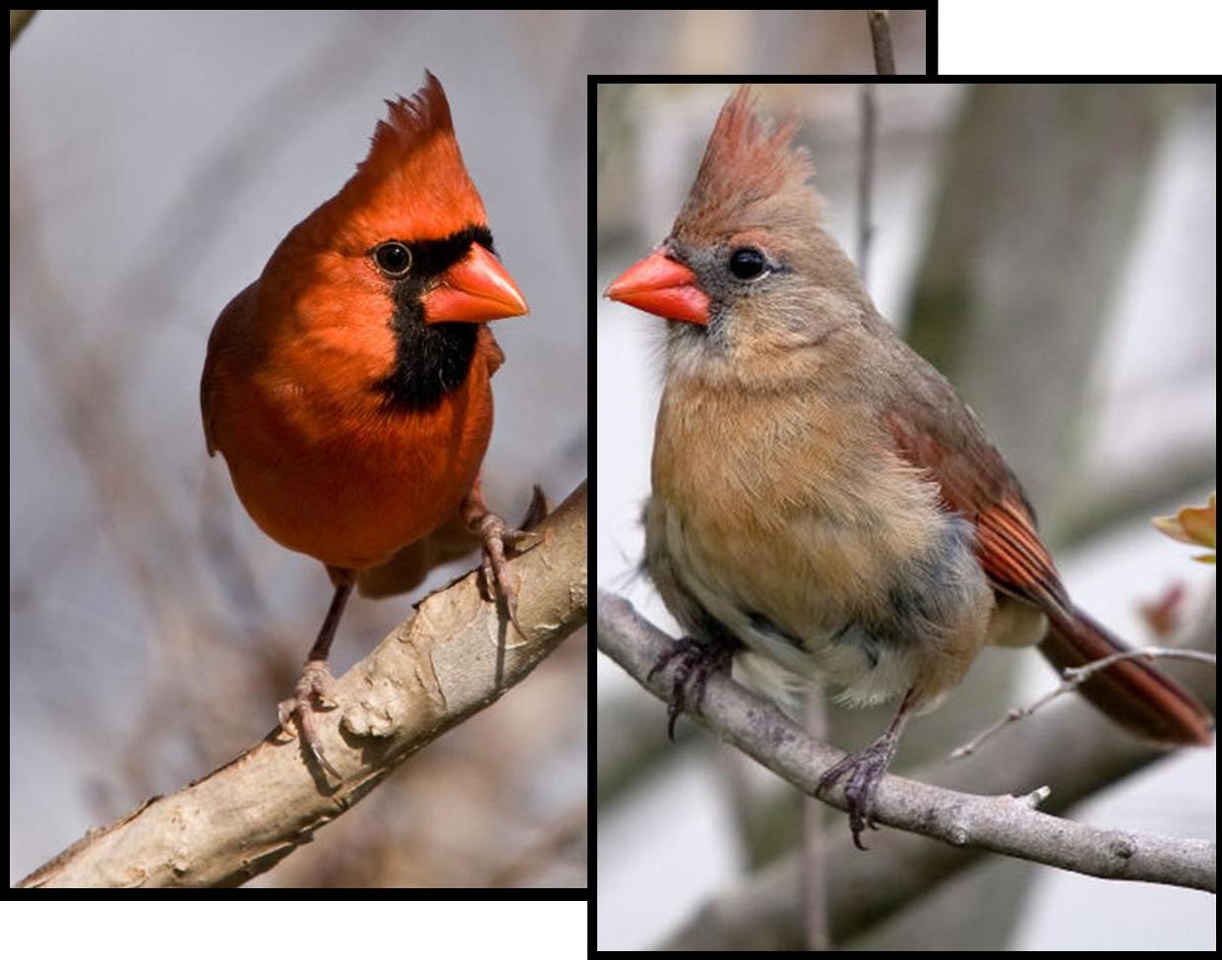
http://ckwri.tamuk.edu

Learn More:

Bird Identification Guide

SIZE & SHAPE
Fairly large, long-tailed with a short, very thick bill

Color Pattern
Males are bright red all over, with a red-orange bill and black face around bill. Females are pale brown with reddish wings, tail, and crest. Females have a softer black face and the same red-orange bill.

behavior & Habitat
Found in shrubs and trees and forage on or near the ground. Often seen in pairs or flocks and found in backyards, parks, woodlots, and shrubby forest edges.
Caesar Kleberg
Wildlife Research Institute http://ckwri.tamuk.edu

Created By: Janel Ortiz
2015

Providing the science behind

wildlife conservation and management

NORTHERN CARDINAL
MALE
FEMALE
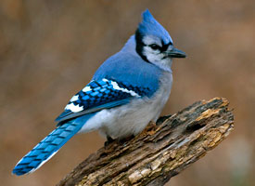
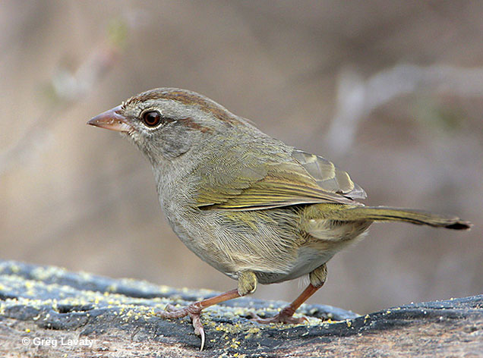
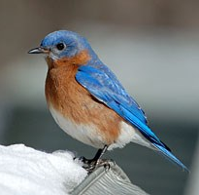
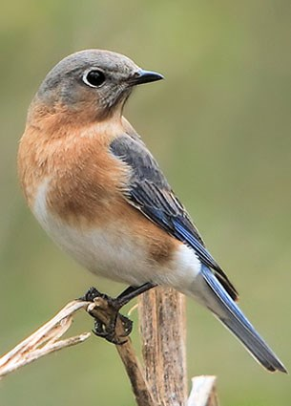
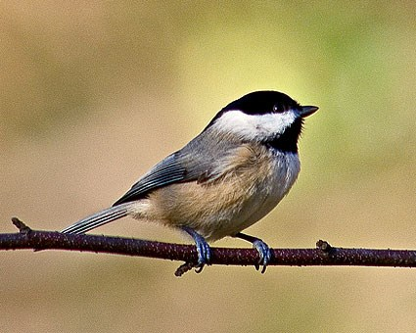

SIZE & SHAPE
Short neck, large head, tail fairly long and narrow

Color Pattern
Black cap and bib, white cheeks; back, wings, and tail are soft gray; buffy sides

behavior & Habitat
An acrobatic, flocking species. Found in forested areas, urban/suburban areas or parks with trees.

SIZE & SHAPE
Medium sized sparrow

Color Pattern
Olive-brown upperparts, olive-gray underparts; brown stripe on each side of crown and through eyes

behavior & Habitat
Rather secretive but it can be lured out with calls. Prefers weedy thickets and thorn scrub habitat.

SIZE & SHAPE
Large crest with broad, rounded tail

Color Pattern
White or light gray underneath; body is mostly blue but also has black and white stripes on wings and tail; black stripe toward back of head

behavior & Habitat
Known to cache food. When eating, holds a seed or nut in feet and pecks it open. A favorite food is acorns, and they are found near oaks, in forests, woodlots, towns, cities, and parks.

BLUE JAY

CAROLINA CHICKADEE
OLIVE SPARROW
EASTERN BLUEBIRD

SIZE & SHAPE
Small with rounded head, large eyes, plump body; tail and legs short; bill short and straight

Color Pattern
Males are deep blue above and rusty red on throat and breast. Females are grayish above with bluish wings and tail and orange-brown breast.

behavior & Habitat
Perches up high with erect posture and drops down to ground onto insects; will also eat berries. Lives in meadows and open areas surrounded by trees. Commonly uses nest boxes if provided.

MALE
FEMALE

