EFFECTS OF DROUGHT AND GRAZING ON LAND BIRD POPULATIONS IN SOUTH TEXAS

A Thesis
by
MAIA LYNN LIPSCHUTZ

Submitted to the College of Graduate Studies
Texas A&M University-Kingsville
in partial fulfillment of the requirements for the degree of

MASTER OF SCIENCE

May 2016

Major Subject: Range and Wildlife Management

EFFECTS OF DROUGHT AND GRAZING ON LAND BIRD POPULATIONS IN SOUTH TEXAS

A Thesis
by
MAIA LYNN LIPSCHUTZ

Approved as to style and content by:

_______________________________
Leonard A. Brennan, Ph.D.
(Chairman of the Committee)

_______________________________  Bart M. Ballard, Ph.D.  (Member of Committee) | _______________________________  David B. Wester, Ph.D.  (Member of Committee)
_______________________________  Scott E. Henke, Ph.D.  (Chair of Department) | _______________________________  Dr. Mohamed Abdelrahman  (Associate VP for Research and Graduate Studies)

May 2016

ABSTRACT

Effects of Drought and Grazing on Land Bird Populations in South Texas
(May 2016)
Maia Lynn Lipschutz, B.S., Humboldt State University
Chairman of Advisory Committee: Dr. Leonard A. Brennan
Breeding bird surveys were conducted on 7 properties belonging to 2 ranches in South Texas. Using these data I calculated temporal trends, and tested the effects of total May – April precipitation and cattle stocking rate on avian abundance. Trends were calculated for each ranch, the East Foundation and King Ranch, individually due to different range and wildlife management practices. Total avian abundance increased significantly on the 3 East Foundation properties between 2008 and 2015. During 39 breeding bird surveys, 16,441 individual birds of 88 species were recorded. Non-breeding bird surveys were also conducted on East Foundation properties, an increasing trend in total avian abundance was also calculated from these data. Total breeding bird abundance was stable on the 4 King Ranch properties between 2005 and 2013. A total of 19,162 individual birds of 87 species were recorded during 40 breeding bird surveys. The combined effect of livestock use and precipitation had a significant effect on total avian abundance on all King Ranch properties, and on the abundance of some individual species and groups.

DEDICATION
To Mary, Ronnie, Patrick, and Rainbow

ACKNOWLEDGEMENTS
Dr. Leonard Brennan, Mr. Tom Langschied, Dr. Fred Bryant, Dr. David Wester, Dr. Bart Ballard, Houston Livestock Show and Rodeo, East Foundation, King Ranch, Rene Barrientos, Promoting Post-baccalaureate Opportunities for Hispanic Americans, South Texas Quail Coalition, Coastal Bend Audubon Society, and the amazing staff at CKWRI

TABLE OF CONTENTS
Page
ABSTRACT iii
DEDICATION iv
ACKNOWLEDGEMENTS v
TABLE OF CONTENTS vi
LIST OF TABLES viii
LIST OF FIGURES xi
CHAPTER I. EFFECTS OF PRECIPITATION AND GRAZING ON LANDBIRD POPULATIONS IN SOUTH TEXAS – EAST FOUNDATION 1

Abstract 1

Introduction 2

Study Area 5

Methods 8

Results 12

Discussion 50

Management Implications 57
LITERATURE CITED 60
CHAPTER II. EFFECTS OF PRECIPITATION AND GRAZING ON LANDBIRD POPULATIONS IN SOUTH TEXAS - KING RANCH 66

Abstract 66

Introduction 67

Study Area 69

Methods 72

Results 75

Discussion 106

Management Implications 112
LITERATURE CITED 115
VITA 120

LIST OF TABLES
Page
Table 1. Number of points surveyed for breeding birds each year on the East Foundation in South Texas, 2008 – 2015. 8
Table 2. Number of individuals of all species observed on each ranch during breeding bird surveys of 3 East Foundation ranches in South Texas, 2008 – 2015. 13
Table 3. Best-fit linear (yr) or quadratic (yr + yr²) models of trends in the mean number of birds counted per point during breeding bird surveys of El Sauz ranch in Kenedy County, Texas, 2008 – 2015. 22
Table 4. Best-fit linear (yr) or quadratic (yr + yr²) models of trends in the mean number of birds counted per point during breeding bird surveys of San Antonio Viejo ranch in Jim Hogg County, Texas, 2009 – 2015. 26
Table 5. Best-fit linear (yr) or quadratic (yr + yr²) models of trends in the mean number of birds counted per point during breeding bird surveys of Santa Rosa ranch in Kenedy County, Texas, 2008 – 2015. 29
Table 6. Effects of precipitation and year on the average number of birds counted per point during breeding bird surveys of El Sauz Ranch in Kenedy County, Texas, 2008 – 2015. 34
Table 7. Effects of precipitation and year on the average number of birds counted per point during breeding bird surveys of San Antonio Viejo Ranch in Willacy County, Texas, 2009 – 2015. 36
Table 8. Models of the effects of precipitation and year on the average number of birds counted per point during annual breeding bird surveys of Santa Rosa Ranch in Kenedy County, Texas, 2008 – 2015. 38
Table 9. Total individuals of all species observed during non-breeding season (Sept. – April) bird surveys of East Foundation ranches in South Texas, March 2008 – April 2015. 42
Table 10. Years in which individual breeding bird survey routes were run on King Ranch divisions in South Texas, 2005 – 2013. 73
Table 11. Total individuals of all species observed during breeding bird surveys of King Ranch in South Texas, 2005 – 2013. 76
Table 12. Trends in the mean number of birds counted per point during breeding bird surveys of the Encino division of King Ranch in Brooks County, Texas, 2007 – 2013. 83
Table 13. Trends in the mean number of birds counted per point during breeding bird surveys of the Laureles division of King Ranch in Kleberg County, Texas, 2005 – 2013. 86
Table 14. Trends in the mean number of birds counted per point during breeding bird surveys of the Norias division of King Ranch in Kenedy County, Texas, 2005 – 2013. 88
Table 15. Trends in the mean number of birds counted per point during breeding bird surveys of the Santa Gertrudis division of King Ranch in Kleberg County, Texas, 2006 – 2013. 90
Table 16. Models of the effect of precipitation and animal unit days/ha on the number of birds counted per point during breeding bird surveys of King Ranch, 2005–2013. 98
Table 17. Models of the effect of precipitation and animal unit days/ha on the number of birds counted per point during breeding bird surveys of the Encino division of King Ranch in Brooks County, Texas, 2007–2013. 99
Table 18. Models of the effect of precipitation and animal unit days/ha on the number of birds counted per point during breeding bird surveys of the Laureles division of King Ranch in Kleberg County, Texas, 2006 – 2013. 102
Table 19. Models of the effect of precipitation and animal unit days/ha on the number of birds observed during breeding bird surveys of the Norias division of King Ranch in Kenedy County, Texas, 2006 – 2013. 104
Table 20. Models of the effect of precipitation and animal unit days/ha on the number of birds counted per point during breeding bird surveys of Santa Gertrudis division of King Ranch in Kleberg County, Texas, 2006 – 2013. 107

LIST OF FIGURES
Page
Figure 1. Map of East Foundation properties in South Texas 6
Figure 2. Species composition of birds (as percentages of total observations) counted during breeding bird surveys of 3 East Foundation ranches in South Texas, 2008 – 2015. 16
Figure 3. Trends in the number of breeding birds (of all species) counted per point on 3 East Foundation ranches in South Texas, 2008 – 2015. 19
Figure 4. Trend in the mean number of birds (of all species) counted per point during breeding bird surveys of the East Foundation in South Texas, 2008 – 2015. 20
Figure 5. Trends in the mean number of individuals counted per point during breeding bird surveys of El Sauz Ranch in Kenedy County, Texas, 2008 – 2015. 23
Figure 6. Trends in the mean number of individuals counted per point during breeding bird surveys of San Antonio Viejo Ranch in Jim Hogg County, Texas, 2009 – 2015. 27
Figure 7. Trends in the mean number of individuals counted per point during breeding bird surveys of the Santa Rosa Ranch of the East Foundation, 2008 – 2015. 30
Figure 8. Total May – April precipitation (cm) on 3 East Foundation Ranches surveyed for breeding birds 2008 – 2015. Mean total May – April precipitation was 60.62 cm 32
Figure 9. Species composition of birds (as a percentage of total observations) counted during non-breeding season surveys on 3 East Foundation Ranches in South Texas, March 2008 – April 2015 47
Figure 10. Percentages of bird species (n = 146) observed during non-breeding season surveys, grouped by residential status, of 3 East Foundation ranches in South Texas, March 2008 – April 2015. 48
Figure 11. Trend in the mean number of birds (of all species) counted per transect during non-breeding season (September – April) surveys of 3 East Foundation ranches in South Texas, 2011 – 2015. 49
Figure 12. South Texas divisions of King Ranch surveyed for breeding birds 2005 – 2013. 70
Figure 13. Percent of total observations accounted for by the 10 most common species observed during breeding bird surveys of King Ranch in South Texas, 2005 – 2013. 79
Figure 14. Trends in the mean number of birds (of all species) counted during breeding bird surveys of 4 King Ranch divisions in South Texas, 2005 – 2013. 82
Figure 15. Trends in the mean number of birds counted per point during breeding bird surveys of the Encino division of King Ranch in Brooks County, Texas, 2007 - 2013. 85
Figure 16. Trends in the mean number of birds counted per point during breeding bird surveys of the Laureles division of King Ranch in Kleberg County, Texas, 2006 – 2013 87
Figure 17. Trends in the mean number of birds counted per point during breeding bird surveys of the Norias division of King Ranch in Kenedy County, Texas, 2005 – 2013 90
Figure 18. Trends in the mean number of birds counted per point during breeding bird surveys of the Santa Gertrudis division of King Ranch in Kleberg County, Texas, 2006 – 2013 92
Figure 19. Mean total May – April precipitation (in cm) on King Ranch divisions in South Texas, 2006 - 2013. 95
Figure 20. Mean total May – April animal unit days per hectare on King Ranch divisions in South Texas, 2006 - 2013 96

EFFECTS OF PRECIPITATION AND GRAZING ON LANDBIRD POPULATIONS IN SOUTH TEXAS – EAST FOUNDATION
MAIA L. LIPSCHUTZ, Caesar Kleberg Wildlife Research Institute, Texas A & M University - Kingsville, Kingsville, TX 78363, USA

Abstract
Breeding and non-breeding bird surveys were conducted annually between 2008 and 2015 on 3 properties in South Texas. Using these data I calculated trends in, and tested the effects of total May – April precipitation on avian abundance. During 39 breeding bird surveys, 16,441 individual birds of 88 species were recorded. Total avian abundance increased significantly during the study. Breeding season data was used to calculate temporal trends in abundance for 23 individual species or groups. Three species, Bewick’s Wren, Mourning Dove, and Northern Mockingbird, increased significantly in abundance on all ranches. During 454, 500-meter non-breeding season transect surveys, 13,270 individuals of 146 species were recorded. Total land bird abundance also increased during the non-breeding season. Total May – April precipitation alone did not have a significant effect on total avian abundance, or on the abundance of any individual species or groups.

Introduction
Grassland and aridland ecosystems and the organisms that inhabit them have been severely affected by land-use practices of the past two centuries (Askins 2007, Brennan and Kuvlesky 2005, NABCI 2014). The decline of grassland and grassland-shrubland birds has been well-documented for nearly 4 decades (Brennan 1991, Vickery and Herkert 2001, Brennan and Kuvlesky 2005, Askins et al. 2007). At the end of the 20th century it was estimated that less than 20% of pre-colonial grassland habitats remained unconverted, and grassland birds as a group had a disproportionately high number of species in decline compared to other North American bird groups (Askins 1993, Vickery and Herkert 2001, Sauer et al. 2003, Niemuth et al. 2008). Aridland birds currently face similar threats: numbers have decreased by 46% since 1968 and by 6% since 2009 (NABCI 2014). Aridland bird species are losing habitat to urban expansion and the development of solar, wind, and traditional energy infrastructures (NABCI 2014). Ecosystem drivers such as fire and native grazers, which were crucial to maintaining western grasslands, have been replaced by human-controlled management practices such as fire-suppression and livestock grazing (Brennan and Kuvlesky 2005, Askins et al. 2007). These activities resulted in a landscape that bore little resemblance to that of pre-colonial North America.
In addition to habitat loss, various other factors made grassland birds exceptionally vulnerable to the ever-accelerating rate of development in the 20th and 21st centuries (Askins 2007, Niemuth et al. 2008). Available patches of grassland habitat are too small to be used as breeding habitat for some species, and species that do nest in smaller patches are subject to increased rates of predation, nest parasitism, and exposure to pesticides (Askins et al. 2007). The early part of this century saw a renewed commitment to the conservation of all avian species (Vickery and Herkert 2001, Fitzpatrick 2002, Brennan and Kuvlesky 2005). A decade later, the number of federally threatened and endangered grassland and aridland birds continues to rise (USFWS 2015). Rangeland continues to be converted at a rapid rate, and non-government land enrolled in conservation reserve programs (CRPs) has been in smaller and smaller parcels (Vickery and Herkert 2001).
Like the rest of the U.S., South Texas ecosystems have undergone a dramatic shift in vegetation over the past two centuries, changing from tall- and mixed- grass prairie to shrubland (Askins 2007). Documentation from the mid-1800s of the land that is now King Ranch describes open grasslands with small mottes of woody vegetation, and a burn frequency of 1 to 3 years (Frost 1998). Over time, increased grazing pressure, fire suppression, and drought, transformed prairie and savanna habitats into mesquite shrub-land (Forgason and Fulbright 2003). Despite the large-scale changes in vegetation, South Texas does contain the Kenedy Sand Prairie, the largest intact prairie in Texas (Fulbright and Bryant 2003).
South Texas is exceptional in its focus on wildlife, wildlife management, and the creation and maintenance of wildlife habitat. Wildlife leases are a major source of income for land owners, and in many instances leasing land for hunting is more profitable than using it for livestock (Fulbright and Bryant 2003). Much of the research on grassland birds has focused on breeding habitat in the northern prairie states (Vickery and Herkert 2001). There is a need for studies that focus on the ecology of wintering, resident, and southern-breeding grassland and aridland bird species.

Objectives
Surveys for breeding and wintering land birds were conducted on the East Foundation in South Texas from 2008 ̶ 2015. The rangelands used for this study contained multiple vegetation communities (McLendon 1991), so this study focused on general trends and responses of all species of land bird, not on any one group of habitat obligate species. South Texas recently experienced the climatic extremes of severe drought followed by record levels of precipitation (NOAA 2015), offering a unique opportunity to study the response of land birds to extreme weather fluctuations. I organized this study to address the following questions about land birds on the East Foundation:
- Did total avian abundance increase or decrease significantly during the study period?
- Were there any spatial or temporal trends in species richness?
- Did any individual species increase or decrease significantly properties during the study period?
- Did local population trends reflect national population trends?
- Did precipitation have a significant effect on land bird abundance on these properties during the study period?

Predictions
- Species richness would be higher along the coast, due to observations of seasonal migrants (Rappole 1979, Rappole and Blacklock 1985).
- Divisions with oak woodlands, parklands, and mottes would have greater species richness than those without (Williges 1989).
- Precipitation would be the main driver of total avian abundance, similar to what has been observed in individual species (Dunning and Brown 1982, DeSante and Geupel 1987, Lusk et al. 2007).
- Correlations between precipitation and the abundance of individual species would be stronger, or more common, in drier areas (Bridges et al. 2001).

Study Area
My study was conducted on the East Foundation, an active cattle operation consisting of 5 properties in South Texas totaling 87,000 ha. The foundation was created from the estate of Robert C. East in 2008. Its mission is “… to support wildlife conservation and other public benefits of ranching and private land stewardship…through research, education and outreach” (East Foundation 2015). Recreational hunting was not permitted on East Foundation properties during the study period, meaning all wildlife management was research or conservation oriented. Detailed cattle stocking records were not available for East Foundation properties during the study period, but an effort was made to reduce the herd to a level that would not result in over-grazing. In 2015 there were approximately 6,500 head of cattle on East Foundation ranches, less than half the number estimated to be on the properties in 2008 (Dr. Pancho Ortega Jr., East Foundation, personal communication, 2015).
A single breeding bird survey route and 3 to 5 non-breeding season transects were created on each of the 3 largest ranches: El Sauz, San Antonio Viejo, and Santa Rosa (Fig. 1). Combined, these ranches cover 78,800 ha of South Texas rangelands. All ranches are within climate division 9, with average rainfall decreasing along an east-west gradient (Western Regional Climatic Data Center 1990). Annual temperature fluctuations are typical of a
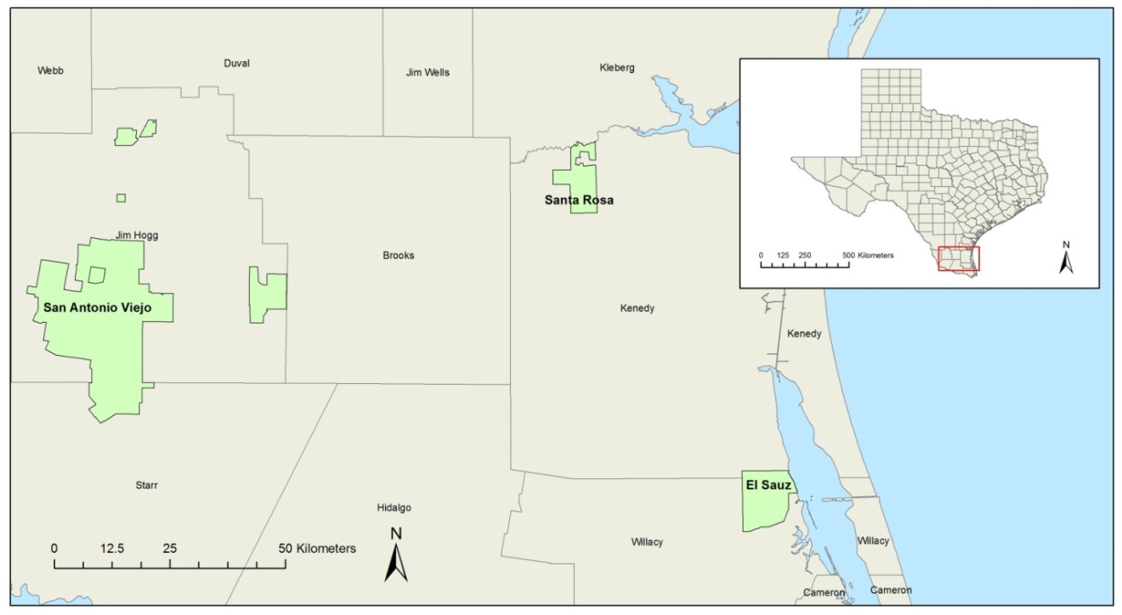
Figure 1. Map of East Foundation properties in South Texas

subtropical climate, with very hot summers and mild winters (Fulbright and Bryant 1993). The study area is within the Tamaulipan Biotic Province, an area that contains at least 10 different vegetation associations and 29 plant communities (TPWD 1984, McLendon 1991). All properties are within the Level III Texas Ecoregion of the Western Gulf Coastal Plain, with the exception of San Antonio Viejo, which was part of the Southern Texas Plains (EPA 2012). Dominant soil orders of the area are alfisols, vertisols, mollisols and inceptisols (NRCS 1990). The study area included portions of several large grasslands including the Coastal Sand Plain, the lower Coastal Prairie, the Kenedy Sand Prairie, and the Bordas Escarpment (Smeins et al. 1991).
San Antonio Viejo is the largest of the East Foundation ranches, totaling 60,300 ha. It is located south-west of Hebbronville, Texas, in Jim Hogg and Starr Counties near the Bordas Escarpment. Elevation is between 36.9 m and 69.5 m (Snelgrove et al. 2013). Dominant vegetation communities include Prosopis glandulosa ̶ Acacia rigidula (Honey Mesquite ̶ Blackbrush) brush, Prosopis glandulosa ̶ Celtis pallida (Honey Mesquite ̶ Granjeno) parks, and both native and introduced grasses (Snelgrove et al. 2013).
El Sauz consists of 10,980 ha of coastal Willacy County in South Texas. Elevation ranged from sea level to 1.3 m (Snelgrove et al. 2013). The ranch includes portions of the Kenedy Sand Prairie which is dominated by Schizachyrium scoparium (Seacoast Bluestem) and Paspalum monostachyum (Gulfdune Paspalum) in low-lying areas (Fulbright and Bryant 2003). Patches of Spartina sp. (Cordgrass) prairie, a unique and vanishing habitat, also occur on this ranch (Adam Toomey, Graduate Research Assistant, Texas A&M University – Kingsville, personal communication, 2015). Other vegetation communities included Honey Mesquite ̶ Granjeno parks and Quercus virginiana (Live Oak) woods/parks (Snelgrove et al. 2013).
At 7,543 ha Santa Rosa is the smallest ranch surveyed. It is located in Kenedy County southeast of Riviera, Texas. Elevations on the property range from sea level to 9.7 m (Snelgrove et al. 2013). This ranch includes part of the Kenedy Sand Prairie in addition to Honey Mesquite ̶ Granjeno parks, Live Oak woods/parks, and Honey Mesquite brush vegetation communities (Fulbright and Bryant 2003, Snelgrove et al. 2013).

Methods

Breeding bird surveys
Breeding bird surveys (BBS) on the East Foundation ranches began in 2008 on El Sauz and Santa Rosa, and in 2009 on San Antonio Viejo. Survey routes and protocol were based on official USGS BBS (USGS 2001). El Sauz and Santa Rosa ranches did not have sufficient roads for 50 survey points, so routes were created with one point every 800 m, with as many points as possible. Additional points were added as infrastructure on the ranches was expanded (Table 1). A single skilled observer conducted all BBS until 2013; I conducted surveys in 2014 and 2015.

Table 1. Number of points surveyed for breeding birds each year on the East Foundation in South Texas, 2008 – 2015.
 | Number of Points/Surveys
Year | El Sauz | San Antonio Viejo | Santa Rosa | Total
2008 | 51/2 | n/a | 26/1 | 77/3
2009 | 27/1 | 40/1 | 35/1 | 102/3
2010 | 27/1 | 40/1 | 35/1 | 102/3
2011 | 56/2 | 92/2 | 68/2 | 216/6
2012 | 56/2 | 92/2 | 68/2 | 216/6
2013 | 64/2 | 100/2 | 68/2 | 232/6
2014 | 74/2 | 100/2 | 70/2 | 244/6
2015 | 74/2 | 99/2 | 68/2 | 241/6
Point counts were conducted using the official BBS protocol described in here or in USGS 2001. Using a vehicle to travel between points, the observer conducted a 3-minute count starting immediately upon arrival. All birds seen or heard within a 400 m radius were recorded at each of the points along the survey route. Surveys started 30 minutes before sunrise and were completed within 6.5 hours. Routes were not run in conditions of low visibility, or with wind speeds greater than 4 on the Beaufort scale (20 – 29 kmph) as determined by environmental cues, or in constant precipitation. Surveys were conducted 1 – 2 times per year in May and June. Breeding bird surveys were designed to serve as an index of avian abundance and diversity, not a complete count or estimate of actual density (USGS 2001).

Non-breeding bird surveys
Non-breeding season bird survey transects (hereafter transects) were created starting in March 2008. Three survey routes were created on Santa Rosa and El Sauz, 5 transects were created on San Antonio Viejo. Transects were surveyed monthly between September and April starting in 2011. Prior to 2011, transects were surveyed sporadically, with additional transects added as late as January 2013.
Transects began at flagged points approximately 10 m from active ranch roads and ran for 500 m east or west. Transects were walked at a steady pace while recording the number and species of all birds seen or heard within approximately 100 m. Stopping along transects was permitted as was ‘pishing’ to call in birds for identification. Transects surveys were conducted between sunrise and 1300 hours.

Analysis
The number of points surveyed per BBS varied among years and locations. To account for this variation analysis was performed on the mean number of birds counted per point each year (hereafter birds/point). Water birds were excluded from analysis as this data set was poorly suited to analysis of trends in water bird populations on the East Foundation. All dove species, with the exception of Zenaida macroura (Mourning Dove), were analyzed as a group. The two commonly observed woodpecker species, Melanerpes aurifrons (Golden-fronted Woodpecker) and Picoides scalaris (Ladder-backed Woodpecker), were grouped for analysis. Species within the genera Toxostoma (Thrashers) and Molothrus (Cowbirds) were also grouped for analysis, due to the high number of individuals identified to genus only.
Descriptive statistics were calculated using basic Microsoft Access and Excel queries. Preliminary analysis of trends in the mean number of birds of all species and the mean number of individual species counted over time were performed in Microsoft Excel. Both linear and quadratic trend lines were fit to each data set. Final regression analyses were performed using R statistical software. Trends were considered significant at α = 0.05 and considered weak, but noteworthy, at α = 0.10. Models (linear or quadratic) were selected based on the greatest r² value. Because a single value was used for the mean number of birds per point each year, tests for equality, normality, and independence of errors were not possible. Analysis of variance tests (ANOVAs) were used to test for equality among models. Trends in the mean number of individuals counted per point of species or groups of interest were analyzed at the ranch level only.
Trends in abundance were modeled for 26 species on all 3 ranches with sufficient observations (n >14). Trends were calculated for the 20 most commonly observed species or groups on the East Foundation ranches with the exception of turkey vultures. Vultures use large areas which made counts from this type of survey a poor index of abundance for these species due to the likelihood of double-counting individuals. This was also true for other raptors observed, but no other raptors were among the 20 most commonly observed species or groups. The 19 most common species or groups were not all observed a sufficient number of times on each ranch for calculation of trends of every species on every ranch. Trends in mean Eastern Meadowlarks/point were calculated for El Sauz only. Trends in mean Cassin’s Sparrows/point were calculated for El Sauz and San Antonio. In addition to the 19 most abundant species or groups, trends were calculated for 7 species or genera considered of interest for their habitat associations (grassland: Botteri’s Sparrow and Red-winged Blackbird, and aridland: Cactus Wren and Thrasher spp.) restricted range (White-eyed Vireos, and Green Jays), or as game species (Wild Turkey).
Weather data from the National Oceanic and Atmospheric Administration (NOAA) station closest to each ranch were used to calculate total precipitation values. To analyze the effect of precipitation on bird abundance over time, total precipitation was calculated for May – April prior to May of the survey year. Due to the size of the data set and the number of model runs needed to test for effects, only one metric of precipitation received was used.
Backwards elimination variable selection using multiple linear regression was used to test the significance of the effects of total May – April precipitation and year on birds/point. My most complex or “global” model included total May – April precipitation, year, and the interaction between precipitation and year, as variables. If the interaction was significant all variables remained in the model, even if they were not all statistically significant. If the interaction term was not significant, the subsequent model only included precipitation and year as variables. Variables remained in the model if they had an associated P-value ≤0.05, or added >5% to the r² value of the model. Adjusted r² values were reported for models containing ≥2 variables, un-adjusted r² values were used for models containing only 1 variable.
The same methods used for breeding bird data were used to calculate descriptive statistics and trends for wintering birds. The mean number of individuals counted per transect (hereafter birds/transect) was used to measure wintering bird abundance. Time intervals analyzed were month and non-breeding season (Sept – April). For analysis, months were numbered continuously from the start of surveys (1 – 80), and non-breeding seasons were labeled using the year in which the non-breeding season began (e.g., 2011: Sept 2011 ̶ April 2012). Monthly mean birds/transect were regressed against the number of transects surveyed that month to test for significant correlations, which would have biased calculated trends. In months that there was a significant correlation between transects surveyed and the number of individuals counted, or in which only 1 transect was surveyed, were excluded from analysis.

Results

Breeding bird surveys
A total of 16,441 land birds of 88 species were recorded during 39 breeding bird surveys (BBS) conducted on East Foundation ranches between May 2008 and June 2015 (Table 2). A grand total of 1,430 3-minute counts were conducted at 123 unique points. Of the species recorded, 54 were observed on all 3 ranches. The 3 most commonly observed species were Mimus polyglottis (Northern Mockingbird), Zenaida macroura (Mourning Dove), and Colinus virginianus (Northern Bobwhite). These were also the 3 most commonly observed species and accounted for 34% of total observations (Fig. 2). Total counts of the 4th – 6th most commonly observed species (Thryomanes bewickii [Bewick’s Wren]), Cardinalis cardinalis [Northern Cardinal], and Melanerpes aurifrons [Golden-fronted Woodpecker]) accounted for 11% of total
Table 2. Number of individuals of all species observed on each ranch during breeding bird surveys of 3 East Foundation ranches in South Texas, 2008 – 2015.
Common Name | Species | ES ª | SAV ^{b} | SR ^{c} | Total
Altamira Oriole | Icterus gularis | 2 | 0 | 0 | 2
American Kestrel | Falco sparverius | 1 | 0 | 0 | 1
Ash-throated Flycatcher | Myiarchus cinerascens | 38 | 77 | 53 | 168
Audubon's Oriole | Icterus graduacauda | 5 | 3 | 0 | 8
Barn Swallow | Hirundo rustica | 24 | 6 | 8 | 38
Bewick's Wren⁴ | Thryomanes bewickii | 121 | 283⁶ | 269⁴ | 673⁴
Black Vulture | Coragyps atratus | 29 | 4 | 41 | 74
Black-crested Titmouse | Baeolophus atricristatus | 78 | 86 | 172 | 336
Black-tailed Gnatcatcher | Polioptila melanura | 0 | 2 | 0 | 2
Black-throated Sparrow | Amphispiza bilineata | 3 | 255⁷ | 13 | 271
Blue Grosbeak | Passerina caerulea | 14 | 13 | 22 | 49
Blue-gray Gnatcatcher | Polioptila caerulea | 10 | 30 | 11 | 51
Bobolink | Dolichonyx oryzivorus | 1 | 0 | 0 | 1
Botteri's Sparrow | Peucaea botterii | 62 | 0 | 0 | 62
Bronzed Cowbird | Molothrus aeneus | 213⁴ | 43 | 173¹⁰ | 429
Brown-crested Flycatcher¹⁰ | Myiarchus tyrannulus | 157⁸ | 58 | 241⁷ | 456¹⁰
Brown-headed Cowbird | Molothrus ater | 75 | 42 | 58 | 175
Buff-bellied Hummingbird | Amazilia yucatanensis | 6 | 0 | 6 | 12
Bullock's Oriole | Icterus bullockii | 2 | 28 | 10 | 40
Cactus Wren | Campylorhynchus brunneicapillus | 8 | 41 | 1 | 50
Carolina Wren | Thryothorus ludovicianus | 3 | 0 | 10 | 13
Cassin's Sparrow | Peucaea cassinii | 81 | 140 | 10 | 231
Cattle Egret | Bubulcus ibis | 48 | 6 | 0 | 54
Cave Swallow | Petrochelidon fulva | 98 | 5 | 5 | 108
Chihuahuan Raven | Corvus cryptoleucus | 0 | 50 | 0 | 50
Cliff Swallow | Petrochelidon pyrrhonota | 33 | 4 | 3 | 40
Common Ground-Dove⁸ | Columbina passerina | 99 | 237⁸ | 190⁹ | 526⁸
Common Nighthawk | Chordeiles minor | 18 | 0 | 6 | 24
Common Pauraque | Nyctidromus albicollis | 6 | 4 | 3 | 13
Cooper's Hawk | Accipiter cooperii | 3 | 1 | 1 | 5
Couch's Kingbird | Tyrannus couchii | 86 | 16 | 54 | 156
Crested Caracara | Caracara cheriway | 35 | 26 | 24 | 85
Curve-billed Thrasher | Toxostoma curvirostre | 0 | 27 | 2 | 29
Dickcissel | Spiza americana | 19 | 3 | 11 | 33
Eastern Kingbird | Tyrannus tyrannus | 3 | 0 | 0 | 3
Eastern Meadowlark | Sturnella magna | 201⁶ | 3 | 4 | 208

Table 2. Continued
Common Name | Species | ES ª | SAV ^{b} | SR ^{c} | Total
Eastern Screech-Owl | Megascops asio | 0 | 3 | 0 | 3
Eurasian Collared-dove | Streptopelia decaocto | 3 | 6 | 8 | 17
European Starling | Sturnus vulgaris | 14 | 0 | 6 | 20
Field Sparrow | Spizella pusilla | 0 | 0 | 1 | 1
Golden-fronted Woodpecker⁶ | Melanerpes aurifrons | 76 | 323⁵ | 203⁸ | 602⁶
Great Horned Owl | Bubo virginianus | 9 | 3 | 9 | 21
Great Kiskadee | Pitangus sulphuratus | 19 | 6 | 12 | 37
Greater Roadrunner | Geococcyx californianus | 47 | 70 | 64 | 181
Great-tailed Grackle | Quiscalus mexicanus | 63 | 27 | 46 | 136
Green Jay | Cyanocorax yncas | 26 | 18 | 41 | 85
Groove-billed Ani | Crotophaga sulcirostris | 9 | 1 | 2 | 12
Harris' Hawk | Parabuteo unicinctus | 19 | 3 | 9 | 31
Hooded Oriole | Icterus cucullatus | 98 | 16 | 22 | 136
House Sparrow | Passer domesticus | 0 | 3 | 0 | 3
Inca Dove | Columbina inca | 1 | 5 | 0 | 6
Indigo Bunting | Passerina cyanea | 0 | 1 | 0 | 1
Killdeer | Charadrius vociferus | 6 | 5 | 0 | 11
Ladder-backed Woodpecker | Picoides scalaris | 52 | 50 | 54 | 156
Lark Bunting | Calamospiza melanocorys | 0 | 0 | 1 | 1
Lark Sparrow | Chondestes grammacus | 91 | 143 | 86 | 320
Lesser Goldfinch | Spinus psaltria | 12 | 0 | 27 | 39
Lesser Nighthawk | Chordeiles acutipennis | 13 | 30 | 3 | 46
Loggerhead Shrike | Lanius ludovicianus | 2 | 0 | 3 | 5
Long-billed Curlew | Numenius americanus | 3 | 1 | 0 | 4
Long-billed Thrasher | Toxostoma longirostre | 109 | 12 | 41 | 162
Mourning Dove² | Zenaida macroura | 677¹ | 585² | 690¹ | 1,952²
Northern Bobwhite³ | Colinus virginianus | 317³ | 582³ | 308³ | 1,207³
Northern Cardinal⁵ | Cardinalis cardinalis | 171⁷ | 182¹⁰ | 252⁵ | 605⁵
Northern Mockingbird¹ | Mimus polyglottos | 566² | 1,232¹ | 681² | 2,479¹
Olive Sparrow | Arremonops rufivirgatus | 212⁵ | 41 | 122 | 375
Painted Bunting | Passerina ciris | 14 | 197⁹ | 130 | 341
Purple Martin | Progne subis | 5 | 0 | 0 | 5
Pyrrhuloxia⁷ | Cardinalis sinuatus | 14 | 445⁴ | 83 | 542⁷
Red-tailed Hawk | Buteo jamaicensis | 10 | 4 | 4 | 18
Red-winged Blackbird | Agelaius phoeniceus | 71 | 6 | 38 | 115
Ruby-throated Hummingbird | Archilochus colubris | 0 | 0 | 1 | 1
Scaled Quail | Callipepla squamata | 0 | 6 | 0 | 6
Scissor-tailed Flycatcher | Tyrannus forficatus | 143⁹ | 137 | 161 | 441
Table 2. Continued
Common Name | Species |  | ES ª | SAV ^{b} | SR ^{c} | Total
Summer Tanager | Piranga rubra |  | 2 | 0 | 21 | 23
Swainson's Hawk | Buteo swainsoni |  | 1 | 6 | 0 | 7
Turkey Vulture | Cathartes aura |  | 101 | 92 | 40 | 233
Unidentified Bunting | Passerina sp. |  | 0 | 1 | 0 | 1
Unidentified Cardinalis | Cardinalis sp. |  | 16 | 141 | 12 | 169
Unidentified Dove | Columbidae sp. |  | 0 | 4 | 4 | 8
Unidentified Empidonax | Empidonax sp. |  | 2 | 0 | 1 | 3
Unidentified Flycatcher | Tyrannidae sp. |  | 0 | 1 | 1 | 2
Unidentified Hawk | Accipitridae sp. |  | 1 | 0 | 0 | 1
Unidentified Hummingbird | Trochilidae sp. |  | 1 | 1 | 4 | 6
Unidentified Icterid | Icterid sp. |  | 0 | 0 | 1 | 1
Unidentified Myiarchus | Myiarchus sp. |  | 12 | 11 | 15 | 38
Unidentified Nightjar | Caprimulgidae sp. |  | 5 | 9 | 0 | 14
Unidentified Oriole | Icterus sp. |  | 4 | 15 | 8 | 27
Unidentified Owl | Strigidae sp. |  | 0 | 0 | 1 | 1
Unidentified Sparrow | Emberizidae sp. |  | 1 | 7 | 0 | 8
Unidentified Swallow | Hirundinidae sp. |  | 15 | 4 | 0 | 19
Unidentified Thrasher | Toxostoma sp. |  | 0 | 4 | 0 | 4
Unidentified Tyrranus | Tyrranus sp. |  | 0 | 0 | 4 | 4
Unidentified Vulture | Cathartidae sp. |  | 0 | 0 | 2 | 2
Unidentified Woodpecker | Picidae sp. |  | 1 | 0 | 0 | 1
Unidentitfied Cowbird | Molothrus sp. |  | 57 | 39 | 35 | 131
Verdin | Auriparus flaviceps |  | 57 | 98 | 12 | 167
Vermilion Flycatcher | Pyrocephalus rubinus |  | 0 | 32 | 17 | 49
Western Kingbird | Tyrannus verticalis |  | 0 | 2 | 2 | 4
White-eyed Vireo | Vireo griseus |  | 71 | 39 | 40 | 150
White-tailed Hawk | Buteo albicaudatus |  | 5 | 1 | 1 | 7
White-tailed Kite | Elanus leucurus |  | 1 | 0 | 0 | 1
White-tipped Dove | Leptotila verreauxi |  | 22 | 2 | 5 | 29
White-winged Dove | Zenaida asiatica |  | 0 | 74 | 6 | 80
Wild Turkey | Meleagris gallopavo |  | 77 | 10 | 90 | 177
Yellow-billed Cuckoo⁹ | Coccyzus americanus |  | 128¹⁰ | 104 | 243⁶ | 475⁹
ª El Sauz Ranch  ^{b} San Antonio Viejo Ranch |  | ^{c} Santa Rosa Ranch  ¹⁻¹⁰ 1st through 10th most commonly observed species

Figure 2. Species composition of birds (as percentages of total observations) counted during breeding bird surveys of 3 East Foundation ranches in South Texas, 2008 – 2015.
observations (Fig. 2, pg. 16). Seven species were observed just once during BBS and 22 species were observed fewer than 10 times. The 22 least abundant species accounted for <1% of total observations.
El Sauz. El Sauz ranch had the highest species richness at 75 species, despite having the lowest total individuals observed at 5,035 (Table 2, pg. 13). The 10 most commonly observed species on El Sauz accounted for 55% of all individuals observed. In contrast 5 species were 1 time, and an additional 21 species were observed ≤10 times (Table 2, pg. 13). Combined observations of the 26 least abundant species accounted for 2.2% total observations. Seven species, Icterus gularis (Altimira Oriole), Falco sparverius (American Kestrel), Dolichonyx oryzivorus (Bobolink), Peucaea botterii (Botteri’s Sparrow), Tyrannus tyrannus (Eastern Kingbird), Progne subis (Purple Martin), and Elanus leucurus (White-tailed Kite), were recorded only on El Sauz during BBS (Table 2, pg. 13). These species, the majority of which were Botteri’s Sparrows, accounted for approximately 1.5% of total observations.
San Antonio Viejo. The greatest number of individuals (6,333) was recorded on San Antonio Viejo, with a species richness of 70. The ten most commonly observed species on San Antonio Viejo accounted for 68% of the individuals observed during BBS. Five species were observed just once on San Antonio Viejo during the study period and an additional 25 species had ≤10 individual observations. The least abundant species accounted for 1.8% of all individuals counted. Six species (Polioptila melanura [Black-tailed Gnatcatcher], Corvus cryptoleucus [Chihuahua Raven], Megascops asio [Eastern Screech-owl], Passer domesticus [House Sparrow], Passerina cyanea [Indigo Bunting], and Callipepla squamata [Scaled Quail]) were recorded during San Antonio Viejo BBS only. These 6 species accounted for 1% of all observations.
Santa Rosa. On Santa Rosa a total of 5,074 individuals of 69 species were recorded. The ten most commonly observed species accounted for 64% of total observations. Six species recorded on Santa Rosa were observed just once during BBS. An additional 22 species had total counts of 10 or fewer. Combined, the least abundant species accounted for 2.6% of total observations. Three species (Spizella pusilla [Field Sparrow], Calamospiza melanocorys [Lark Bunting], and Archilochus colubris [Ruby-throated Hummingbird]) were observed during Santa Rosa BBS only. There was a single observation recorded for each of these 3 species during the study period (Table 2, pg. 13).
Two species listed as threatened by the state of Texas (Botteri’s Sparrow and Buteo albicaudatus [White-tailed Hawk]) were observed during BBS on the East Foundation. A total of 62 individual observations of Botteri’s Sparrows were recorded on El Sauz (Table 2, pg. 13). White-tailed Hawks were recorded 6 times during BBS on El Sauz, 3 times in 2008 and once each in 2010 and 2013. A single White-tailed Hawk was recorded on San Antonio Viejo Ranch BBS during 2009.
Trends in Abundance. Total avian abundance increased significantly during the study period. Positive quadratic models best fit the trends in birds/point on all 3 ranches, and were not statistically different (F_{calc 4, 17} 0.055 < F_{tab 4, 17} 2.965; Fig. 3). This meant it was possible to create a single model to calculate the trend in avian abundance on the East Foundation during the study period (Fig. 4). Both linear and quadratic models calculated a significant increase in avian abundance over time (F_{1, 21} = 22.39, P < 0.001 and F_{2, 20} = 50.29, P < 0.001). The quadratic model was chosen as a better fit based on the lower P-value and higher r² value (linear r² = 0.49, quadratic r² = 0.82). The quadratic model in Figure 3 reflects a decline in birds/point early in the study period, when it dropped from 10.03 in 2008 to 7.32 in 2009. Mean birds/point remained
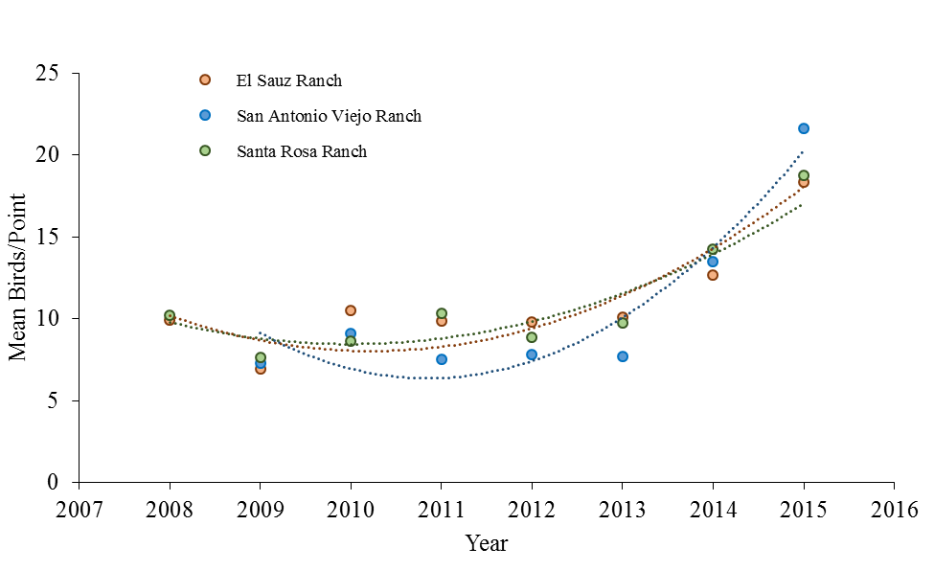
Figure 3. Trends in the number of breeding birds (of all species) counted per point on 3 East Foundation ranches in South Texas, 2008 – 2015.

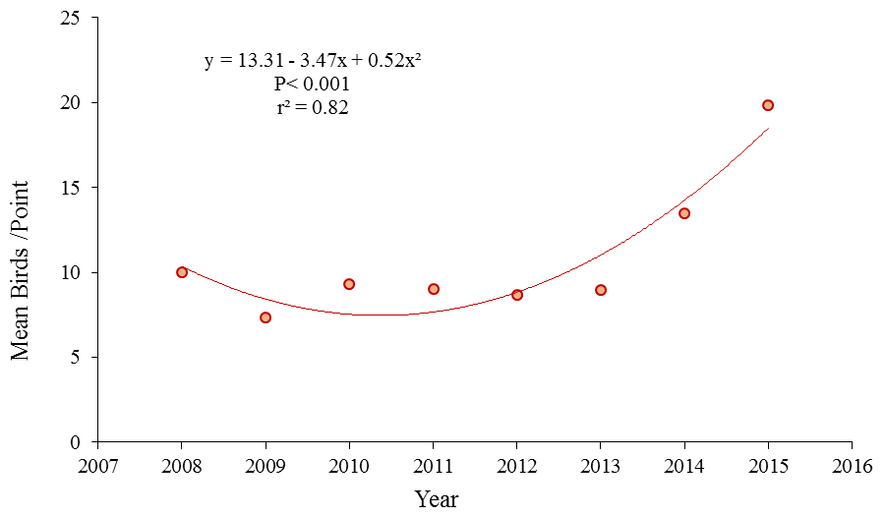
Figure 4. Trend in the mean number of birds (of all species) counted per point during breeding bird surveys of the East Foundation in South Texas, 2008 – 2015.
fairly stable from 2010 – 2013, with means between 8.65 and 9.32. This was followed by an increase to 13.47 birds/point in 2014. In 2015 mean bird/point increased to 19.82 nearly double what it was in 2008.
Three species (Bewick’s Wren, Mourning Dove, and Northern Mockingbird), significantly increased in abundance on all ranches during the study period. A total of 134 trend models were generated. A best-fit model (linear or quadratic) was selected for each species/group. Of the 67 best-fit models 26 were linear and 41 were quadratic, with 34 models showing a positive trend (α = 0.10), 28 models showing a stable trend (α = 0.10), and 3 models showing a negative trend (α = 0.10). Out of the 67 models, 49 had an r² >0.20. Of the 19 most commonly observed species or groups, 18 were observed a sufficient number times to calculate trends in abundance on all 3 ranches.
El Sauz. Including the trend in total avian abundance and 5 species of interest, 24 trend models were calculated using data from El Sauz BBS (Table 3). Six species or groups on El Sauz had significantly increasing trends (Bewick’s Wren, Cowbird spp., Mourning Dove, Northern Bobwhite, Northern Mockingbird, and Vireo griseus [White-eyed Vireo]; Fig. 5a – f). Three species (Myiarchus tyrannulus [Brown-crested Flycatcher], Eastern Meadowlark, and Tyrannus forficatus [Scissor-tailed Flycatcher]) had weakly increasing trends (Fig. 5g – i). Botteri’s Sparrow was the only species with a significantly decreasing trend on El Sauz (Fig. 5j). Stable trends were calculated for the remaining 13 species or groups (Table 3). Trends were calculated for Eastern Meadowlarks and Botteri’s Sparrows using data collected during El Sauz BBS only. Trends in the abundance of Cassin’s Sparrows were calculated using data from El Sauz and San Antonio Viejo only. Abundance of this species was stable on El Sauz (Fig. 5k). Trends in the abundance of Wild Turkey (Fig. 5l), and Red-winged Blackbird were calculated using data from
Table 3. Best-fit linear (yr) or quadratic (yr + yr²) models of trends in the mean number of birds counted per point during breeding bird surveys of El Sauz ranch in Kenedy County, Texas, 2008 – 2015.
Species | N¹ | Model | Trend | P-value | r²
All | 5035 | yr + yr² | Increase | 0.014** | 0.75
Brown-crested Flycatcher | 157 | yr | Weak increase | 0.086* | 0.41
Black-crested Titmouse | 78 | yr + yr² | Stable | 0.260 | 0.18
Bewick's Wren | 121 | yr + yr² | Increase | 0.036** | 0.63
Botteri's Sparrow | 62 | yr | Decrease | 0.023** | 0.61
Cassin's Sparrow | 81 | yr | Stable | 0.401 | 0.12
Cowbird spp. | 345 | yr + yr² | Increase | 0.006** | 0.82
Dove spp. | 125 | yr + yr² | Stable | 0.594 | 0.00
Eastern Meadowlark | 201 | yr + yr² | Weak increase | 0.091* | 0.46
Lark Sparrow | 91 | yr + yr² | Stable | 0.122 | 0.40
Mourning Dove | 677 | yr | Increase | 0.004** | 0.77
Northern Bobwhite | 317 | yr + yr² | Increase | 0.005** | 0.84
Northern Cardinal | 171 | yr | Stable | 0.226 | 0.10
Northern Mockingbird | 566 | yr + yr² | Increase | 0.001** | 0.90
Olive Sparrow | 212 | yr | Stable | 0.979 | 0.00
Painted Bunting | 14 | yr | Stable | 0.917 | 0.00
Pyrrhuloxia | 14 | yr + yr² | Stable | 0.435 | 0.00
Red-winged Blackbird | 71 | yr | Stable | 0.486 | 0.08
Scissor-tailed Flycatcher | 143 | yr | Weak increase | 0.090* | 0.41
Thrasher spp. | 43 | yr | Stable | 0.386 | 0.13
White-eyed Vireo | 71 | yr + yr² | Increase | 0.009** | 0.78
Wild Turkey | 77 | yr | Stable | 0.243 | 0.22
Woodpecker spp. | 129 | yr + yr² | Stable | 0.159 | 0.33
Yellow-billed Cuckoo | 128 | yr | Stable | 0.678 | 0.03
¹ Number of individuals observed
*p < 0.10
**p< 0.05

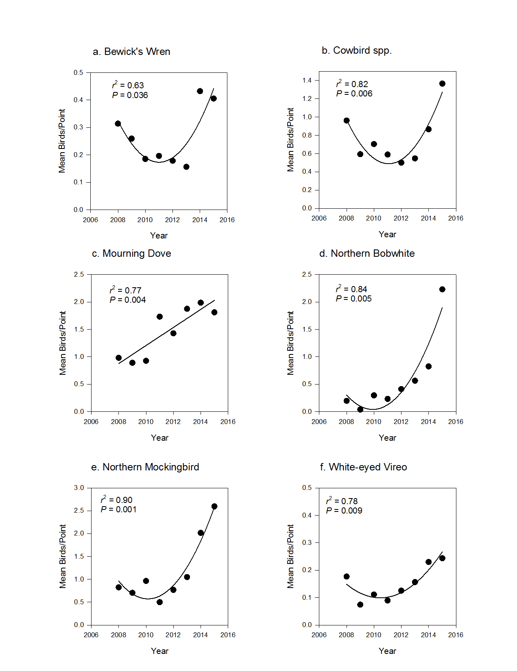
Figure 5. Trends in the mean number of individuals counted per point during breeding bird surveys of El Sauz Ranch in Kenedy County, Texas, 2008 – 2015.
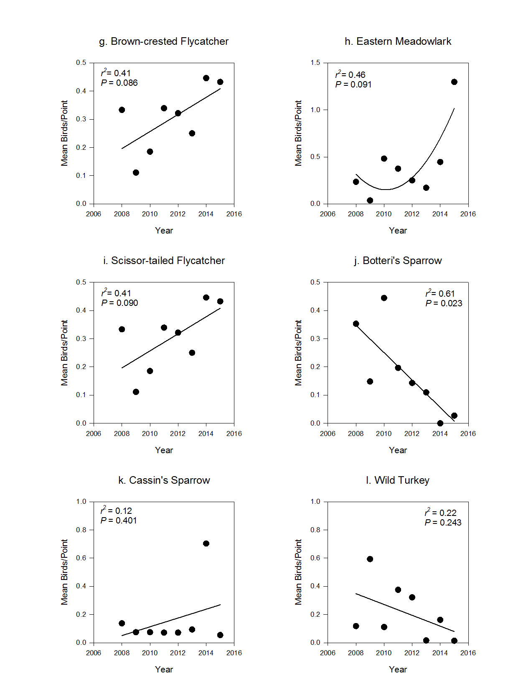
Figure 5. Continued

El Sauz and Santa Rosa only. The abundance of both species remained stable on El Sauz during the study period (Table 3, pg. 22).
San Antonio Viejo. A total of 22 trend models were calculated using BBS data from San Antonio Viejo including the trend in total avian abundance and 3 species of interest (Table 4). San Antonio Viejo had 10 species or groups with increasing trends (Brown-crested Flycatcher, Black-crested Titmouse, Bewick’s Wren, Cowbird spp., Lark Sparrow, Mourning Dove, Northern Bobwhite, Northern Mockingbird, Painted Bunting, and Scissor-tailed Flycatcher; Fig. 6a – j). Three species (Black-throated Sparrow [Fig. 6k], Cassin’s Sparrow [Fig. 6l], and Yellow-billed Cuckoo) had weakly increasing trends. Only White-eyed Vireo had a significantly declining trend. The remaining 7 species or groups had stable trends (Table 4). Trends in the abundance of Cactus Wren and Black-throated Sparrow were calculated using data from San Antonio Viejo only. Mean Cactus Wrens/point remained stable during the study period (Table 4).
Santa Rosa. Including the trend in total avian abundance, and 2 species of interest, 21 trend models were calculated using data from Santa Rosa BBS (Table 5). Santa Rosa also had 10 species with increasing trends (Brown-crested Flycatcher, Black-crested Titmouse, Bewick’s Wren, Lark Sparrow, Mourning Dove, Northern Cardinal, Northern Mockingbird, Red-winged Blackbird, Scissor-tailed Flycatcher, and White-eyed Vireo; Fig. 7a – j). Two species or groups (Northern Bobwhite [Fig. 7k] and Woodpecker spp.) had weakly increasing trends. Olive Sparrow was the only species with a significantly declining trend on Santa Rosa (Fig. 7l). The remaining 7 species or groups had stable trends (Table 5).
Precipitation. Total May – April precipitation during the study period varied considerably among years and ranches (Fig. 8). Mean total May – April precipitation during
Table 4. Best-fit linear (yr) or quadratic (yr + yr²) models of trends in the mean number of birds counted per point during breeding bird surveys of San Antonio Viejo ranch in Jim Hogg County, Texas, 2009 – 2015.
Species | Nª | Model | Trend | P-value | r²
All | 6333 | yr + yr² | Increase | 0.011** | 0.84
Brown-crested Flycatcher | 58 | yr + yr² | Increase | 0.003** | 0.92
Black-crested Titmouse | 86 | yr + yr² | Increase | 0.017** | 0.80
Bewick's Wren | 283 | yr + yr² | Increase | 0.013** | 0.83
Black-throated Sparrow | 255 | yr | Weak increase | 0.079* | 0.49
Cactus Wren | 41 | yr | Stable | 0.289 | 0.22
Cassin's Sparrow | 141 | yr + yr² | Weak increase | 0.057* | 0.46
Cowbird spp. | 124 | yr + yr² | Increase | 0.007** | 0.88
Dove spp. | 328 | yr + yr² | Stable | 0.206 | 0.32
Lark Sparrow | 143 | yr + yr² | Increase | 0.048** | 0.67
Mourning Dove | 585 | yr + yr² | Increase | 0.016** | 0.81
Northern Bobwhite | 582 | yr + yr² | Increase | 0.043** | 0.69
Northern Cardinal | 182 | yr | Stable | 0.240 | 0.11
Northern Mockingbird | 1,232 | yr + yr² | Increase | 0.006** | 0.88
Olive Sparrow | 41 | yr + yr² | Stable | 0.584 | 0.00
Painted Bunting | 197 | yr | Increase | 0.051** | 0.57
Pyrrhuloxia | 445 | yr + yr² | Stable | 0.413 | 0.03
Scissor-tailed Flycatcher | 137 | yr + yr² | Increase | 0.003** | 0.92
Thrasher spp. | 66 | yr | Stable | 0.185 | 0.32
White-eyed Vireo | 39 | yr + yr² | Decrease | 0.025** | 0.76
Woodpecker spp. | 373 | yr + yr² | Stable | 0.509 | 0.06
Yellow-billed Cuckoo | 104 | yr | Weak increase | 0.064* | 0.53
ª Number of individuals observed
*p < 0.10
**p< 0.05

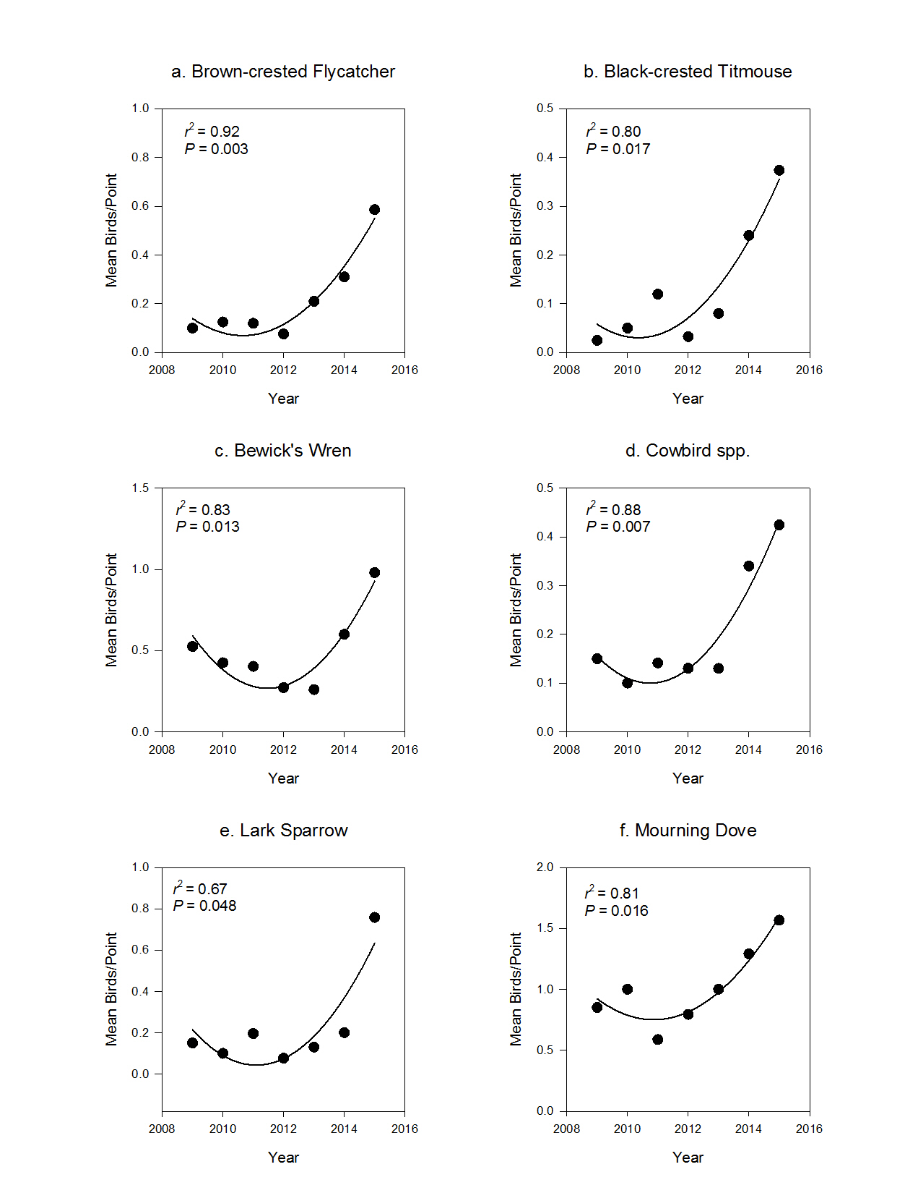
Figure 6. Trends in the mean number of individuals counted per point during breeding bird surveys of San Antonio Viejo Ranch in Jim Hogg County, Texas, 2009 – 2015.
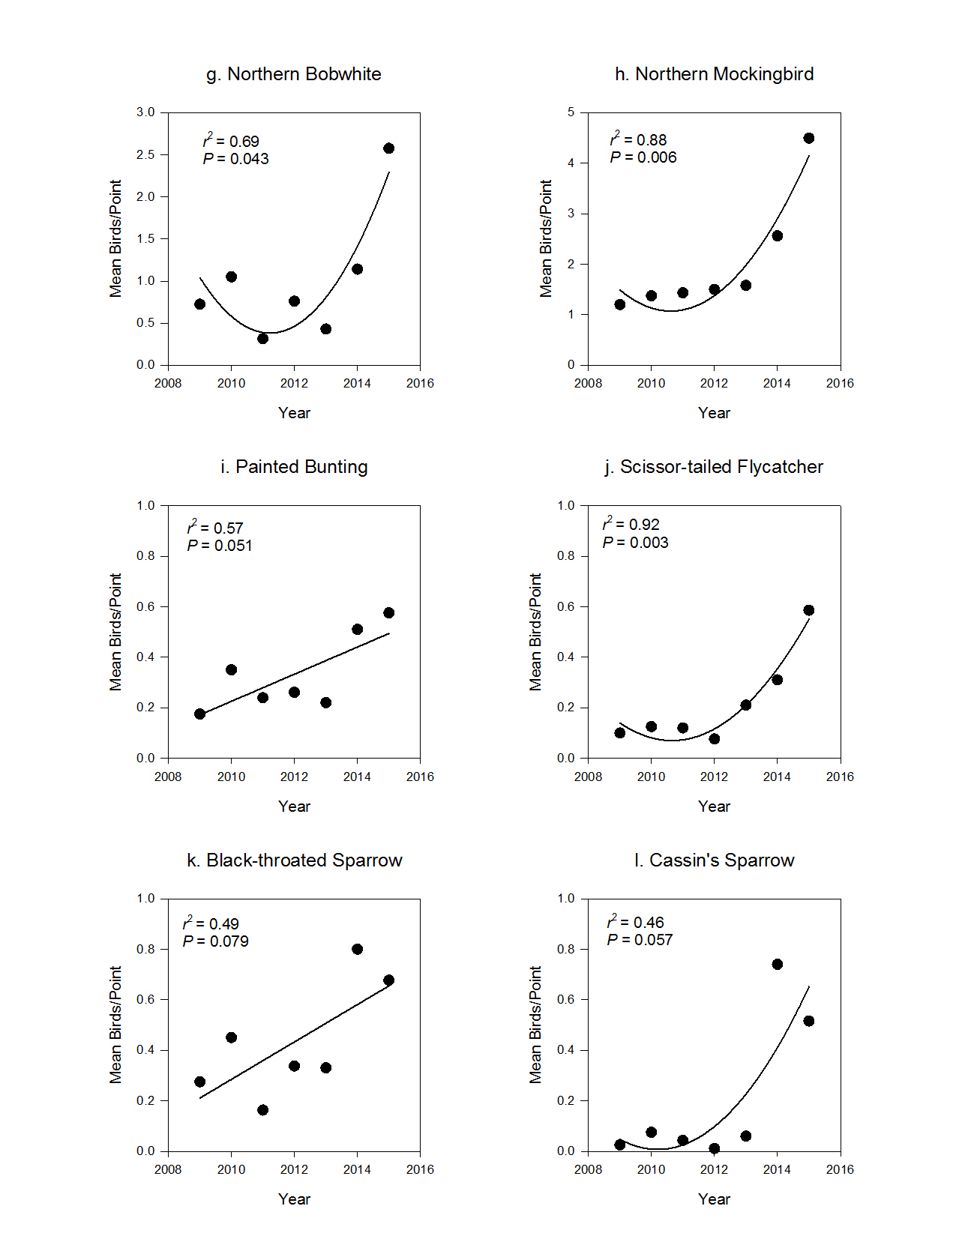
Figure 6. Continued

Table 5. Best-fit linear (yr) or quadratic (yr + yr²) models of trends in the mean number of birds counted per point during breeding bird surveys of Santa Rosa ranch in Kenedy County, Texas, 2008 – 2015.
Species | Nª | Model | Trend | P-value | r²
All | 5074 | yr + yr² | Increase | 0.003** | 0.86
Brown-crested Flycatcher | 241 | yr + yr² | Increase | 0.020** | 0.70
Black-crested Titmouse | 172 | yr + yr² | Increase | 0.002** | 0.88
Bewick's Wren | 269 | yr + yr² | Increase | 0.001** | 0.90
Cowbird spp. | 266 | yr + yr² | Stable | 0.583 | 0.00
Dove spp. | 213 | yr + yr² | Stable | 0.229 | 0.22
Lark Sparrow | 86 | yr + yr² | Increase | 0.028** | 0.66
Mourning Dove | 690 | yr | Increase | 0.051** | 0.41
Northern Bobwhite | 308 | yr + yr² | Weak increase | 0.063* | 0.54
Northern Cardinal | 252 | yr | Increase | 0.037** | 0.54
Northern Mockingbird | 681 | yr + yr² | Increase | < 0.001** | 0.94
Olive Sparrow | 122 | yr | Decrease | 0.038** | 0.54
Painted Bunting | 130 | yr | Stable | 0.321 | 0.16
Pyrrhuloxia | 83 | yr | Stable | 0.856 | 0.00
Red-winged Blackbird | 38 | yr + yr² | Increase | 0.043** | 0.60
Scissor-tailed Flycatcher | 161 | yr + yr² | Increase | 0.021** | 0.70
Thrasher spp. | 10 | yr | Stable | 0.126 | 0.34
White-eyed Vireo | 40 | yr + yr² | Increase | 0.006** | 0.82
Wild Turkey | 90 | yr | Stable | 0.656 | 0.03
Woodpecker spp. | 257 | yr + yr² | Weak increase | 0.086* | 0.47
Yellow-billed Cuckoo | 243 | yr | Stable | 0.819 | 0.01
ª Number of individuals observed
*p < 0.10
**p< 0.05

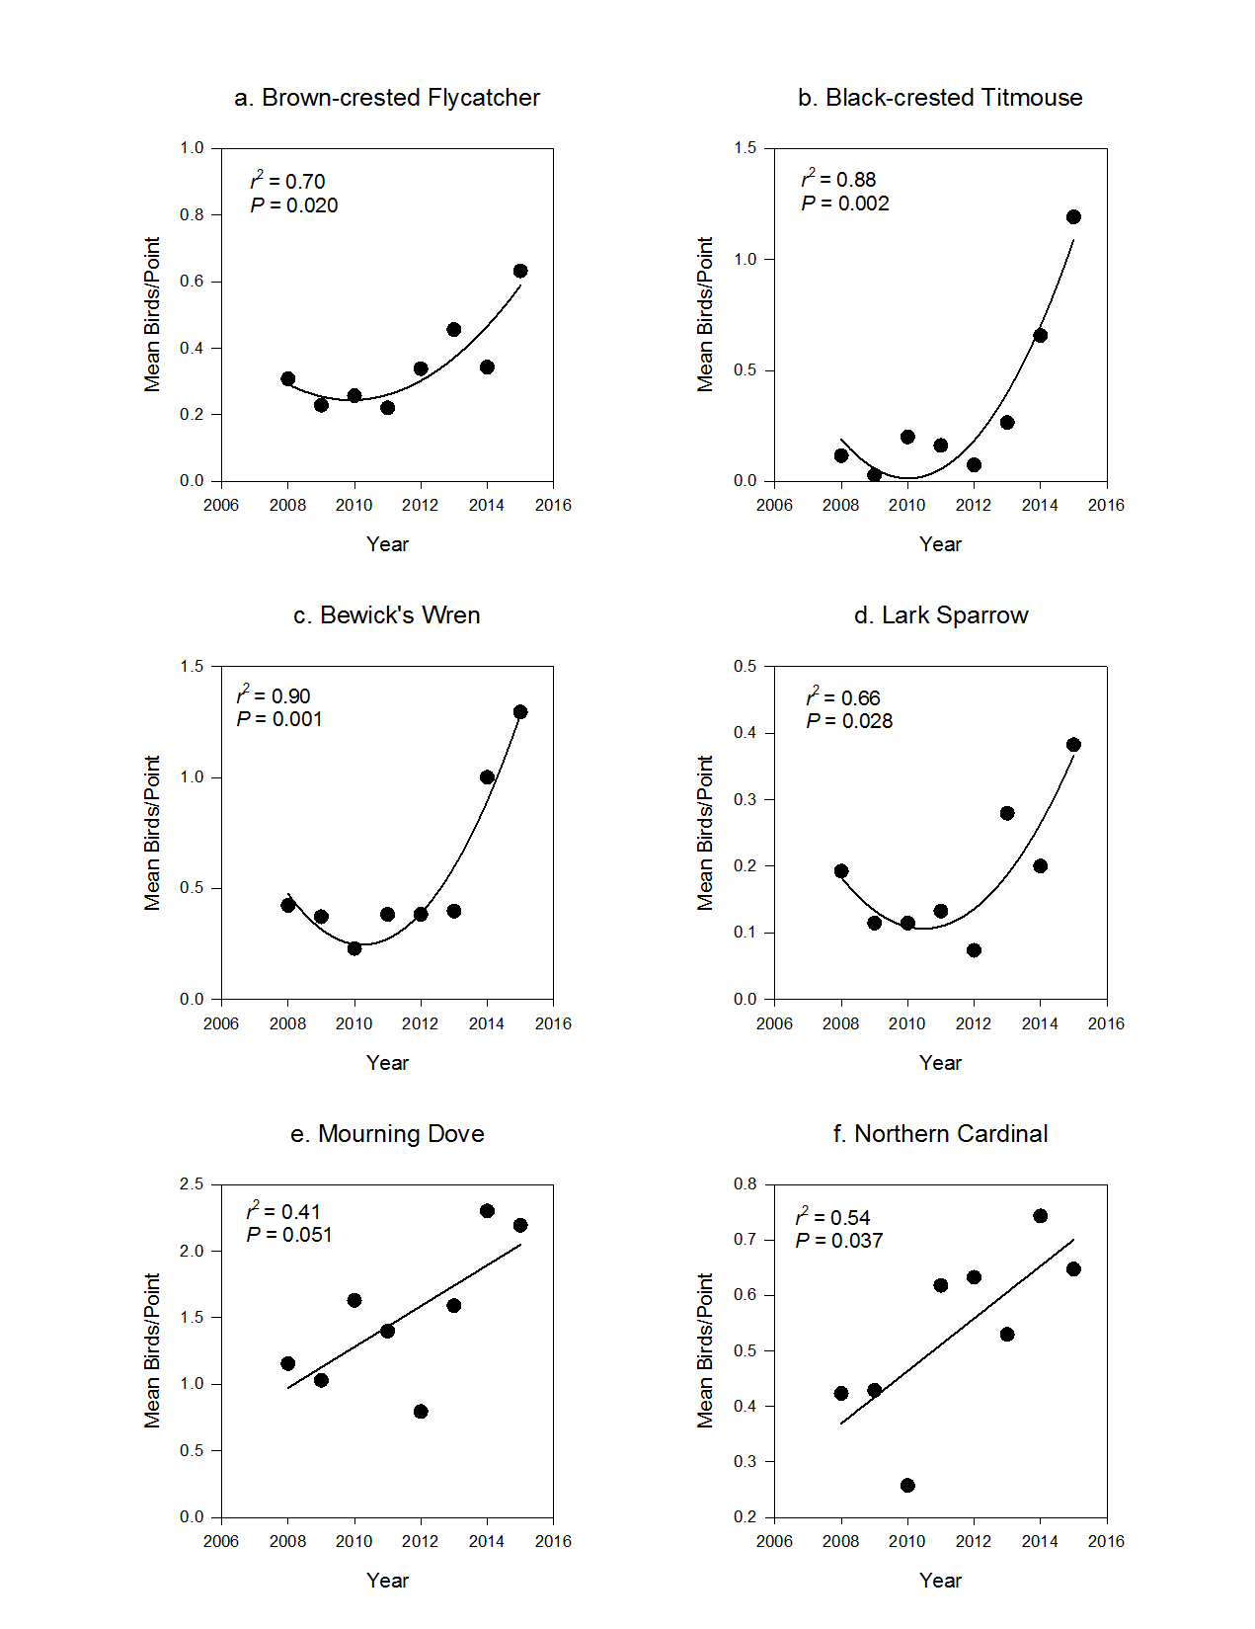
Figure 7. Trends in the mean number of individuals counted per point during breeding bird surveys of the Santa Rosa Ranch of the East Foundation, 2008 – 2015.
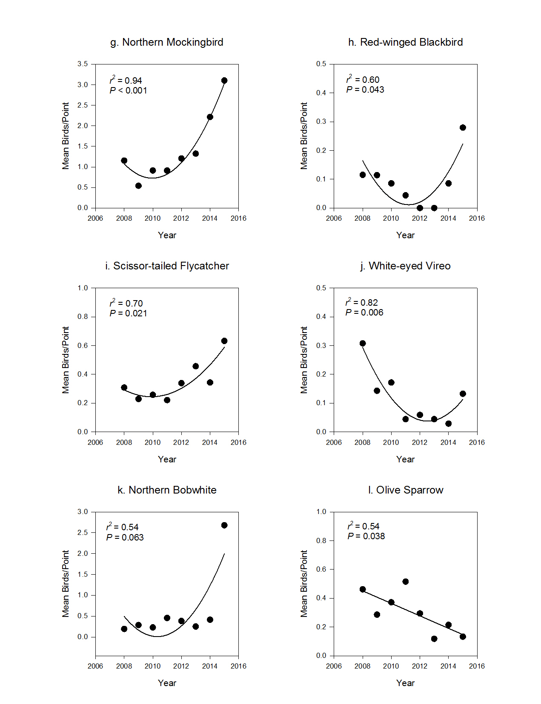
Figure 7. Continued

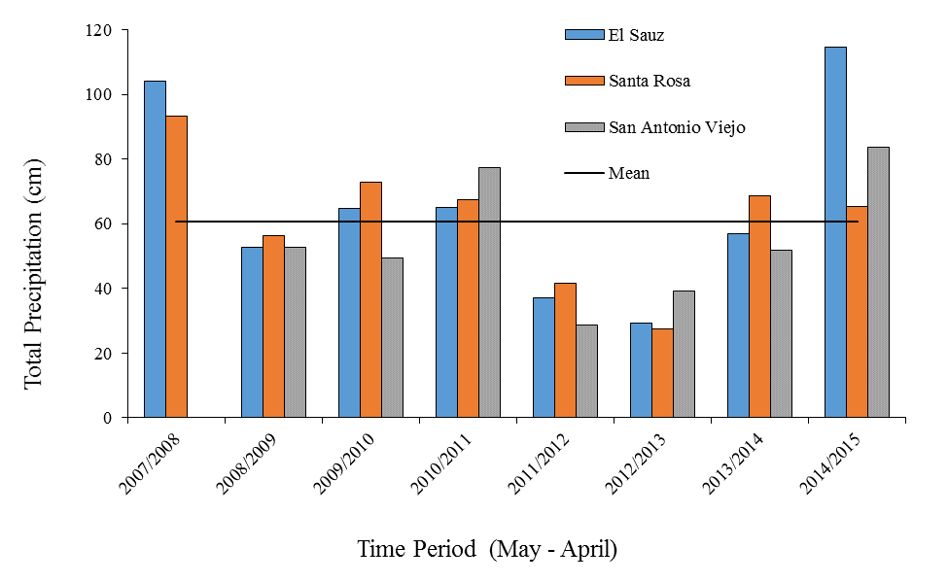
Figure 8. Total May – April precipitation (cm) on 3 East Foundation Ranches surveyed for breeding birds 2008 – 2015. Mean total May – April precipitation was 60.62 cm.

the study period was highest on El Sauz at 65.54 cm, ranging from a high of 114.5 cm during May 2014 ̶ April 2015 to a low of 29.2 cm during May 2012 ̶ April 2013 (Fig. 8, pg. 32). Mean total May – April precipitation was lowest on San Antonio Viejo at 54.7 cm, with a high of 83.6 cm during May 2014 ̶ April 2015, and a low of 28.77 cm during May 2012 ̶ April 2013 (Fig. 8, pg. 32). Santa Rosa had mean total May – April precipitation of 61.6 cm, with a high of 93.4 cm during May 2007 ̶ April 2008, and a low of 27.4 cm during May 2012 ̶ April 2013 (Fig. 8, pg. 32). The effect of precipitation on birds/point was analyzed at the individual ranch level only.
Precipitation alone did not have a significant effect on birds/point of all species on any of the 3 ranches, although it did explain some variation on El Sauz (r² = 0.26) and San Antonio Viejo (r² = 0.23, Tables 6 and 7). Precipitation did not explain any of the variation in birds/point on Santa Rosa (r² = 0.00 [Table 8]). Models of birds/point (of all species) that included both year and precipitation were significant for all 3 ranches, and explained a large amount of variation. The variation explained by precipitation and year was greatest on El Sauz (r² = 0.95 [Table 6]), high on San Antonio Viejo (r² = 0.91 [Table 7]), and lowest on Santa Rosa (r² = 0.71 [Table 8]).
Precipitation did not have a significant effect on any of the 10 species or groups analyzed, although the effect of precipitation approached significance for several species (Tables 6 – 8). Models that incorporated both precipitation and year were significant for multiple species on all 3 ranches (Tables 6 – 8). Northern Mockingbird was the only species for which models that included precipitation were significant on all 3 ranches (Tables 6 – 8).
El Sauz. Models of the combined effects of precipitation and year on birds/point were the best models for 4 species (Eastern Meadowlark, Northern Bobwhite, Northern Mockingbird, and
Table 6. Effects of precipitation and year on the average number of birds counted per point during breeding bird surveys of El Sauz Ranch in Kenedy County, Texas, 2008 – 2015.
Species | Nª | Model |  | Coefficient | SE ^{b} | P-value | r^{2c} | DF ^{d}
All | 5,034 | yr + ppt |  |  |  | <0.001** | 0.93 | 2, 5
All | 5,034 | yr + ppt | yr ^{e} | 1.074 | 0.131 | <0.001
All | 5,034 | yr + ppt | ppt ^{f} | 0.06 | 0.011 | 0.003
All | 5,034 | yr |  | 1.045 | 0.32 | 0.017** | 0.64 | 1,6
All | 5,034 | ppt |  | 0.056 | 0.037 | 0.182 | 0.27 | 1, 6
Bewick’s Wren | 121 | ppt |  | 0.002 | 0.091 | 0.103* | 0.38 | 1, 6
Bewick’s Wren | 121 | yr + ppt |  |  |  | 0.138 | 0.37 | 2, 5
Bewick’s Wren | 121 | yr + ppt | yr | 0.018 | 0.013 | 0.234
Bewick’s Wren | 121 | yr + ppt | ppt | 0.002 | 0.001 | 0.089*
Bewick’s Wren | 121 | yr |  | 0.017 | 0.017 | 0.351 | 0.15 | 1, 6
Doves | 125 | ppt |  | 7.47E-04 | 0.001 | 0.595 | 0.05 | 1, 6
Doves | 125 | yr |  | -0.004 | 0.017 | 0.823 | 0.01 | 1, 6
Doves | 125 | yr + ppt |  |  |  | 0.863 | 0.00 | 2, 5
Doves | 125 | yr + ppt | yr | -0.004 | 0.018
Doves | 125 | yr + ppt | ppt | 7.35E-04 | 0.001
Mourning Dove | 677 | yr |  | 0.165 | 0.037 | 0.004** | 0.76 | 1, 6
Mourning Dove | 677 | yr + ppt |  |  |  | 0.024** | 0.69 | 2, 5
Mourning Dove | 677 | yr + ppt | yr | 0.164 | 0.04 | 0.009
Mourning Dove | 677 | yr + ppt | ppt | -0.001 | 0.003 | 0.676
Mourning Dove | 677 | ppt |  | -0.002 | 0.006 | 0.76 | 0.02 | 1, 6
Northern Bobwhite | 317 | yr + ppt |  |  |  | 0.001** | 0.94 | 2, 5
Northern Bobwhite | 317 | yr + ppt | yr | 0.234 | 0.032 | <0.001
Northern Bobwhite | 317 | yr + ppt | ppt | 0.013 | 0.003 | <0.001
Northern Bobwhite | 317 | yr |  | 0.228 | 0.071 | 0.018** | 0.63 | 1, 6
Northern Bobwhite | 317 | ppt |  | 0.012 | 0.647 | 0.185 | 0.27 | 1, 6
Northern Cardinal | 171 | yr |  | 0.029 | 0.022 | 0.226 | 0.23 | 1, 6
Northern Cardinal | 171 | yr + ppt |  |  |  | 0.283 | 0.15 | 2, 5
Northern Cardinal | 171 | yr + ppt | yr | 0.03 | 0.021 | 0.211
Northern Cardinal | 171 | yr + ppt | ppt | 0.002 | 0.002 | 0.298
Northern Cardinal | 171 | ppt |  | 0.002 | 0.148 | 0.348 | 0.15 | 1, 6
Northern Mockingbird | 566 | yr + ppt |  |  |  | 0.009** | 0.85 | 2, 5
Northern Mockingbird | 566 | yr + ppt | yr | 0.238 | 0.052 | 0.006
Northern Mockingbird | 566 | yr + ppt | ppt | 0.012 | 0.004 | 0.035
Northern Mockingbird | 566 | yr |  | 0.232 | 0.077 | 0.024** | 0.60 | 1, 6
Northern Mockingbird | 566 | ppt |  | 0.011 | 0.699 | 0.245 | 0.22 | 1, 6

Table 6. Continued
Species | Nª | Model |  |  | Coefficient | SE ^{b} | P-value | r^{2c} | DF ^{d}
Olive Sparrow | 212 | ppt |  |  | 6.03E-04 | 0.088 | 0.606 | 0.05 | 1, 6
Olive Sparrow | 212 | yr + ppt |  |  |  |  | 0.886 | 0.00 | 2, 5
Olive Sparrow | 212 | yr + ppt | yr |  | 6.83E-04 | 0.015 | 0.965
Olive Sparrow | 212 | yr + ppt | ppt |  | 6.05E-04 | 0.001 | 0.639
 |  | yr |  |  | 3.82E-04 | 0.014 | 0.979 | 0.00 | 1, 6
Painted Bunting | 14 | ppt |  |  | -1.59E-04 | 0.019 | 0.534 | 0.07 | 1, 6
Painted Bunting | 14 | yr + ppt |  |  |  |  | 0.837 | 0.00 | 2, 5
Painted Bunting | 14 | yr + ppt | yr |  | 2.54E-04 | 0.003 | 0.94
Painted Bunting | 14 | yr + ppt | ppt |  | -1.59E-04 | 2.65E-04 | 0.575
Painted Bunting | 14 | yr |  |  | 3.33E-04 | 0.003 | 0.917 | 0.00 | 1, 6
Pyrrhuloxia | 14 | ppt |  |  | 5.52E-04 | 0.044 | 0.381 | 0.13 | 1, 6
Pyrrhuloxia | 14 | yr |  |  | 7.85E-04 | 0.007 | 0.917 | 0.00 | 1, 6
Pyrrhuloxia | 14 | yr + ppt |  |  |  |  | 0.699 | 0.00 | 2, 5
Pyrrhuloxia | 14 | yr + ppt | yr |  | 0.001 | 0.007 | 0.893
Pyrrhuloxia | 14 | yr + ppt | ppt |  | 5.26E-04 | 6.04E-04 | 0.424
Scissor-tailed Flycatcher | 143 | yr + ppt |  |  |  |  | 0.052** | 0.83 | 2, 5
Scissor-tailed Flycatcher | 143 | yr + ppt | yr |  | 0.031 | 0.013 | 0.063
Scissor-tailed Flycatcher | 143 | yr + ppt | ppt |  | 0.002 | 0.001 | 0.166
Scissor-tailed Flycatcher | 143 | yr |  |  | 0.03 | 0.015 | 0.085* | 0.41 | 1, 6
Scissor-tailed Flycatcher | 143 | ppt |  |  | 0.002 | 0.113 | 0.297 | 0.18 | 1, 6
Botteri’s Sparrow | 62 | yr |  |  | -0.049 | 0.016 | 0.022** | 0.61 | 1, 6
Botteri’s Sparrow | 62 | yr + ppt |  |  |  |  | 0.089* | 0.47 | 2, 5
Botteri’s Sparrow | 62 | yr + ppt | yr |  | -0.048 | 0.017 | 0.038
Botteri’s Sparrow | 62 | yr + ppt | ppt |  | 5.67E-04 | 0.001 | 0.704
Botteri’s Sparrow | 62 | ppt |  |  | 7.29E-04 | 0.002 | 0.736 | 0.02 | 1, 6
Cassin’s Sparrow | 81 | yr |  |  | 0.031 | 0.035 | 0.401 | 0.12 | 1, 6
Cassin’s Sparrow | 81 | ppt |  |  | -7.48E-04 | 0.002 | 0.811 | 0.01 | 1, 6
Cassin’s Sparrow | 81 | yr + ppt |  |  |  |  | 0.711 | 0.00 | 2, 5
Cassin’s Sparrow | 81 | yr + ppt | yr |  | 0.031 | 0.038 | 0.45
Cassin’s Sparrow | 81 | yr + ppt | ppt |  | -6.45E-04 | 0.003 | 0.843
Eastern Meadowlark | 201 | yr + ppt |  |  |  |  | 0.004** | 0.89 | 2, 5
Eastern Meadowlark | 201 | yr + ppt | yr |  | 0.105 | 0.023 | 0.007
Eastern Meadowlark | 201 | yr + ppt | ppt |  | 0.009 | 0.002 | 0.005
Eastern Meadowlark | 201 | ppt |  |  | 0.009 | 0.004 | 0.069* | 0.45 | 1, 6
Eastern Meadowlark | 201 | yr |  |  | 0.1 | 0.05 | 0.091* | 0.40 | 1, 6
ª Number of individuals  ^{b} Standard error  ^{c} adjusted r² for models with ≥2 effects |  |  |  | ^{d} DF = Degrees of freedom,  ^{e} Year  ^{f} Total May – April precipitation  ** P < 0.05, * P < 0.10

Table 7. Effects of precipitation and year on the average number of birds counted per point during breeding bird surveys of San Antonio Viejo Ranch in Willacy County, Texas, 2009 – 2015.
Species | Nª | Model |  | Coefficient | SE ^{b} | P-value | r^{2c} | DF ^{d}
All | 6,333 | yr + ppt + yr*ppt |  |  |  | 0.015** | 0.91 | 3, 3
All | 6,333 | yr + ppt + yr*ppt | yr^{e} | -3.428 | 1.395 | 0.091
All | 6,333 | yr + ppt + yr*ppt | ppt^{f} | -0.275 | 0.112 | 0.091
All | 6,333 | yr + ppt + yr*ppt | yr*ppt | 0.083 | 0.022 | 0.034
All | 6,333 | yr |  | 1.858 | 0.721 | 0.05** | 0.57 | 1, 5
All | 6,333 | ppt |  | 0.162 | 0.097 | 0.157 | 0.36 | 1, 5
Bewick's Wren | 283 | yr + ppt + yr*ppt |  |  |  | 0.071* | 0.75 | 3, 3
Bewick's Wren | 283 | yr + ppt + yr*ppt | yr | -0.212 | 0.109 | 0.148
Bewick's Wren | 283 | yr + ppt + yr*ppt | ppt | -0.011 | 0.009 | 0.284
Bewick's Wren | 283 | yr + ppt + yr*ppt | yr*ppt | 0.004 | 0.002 | 0.100
Bewick's Wren | 283 | ppt |  | 0.009 | 0.004 | 0.059* | 0.54 | 1, 5
Bewick's Wren | 283 | yr |  | 0.056 | 0.045 | 0.263 | 0.09 | 2, 5
Doves | 328 | yr + ppt + yr*ppt |  |  |  | 0.061* | 0.78 | 3, 3
Doves | 328 | yr + ppt + yr*ppt | yr | -0.363 | 0.124 | 0.061
Doves | 328 | yr + ppt + yr*ppt | ppt | -0.028 | 0.01 | 0.070
Doves | 328 | yr + ppt + yr*ppt | yr*ppt | 0.007 | 0.002 | 0.039
Doves | 328 | yr |  | 0.074 | 0.051 | 0.210 | 0.29 | 1, 5
Doves | 328 | ppt |  | 0.007 | 0.006 | 0.263 | 0.24 | 1, 5
Mourning Dove | 585 | yr + ppt + yr*ppt |  |  |  | 0.145 | 0.60 | 3, 3
Mourning Dove | 585 | yr + ppt + yr*ppt | yr | -0.224 | 0.185 | 0.312
Mourning Dove | 585 | yr + ppt + yr*ppt | ppt | -0.024 | 0.015 | 0.209
Mourning Dove | 585 | yr + ppt + yr*ppt | yr*ppt | 0.005 | 0.003 | 0.164
Mourning Dove | 585 | yr |  | 0.112 | 0.045 | 0.056* | 0.55 | 1, 5
Mourning Dove | 585 | ppt |  | 0.005 | 0.007 | 0.503 | 0.09 | 1, 5
Northern Bobwhite | 582 | yr + ppt + yr*ppt |  |  |  | 0.014** | 0.92 | 3, 3
Northern Bobwhite | 582 | yr + ppt + yr*ppt | yr | -0.916 | 0.195 | 0.018
Northern Bobwhite | 582 | yr + ppt + yr*ppt | ppt | -36.17 | 6.292 | 0.011
Northern Bobwhite | 582 | yr + ppt + yr*ppt | yr*ppt | 0.018 | 0.003 | 0.010
Northern Bobwhite | 582 | yr |  | 0.209 | 0.126 | 0.157 | 0.36 | 1, 5
Northern Bobwhite | 582 | ppt |  | 0.019 | 0.015 | 0.248 | 0.26 | 1, 5
Northern Cardinal | 182 | yr |  | 0.048 | 0.036 | 0.240 | 0.26 | 1, 5
Northern Cardinal | 182 | yr + ppt |  |  |  | 0.527 | 0.00 | 2, 4
Northern Cardinal | 182 | yr + ppt | yr | 0.051 | 0.041 | 0.287
Northern Cardinal | 182 | yr + ppt | ppt | -0.001 | 0.005 | 0.811
Northern Cardinal | 182 | ppt |  | 1.33E-04 | 0.005 | 0.978 | 0.00 | 1, 5
Table 7. Continued
Species | Nª | Model |  | Coefficient |  | SE ^{b} | P-value | r^{2c} | DF ^{d}
Northern Mockingbird | 1,232 | yr + ppt + yr*ppt |  |  |  |  | 0.002** | 0.98 | 3, 3
Northern Mockingbird | 1,232 | yr + ppt + yr*ppt | yr | -0.599 |  | 0.16 | 0.033
Northern Mockingbird | 1,232 | yr + ppt + yr*ppt | ppt | -0.052 |  | 0.013 | 0.027
Northern Mockingbird | 1,232 | yr + ppt + yr*ppt | yr*ppt | 0.016 |  | 0.003 | 0.008
Northern Mockingbird | 1,232 | yr |  | 0.443 |  | 0.142 | 0.0263** | 0.66 | 1, 5
Northern Mockingbird | 1,232 | ppt |  | 0.036 |  | 0.022 | 0.161 | 0.35 | 1, 5
Olive Sparrow | 41 | yr |  | 2.00E-03 |  | 0.009 | 0.869 | 0.00 | 1, 5
Olive Sparrow |  | ppt |  | 2.05E-05 |  | 0.001 | 0.985 | 0.00 | 1, 5
Olive Sparrow |  | yr + ppt |  |  |  |  | 0.988 | 0.00 | 2, 4
Olive Sparrow |  | yr + ppt | yr | 0.002 |  | 0.001 | 0.884
Olive Sparrow |  | yr + ppt | ppt | -2.09E-05 |  | 0.001 | 0.986
Painted Bunting | 197 | yr |  | 0.054 |  | 0.021 | 0.051** | 0.57 | 1, 5
Painted Bunting |  | yr + ppt |  |  |  |  | 0.123 | 0.47 | 2, 4
Painted Bunting |  | yr + ppt | yr | 0.049 |  | 0.022 | 0.088
Painted Bunting |  | yr + ppt | ppt | 0.002 |  | 0.002 | 0.387
Painted Bunting |  | ppt |  | 0.004 |  | 0.003 | 0.306 | 0.21 | 1, 5
Pyrrhuloxia | 445 | ppt |  | 0.006 |  | 0.003 | 0.094* | 0.46 | 1, 5
Pyrrhuloxia |  | yr + ppt |  |  |  |  | 0.286 | 0.20 | 2, 4
Pyrrhuloxia |  | yr + ppt | yr | -0.005 |  | 0.028 | 0.861
Pyrrhuloxia |  | yr + ppt | ppt | 0.006 |  | 0.003 | 0.138
Pyrrhuloxia |  | yr |  | 0.007 |  | 0.033 | 0.846 | 0.00 | 1, 5
Scissor-tailed Flycatcher | 137 | yr + ppt + yr*ppt |  |  |  |  | 0.016** | 0.91 | 3, 3
Scissor-tailed Flycatcher |  | yr + ppt + yr*ppt | yr | -0.068 |  | 0.049 | 0.255
Scissor-tailed Flycatcher |  | yr + ppt + yr*ppt | ppt | -0.006 |  | 0.004 | 0.016
Scissor-tailed Flycatcher |  | yr + ppt + yr*ppt | yr*ppt | 0.002 |  | 0.001 | 0.073
Scissor-tailed Flycatcher |  | yr |  | 0.069 |  | 0.022 | 0.024** | 0.67 | 1, 5
Scissor-tailed Flycatcher |  | ppt |  | 0.005 |  | 0.003 | 0.159 | 0.35 | 1, 5
Cactus Wren | 41 | yr |  | -0.016 |  | 0.014 | 0.290 | 0.22 | 1, 5
Cactus Wren |  | yr + ppt |  |  |  |  | 0.364 | 0.10 | 2, 4
Cactus Wren |  | yr + ppt | yr | -0.02 |  | 0.014 | 0.228
Cactus Wren |  | yr + ppt | ppt | 0.002 |  | 0.002 | 0.339
Cactus Wren |  | ppt |  | 0.001 |  | 0.002 | 0.511 | 0.09 | 1, 5
Cassin's Sparrow | 141 | yr |  | 0.101 |  | 0.041 | 0.057* | 0.55 | 1, 5
Cassin's Sparrow |  | yr + ppt |  |  |  |  | 0.174 | 0.37 | 2, 4
Cassin's Sparrow |  | yr + ppt | yr | 0.095 |  | 0.045 | 0.104
Cassin's Sparrow |  | yr + ppt | ppt | 0.003 |  | 0.005 | 0.601
Cassin's Sparrow |  | ppt |  | 0.005 |  | 0.006 | 0.441 | 0.12 | 1, 5
ª Number of individuals  ^{b} Standard error  ^{c} adjusted r² for models with ≥2 effects |  |  |  |  | ^{d} DF = Degrees of freedom, ^{e} Year  ^{f} Total May – April precipitation  ** P < 0.05, * P < 0.10

Table 8. Models of the effects of precipitation and year on the average number of birds counted per point during annual breeding bird surveys of Santa Rosa Ranch in Kenedy County, Texas, 2008 – 2015.
Species | Nª | Model |  | Coefficient | SE ^{b} | P-value | r^{2c} | DF ^{d}
All | 5,074 | yr + ppt |  |  |  | 0.005** | 0.83 | 2, 5
All |  | yr + ppt | yr^{e} | 1.523 | 0.258 | 0.002
All |  | yr + ppt | ppt^{f} | 0.118 | 0.031 | 0.013
All |  | yr |  | 1.107 | 0.414 | 0.037** | 0.54 | 1, 6
All |  | ppt |  | 0.037 | 0.073 | 0.627 | 0.04 | 1, 6
Bewick’s Wren | 269 | yr + ppt |  |  |  | 0.012** | 0.76 | 2, 5
Bewick’s Wren |  | yr + ppt | yr | 0.153 | 0.032 | 0.060
Bewick’s Wren |  | yr + ppt | ppt | 0.01 | 0.004 | 0.041
Bewick’s Wren |  | yr |  | 0.116 | 0.041 | 0.03** | 0.57 | 1, 6
Bewick’s Wren |  | ppt |  | 0.002 | 0.008 | 0.762 | 0.02 | 1, 6
Doves | 213 | yr |  | 0.052 | 0.033 | 0.178 | 0.28 | 1, 6
Doves |  | ppt |  | -0.006 | 0.004 | 0.195 | 0.26 | 1, 6
Doves |  | yr + ppt |  |  |  | 0.304 | 0.13 | 2, 5
Doves |  | yr + ppt | yr | 0.037 | 0.378 | 0.377
Doves |  | yr + ppt | ppt | -0.004 | 0.005 | 0.413
Mourning Dove | 690 | yr + ppt |  |  |  | 0.03** | 0.66 | 2, 5
Mourning Dove |  | yr + ppt | yr | 0.206 | 0.053 | 0.012
Mourning Dove |  | yr + ppt | ppt | 0.015 | 0.006 | 0.070
Mourning Dove |  | yr |  | 0.154 | 0.063 | 0.051** | 0.50 | 1, 6
Mourning Dove |  | ppt |  | 0.004 | 0.011 | 0.716 | 0.02 | 1, 6
Northern Bobwhite | 308 | yr |  | 0.215 | 0.109 | 0.097* | 0.39 | 1, 6
Northern Bobwhite |  | yr + ppt |  |  |  | 0.159 | 0.33 | 2, 5
Northern Bobwhite |  | yr + ppt | yr | 0.274 | 0.118 | 0.070
Northern Bobwhite |  | yr + ppt | ppt | 0.017 | 0.014 | 0.298
Northern Bobwhite |  | ppt |  | 0.002 | 0.017 | 0.900 | 0.00 | 1, 6
Northern Cardinal | 252 | yr |  | 0.047 | 0.018 | 0.037** | 0.54 | 1, 6
Northern Cardinal |  | yr + ppt |  |  |  | 0.138 | 0.37 | 2, 5
Northern Cardinal |  | yr + ppt | yr | 0.05 | 0.021 | 0.069
Northern Cardinal |  | yr + ppt | ppt | 6.47E-04 | 0.003 | 0.814
Northern Cardinal |  | ppt |  | -0.002 | 0.003 | 0.550 | 0.06 | 1, 6
Northern Mockingbird | 681 | yr + ppt |  |  |  | 0.004** | 0.84 | 2, 5
Northern Mockingbird |  | yr + ppt | yr | 0.355 | 0.057 | 0.002
Northern Mockingbird |  | yr + ppt | ppt | 0.021 | 0.007 | 0.029
Northern Mockingbird |  | yr |  | 0.28 | 0.079 | 0.012** | 0.68 | 1, 6
Northern Mockingbird |  | ppt |  | 0.002 | 0.017 | 0.891 | 0.00 | 1, 6
Table 8. Continued
Species | Nª | Model |  |  | Coefficient | SE ^{b} | P-value | r^{2c} | DF ^{d}
Olive Sparrow | 122 | yr |  |  | -0.043 | 0.016 | 0.038** | 0.54 | 1, 6
Olive Sparrow |  | yr + ppt |  |  |  |  | 0.075* | 0.50 | 2, 5
Olive Sparrow |  | yr + ppt | yr |  | -0.034 | 0.017 | 0.107
Olive Sparrow |  | yr + ppt | ppt |  | 0.003 | 0.002 | 0.279
Olive Sparrow |  | ppt |  |  | 0.004 | 0.002 | 0.109 | 0.37 | 1, 6
Painted Bunting | 130 | yr + ppt |  |  |  |  | 0.213 | 0.25 | 2, 5
Painted Bunting |  | yr + ppt | yr |  | -0.011 | 0.006 | 0.127
Painted Bunting |  | yr + ppt | ppt |  | -0.001 | 0.008 | 0.157
Painted Bunting |  | yr |  |  | -0.007 | 0.006 | 0.321 | 0.16 | 1, 6
Painted Bunting |  | ppt |  |  | -6.68E-04 | 8.12E-04 | 0.442 | 0.10 | 1, 6
Pyrrhuloxia | 83 | yr + ppt + yr*ppt |  |  |  |  | 0.157 | 0.46 | 3, 4
Pyrrhuloxia |  | yr + ppt + yr*ppt | yr |  | -0.104 | 0.044 | 0.076
Pyrrhuloxia |  | yr + ppt + yr*ppt | ppt |  | -0.005 | 0.003 | 0.144
Pyrrhuloxia |  | yr + ppt + yr*ppt | yr*ppt |  | 0.002 | 6.02E-04 | 0.057
Pyrrhuloxia |  | ppt |  |  | 0.001 | 0.002 | 0.449 | 0.10 | 1, 6
Pyrrhuloxia |  | yr |  |  | 0.002 | 0.013 | 0.856 | 0.00 | 1, 6
Scissor-tailed Flycatcher | 161 | yr |  |  | 0.042 | 0.015 | 0.031** | 0.57 | 1, 6
Scissor-tailed Flycatcher |  | ppt |  |  | -0.002 | 0.003 | 0.547 | 0.06 | 1, 6
Scissor-tailed Flycatcher |  | yr + ppt |  |  |  |  | 0.658 | 0.00 | 2, 5
Scissor-tailed Flycatcher |  | yr + ppt | yr |  | 0.009 | 0.015 | 0.591
Scissor-tailed Flycatcher |  | yr + ppt | ppt |  | 0.002 | 0.002 | 0.392
ª Number of individuals  ^{b} Standard error  ^{c} adjusted r² for models with ≥2 effects |  |  |  | ^{d} DF = Degrees of freedom,  ^{e} Year  ^{f} Total May – April precipitation  ** P < 0.05, * P < 0.10

Scissor-tailed Flycatcher) on El Sauz (Table 6, pg. 34). The interaction between precipitation and year did was not significant for any of the species modeled. The effect of precipitation approached significance for 2 species (Bewick’s Wren and Botteri’s Sparrow [Table 6, pg. 34]). Although not significant, precipitation explained a small amount of variation in birds/point of 3 species (Olive Sparrow, Painted Bunting, and Pyrrhuloxia), not explained by year (Table 6, pg. 34).
San Antonio Viejo. Models of the combined effects of precipitation and year were significant for 3 species (Northern Bobwhite, Northern Mockingbird, and Scissor-tailed Flycatcher) on San Antonio Viejo, and approaching significance for 2 species or groups (Bewick’s Wren and Dove spp., [Table 7, pg. 36]). Models that included precipitation, year, and their interaction was best for 6 species or groups (Bewick’s Wren, Dove spp., Mourning Dove, Northern Bobwhite, Northern Mockingbird, and Scissor-tailed Flycatcher) and was included in models of the effect of year and precipitation (Table 7, pg. 36). Precipitation alone was the best model of mean Pyrrhuloxia/point (Table 7, pg. 36).
Santa Rosa. Models of the combined effects of precipitation and year on birds/point were the best models for 4 species (Bewick's Wren, Mourning Dove, Northern Mockingbird, and Olive Sparrow) on Santa Rosa, and approached significance for Olive Sparrow (Table 8, pg. 38). Models of the combined effects of year and precipitation that included an interaction term were not significant, but did have a considerably higher r² value, for Pyrrhuloxia when compared to models that did not include the interaction term. Precipitation alone did not have a significant effect on birds/point of any species on Santa Rosa.

Non-Breeding Bird Surveys
A grand total of 13,270 individuals of 146 species of land bird were recorded during 454 non-breeding season (September – April) transect surveys from March 2008 – April 2015 (Table 9). Species composition was different during the non-breeding season compared to the breeding season. The 10 most common species accounted for 52% of total observations, and the 3 most common species accounted for 26% of total observations (Fig. 9). Mourning Doves and Northern Mockingbirds were still the most commonly observed species on each ranch, but Northern Bobwhite were the 10th most abundant species compared to the 3rd most abundant species during the breeding season (Fig. 9 and 2, pg.16). Just 58 of the species were observed on all 3 ranches (Table 9). Fifty species were observed on a single ranch only, 29 species on El Sauz Ranch, 11 species on Santa Rosa Ranch and 10 species on San Antonio Viejo Ranch. A total of 33 species that use the region during migration only were recorded, but accounted for just 1.4% of total observations (Fig. 10). Of the other 113 species, 55 were year-round residents, 16 were summer breeders, 2 were vagrants, and 40 were winter residents (Fig. 10).
El Sauz. El Sauz ranch had the highest species richness (112) and least number of individuals (3,068) observed during non-breeding surveys. Of the 112 species observed 27 were documented only once, and 69 species were observed 10 or fewer times, accounting for 6.1% of all individuals observed. The 10 most commonly observed species accounted for 37% of all individuals observed.
San Antonio Viejo. The greatest number of individuals was observed on San Antonio Viejo (6,137), and species richness was 94. A total of 16 species were observed just once on San Antonio Viejo, and 44 species were observed 10 times or less, accounting for 2.4% of all individuals observed. The 10 most commonly observed species accounted for 58% of all individuals observed.
Table 9. Total individuals of all species observed during non-breeding season (Sept. – April) bird surveys of East Foundation ranches in South Texas, March 2008 – April 2015.
Common Name | Species | ESª | SAV^{b} | SR^{c} | Total
American Kestrel | Falco sparverius | 2 | 16 | 17 | 35
American Pipit | Anthus rubescens | 0 | 0 | 4 | 4
Ash-throated Flycatcher | Myiarchus cinerascens | 1 | 41 | 40 | 82
Audubon's Oriole | Icterus graduacauda | 0 | 2 | 0 | 2
Baltimore Oriole | Icterus galbula | 17 | 0 | 0 | 17
Bank Swallow | Riparia riparia | 1 | 36 | 0 | 1
Barn Swallow | Hirundo rustica | 30 | 0 | 52 | 118
Bay-breasted Warbler | Setophaga castanea | 2 | 0 | 0 | 2
Bewick's Wren³ | Thryomanes bewickii | 215³ | 338⁵ | 232³ | 785³
Black Vulture | Coragyps atratus | 24 | 1 | 7 | 32
Black-and-white Warbler | Mniotilta varia | 1 | 1 | 0 | 2
Blackburnian Warbler | Setophaga fusca | 0 | 2 | 0 | 2
Black-chinned Hummingbird | Archilochus alexandri | 1 | 0 | 0 | 1
Black-crested Titmouse⁵ | Baeolophus atricristatus | 191⁴ | 94 | 316² | 601⁵
Black-tailed Gnatcatcher | Polioptila melanura | 0 | 42 | 0 | 42
Black-throated Sparrow⁶ | Amphispiza bilineata | 0 | 528³ | 0 | 528⁶
Blue Grosbeak | Passerina caerulea | 0 | 1 | 11 | 12
Blue-gray Gnatcatcher | Polioptila caerulea | 42 | 101 | 61 | 204
Blue-headed Vireo | Vireo solitarius | 1 | 2 | 1 | 4
Blue-winged Warbler | Vermivora cyanoptera | 2 | 1 | 2 | 5
Botteri's Sparrow | Peucaea botterii | 14 | 0 | 0 | 14
Brewer's Blackbird | Euphagus cyanocephalus | 3 | 0 | 50 | 50
Brewer's Sparrow | Spizella breweri | 0 | 2 | 0 | 2
Broad-winged Hawk | Buteo platypterus | 0 | 0 | 4 | 4
Bronzed Cowbird | Molothrus aeneus | 0 | 9 | 17 | 29
Brown-crested Flycatcher | Myiarchus tyrannulus | 47 | 9 | 31 | 87
Brown-headed Cowbird | Molothrus ater | 76 | 26 | 22 | 124
Bullock's Oriole | Icterus bullockii | 0 | 6 | 6 | 12
Cactus Wren | Campylorhynchus brunneicapillus | 3 | 121 | 0 | 124
Canada Warbler | Cardellina canadensis | 1 | 0 | 0 | 1
Carolina Wren | Thryothorus ludovicianus | 0 | 0 | 8 | 8
Cassin's Sparrow | Peucaea cassinii | 11 | 228⁶ | 8 | 247
Cattle Egret | Bubulcus ibis | 22 | 0 | 0 | 22
Cave Swallow | Petrochelidon fulva | 24 | 0 | 0 | 24
Chestnut-sided Warbler | Setophaga pensylvanica | 2 | 1 | 0 | 3
Chimney Swift | Chaetura pelagica | 3 | 0 | 0 | 3
Chipping Sparrow | Spizella passerina | 0 | 9 | 34 | 43
Table 9. Continued
Common Name | Species | ESª | SAV^{b} | SR^{c} | Total
Chuck-will's-widow | Antrostomus carolinensis | 1 | 0 | 0 | 1
Clay-colored Sparrow | Spizella pallida | 0 | 99 | 33 | 132
Cliff Swallow | Petrochelidon pyrrhonota | 3 | 1 | 7 | 11
Common Ground-Dove⁹ | Columbina passerina | 98⁷ | 120 | 186⁵ | 404⁹
Common Pauraque | Nyctidromus albicollis | 2 | 1 | 4 | 7
Cooper's Hawk | Accipiter cooperii | 2 | 0 | 0 | 7
Couch's Kingbird | Tyrannus couchii | 34 | 5 | 28 | 62
Crested Caracara | Caracara cheriway | 30 | 39 | 33 | 102
Curve-billed Thrasher | Toxostoma curvirostre | 7 | 87 | 0 | 94
Dickcissel | Spiza americana | 1 | 0 | 0 | 1
Eastern Bluebird | Sialia sialis | 0 | 0 | 12 | 12
Eastern Kingbird | Tyrannus tyrannus | 0 | 0 | 17 | 17
Eastern Meadowlark | Sturnella magna | 1 | 16 | 84 | 101
Eastern Phoebe | Sayornis phoebe | 57 | 40 | 99⁹ | 196
Eastern Screech-Owl | Megascops asio | 0 | 0 | 1 | 1
Eastern Wood-Pewee | Contopus virens | 3 | 0 | 3 | 6
Field Sparrow | Spizella pusilla | 0 | 11 | 15 | 26
Golden-crowned Kinglet | Regulus satrapa | 1 | 0 | 0 | 1
Golden-fronted Woodpecker⁸ | Melanerpes aurifrons | 78 | 224⁷ | 132⁸ | 434⁸
Grasshopper Sparrow | Ammodramus savannarum | 2 | 63 | 16 | 81
Gray Catbird | Dumetella carolinensis | 4 | 0 | 0 | 4
Great Crested Flycatcher | Myiarchus crinitus | 2 | 0 | 0 | 2
Great Horned Owl | Bubo virginianus | 3 | 12 | 2 | 17
Great Kiskadee | Pitangus sulphuratus | 30 | 3 | 10 | 43
Greater Roadrunner | Geococcyx californianus | 29 | 55 | 7 | 91
Great-tailed Grackle | Quiscalus mexicanus | 19 | 0 | 17 | 36
Green Jay | Cyanocorax yncas | 42 | 36 | 79 | 157
Green-tailed Towhee | Pipilo chlorurus | 0 | 8 | 0 | 8
Groove-billed Ani | Crotophaga sulcirostris | 1 | 1 | 0 | 2
Harris's Hawk | Parabuteo unicinctus | 17 | 11 | 1 | 29
Hermit Thrush | Catharus guttatus | 0 | 1 | 0 | 1
Hooded Oriole | Icterus cucullatus | 0 | 2 | 2 | 4
Hooded Warbler | Setophaga citrina | 1 | 0 | 0 | 1
House Wren | Troglodytes aedon | 33 | 56 | 15 | 104
Inca Dove | Columbina inca | 0 | 2 | 1 | 3
Indigo Bunting | Passerina cyanea | 8 | 2 | 2 | 12
Kentucky Warbler | Geothlypis formosa | 1 | 0 | 0 | 1
Killdeer | Charadrius vociferus | 5 | 1 | 0 | 6

Table 9. Continued
Common Name | Species | ESª | SAV^{b} | SR^{c} | Total
Ladder-backed Woodpecker | Picoides scalaris | 79 | 50 | 83 | 212
Lark Bunting | Calamospiza melanocorys | 0 | 155¹⁰ | 0 | 155
Lark Sparrow | Chondestes grammacus | 20 | 89 | 71 | 180
Least Flycatcher | Empidonax minimus | 1 | 1 | 0 | 2
Lesser Goldfinch | Spinus psaltria | 0 | 3 | 4 | 7
Lesser Nighthawk | Chordeiles acutipennis | 0 | 2 | 0 | 2
Lincoln's Sparrow | Melospiza lincolnii | 78 | 21 | 17 | 116
Loggerhead Shrike | Lanius ludovicianus | 0 | 18 | 8 | 26
Long-billed Curlew | Numenius americanus | 0 | 0 | 3 | 3
Long-billed Thrasher | Toxostoma longirostre | 57 | 34 | 14 | 105
Louisiana Waterthrush | Parkesia motacilla | 2 | 0 | 0 | 2
Magnolia Warbler | Setophaga magnolia | 2 | 1 | 0 | 3
Marsh Wren | Cistothorus palustris | 2 | 0 | 0 | 2
Meadowlark | Sturnella sp. | 21 | 31 | 0 | 52
Mississippi Kite | Ictinia mississippiensis | 0 | 0 | 4 | 4
Mourning Dove¹ | Zenaida macroura | 233² | 416⁴ | 893¹ | 1,542¹
Nashville Warbler | Oreothlypis ruficapilla | 5 | 8 | 1 | 14
Northern Bobwhite¹⁰ | Colinus virginianus | 162⁵ | 150 | 70 | 382¹⁰
Northern Cardinal⁷ | Cardinalis cardinalis | 96⁸ | 179⁸ | 166⁷ | 441⁷
Northern Harrier | Circus cyaneus | 2 | 6 | 4 | 12
Northern Mockingbird² | Mimus polyglottos | 279¹ | 772¹ | 179⁶ | 1,230²
Northern Rough-winged Swallow | Stelgidopteryx serripennis | 12 | 2 | 1 | 15
Northern Waterthrush | Parkesia noveboracensis | 1 | 0 | 1 | 2
Olive Sparrow | Arremonops rufivirgatus | 90⁹ | 64 | 11 | 165
Orange-crowned Warbler | Oreothlypis celata | 84 | 129 | 73 | 286
Orchard Oriole | Icterus spurius | 5 | 0 | 1 | 6
Painted Bunting | Passerina ciris | 3 | 15 | 10 | 28
Peregrine Falcon | Falco peregrinus | 1 | 0 | 0 | 1
Philadelphia Vireo | Vireo philadelphicus | 1 | 0 | 0 | 1
Pine Warbler | Setophaga pinus | 0 | 0 | 1 | 1
Prothonotary Warbler | Protonotaria citrea | 1 | 0 | 0 | 1
Purple Martin | Progne subis | 5 | 0 | 0 | 5
Pyrrhuloxia⁴ | Cardinalis sinuatus | 31 | 582 | 29 | 642⁴
Red-eyed Vireo | Vireo olivaceus | 5 | 0 | 0 | 5
Red-shouldered Hawk | Buteo lineatus | 3 | 0 | 1 | 4
Red-tailed Hawk | Buteo jamaicensis | 3 | 9 | 8 | 20
Red-winged Blackbird | Agelaius phoeniceus | 30 | 9 | 2 | 41
Ruby-crowned Kinglet | Regulus calendula | 13 | 27 | 52 | 92

Table 9. Continued
Common Name | Species | ESª | SAV^{b} | SR^{c} | Total
Ruby-throated Hummingbird | Archilochus colubris | 6 | 2 | 3 | 11
Savannah Sparrow | Passerculus sandwichensis | 6 | 35 | 201⁴ | 242
Say's Phoebe | Sayornis saya | 0 | 0 | 1 | 1
Scaled Quail | Callipepla squamata | 0 | 19 | 0 | 19
Scissor-tailed Flycatcher | Tyrannus forficatus | 16 | 56 | 94¹⁰ | 166
Sharp-shinned Hawk | Accipiter striatus | 5 | 2 | 2 | 9
Song Sparrow | Melospiza melodia | 1 | 0 | 0 | 1
Spotted Towhee | Pipilo maculatus | 0 | 1 | 0 | 1
Sprague's Pipit | Anthus spragueii | 1 | 0 | 0 | 1
Summer Tanager | Piranga rubra | 7 | 1 | 11 | 19
Swainson's Hawk | Buteo swainsoni | 1 | 4 | 5 | 10
Swainson's Thrush | Catharus ustulatus | 1 | 0 | 0 | 1
Tennessee Warbler | Oreothlypis peregrina | 9 | 1 | 0 | 10
Tree Swallow | Tachycineta bicolor | 0 | 1 | 0 | 1
Turkey Vulture | Cathartes aura | 107⁶ | 69 | 60 | 236
Unidentified Accipiter | Accipitridae sp. | 1 | 1 | 2 | 4
Unidentified Bunting | passerina sp. | 1 | 0 | 1 | 3
Unidentified Cardinalis | Cardinalis sp. | 2 | 9 | 0 | 11
Unidentified Cowbird | Molothrus sp. | 24 | 31 | 30 | 85
Unidentified Dove | Columbidae sp. | 4 | 4 | 1 | 9
Unidentified Empidonax | Empidonax sp. | 3 | 6 | 4 | 13
Unidentified Flycatcher | Tyrannidae sp. | 0 | 0 | 0 | 1
Unidentified Myiarchus | Myiarchus sp. | 1 | 2 | 5 | 8
Unidentified Oriole | Icterus sp. | 3 | 0 | 2 | 5
Unidentified Trasher | Toxostoma sp. | 5 | 0 | 4 | 9
Unidentified Warbler | Setophaga sp. | 5 | 2 | 7 | 14
Unidentified Woodpecker | Picidae sp. | 4 | 0 | 0 | 4
Unidentified Wren | Troglodytidae sp. | 4 | 1 | 4 | 9
Unidentitfied Hummingbird | Apodidae sp. | 0 | 4 | 9 | 13
Unidentitfied Nightjar | Caprimulgidae | 0 | 0 | 1 | 1
Unidentitfied Sparrow | Emberizidae | 4 | 80 | 34 | 118
Unidentitfied Swallow | Hirundinidae sp. | 41 | 32 | 31 | 104
Veery | Catharus fuscescens | 1 | 0 | 0 | 1
Verdin | Auriparus flaviceps | 88¹⁰ | 146 | 1 | 235
Vermilion Flycatcher | Pyrocephalus rubinus | 2 | 7 | 12 | 21
Vesper Sparrow | Pooecetes gramineus | 2 | 57 | 27 | 86
Warbling Vireo | Vireo gilvus | 1 | 0 | 0 | 1
Western Kingbird | Tyrannus verticalis | 1 | 0 | 1 | 2

Table 9. Continued
Common Name | Species |  | ESª | SAV^{b} | SR^{c} | Total
Western Meadowlark | Sturnella neglecta |  | 4 | 17 | 10 | 31
White-crowned Sparrow | Zonotrichia leucophrys |  | 4 | 31 | 0 | 35
White-eyed Vireo | Vireo griseus |  | 44 | 53 | 4 | 101
White-tailed Hawk | Buteo albicaudatus |  | 2 | 0 | 2 | 4
White-tailed Kite | Elanus leucurus |  | 1 | 0 | 0 | 1
White-tipped Dove | Leptotila verreauxi |  | 2 | 5 | 0 | 7
White-winged Dove | Zenaida asiatica |  | 0 | 162⁹ | 4 | 166
Wild Turkey | Meleagris gallopavo |  | 33 | 0 | 17 | 50
Wilson's Warbler | Cardellina pusilla |  | 1 | 0 | 0 | 1
Yellow Warbler | Setophaga petechia |  | 8 | 0 | 7 | 15
Yellow-bellied Sapsucker | Sphyrapicus varius |  | 0 | 0 | 2 | 2
Yellow-billed Cuckoo | Coccyzus americanus |  | 10 | 6 | 5 | 21
Yellow-rumped Warbler | Setophaga coronata |  | 24 | 4 | 24 | 52
ª El Sauz Ranch  ^{b} San Antonio Viejo Ranch |  | ^{c} Santa Rosa Ranch  ¹⁻¹⁰ 1st through 10th most commonly observed species

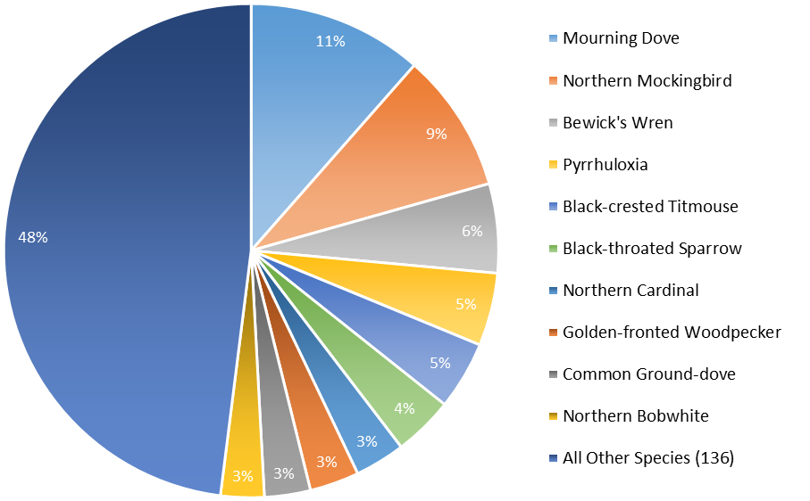

Figure 9. Species composition of birds (as a percentage of total observations) counted during non-breeding season surveys on 3 East Foundation Ranches in South Texas, March 2008 – April 2015.
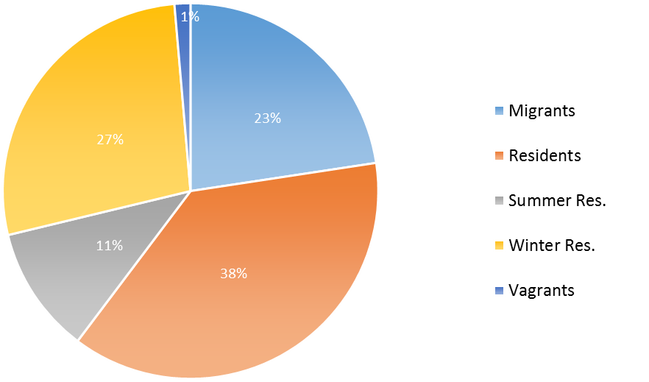

Figure 10. Percentages of bird species (n = 146) observed during non-breeding season surveys, grouped by residential status, of 3 East Foundation ranches in South Texas, March 2008 – April 2015.

Santa Rosa. A total of individuals 4,064, of 92 species were observed on Santa Rosa. Of the species recorded, 13 were observed just once and 46 species were observed 10 or fewer times. The least common species accounted for 4.3% of the observations of all individuals. In contrast, the 10 most commonly observed species accounted for 61% of all individuals observed on Santa Rosa.
Due to the variation in the number of transects surveyed monthly at each location between 2008 and 2010, trends could only be calculated for non-breeding surveys conducted after September 2011. Models of the mean birds/transect over time were statistically equal among ranches. Overall the mean birds/transect increased significantly during the study period, best modeled by a positive quadratic trend. Mean birds/transect started increasing in fall 2012, and continued to increase for the duration of the study (Fig. 11).

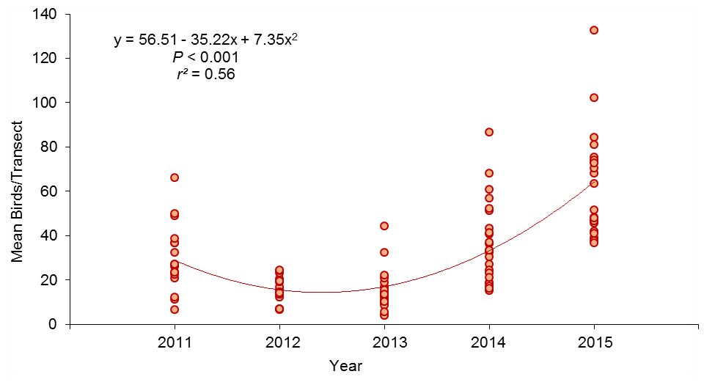
Figure 11. Trend in the mean number of birds (of all species) counted per transect during non-breeding season (September – April) surveys of 3 East Foundation ranches in South Texas, 2011 – 2015.

Discussion
The geographic location of South Texas is unique in a number of ways, creating an area of exceptionally high avian species richness and diversity (Forgason and Fulbright 2003). The South Texas coast acts as an important migratory corridor that is used by 80% of North American migratory bird species (Rappole and Blacklock 1985). Birds that use the Central and Atlantic flyways pass through a bottleneck along the South Texas Coast created by the Gulf of Mexico to the east and arid plains and scrubland to the west (Rappole et al. 1979).
I found that the East Foundation ranches supported a high number of bird species during both breeding and non-breeding seasons. As predicted, species richness was highest on the coastal division El Sauz, in part due to observations of seasonal migrants. Species richness was also high due to a number of breeding species that were only observed in coastal grassland habitats on El Sauz. Proximity to the coast affects everything from climate, to soil type, to vegetation community. Oak mottes and woodlands found in sandy coastal soils are attractive resting spots for migrating birds (Williges 1989, Schmidly 2003). A single study of birds in oak mottes along the South Texas coast documented 101 species, 39 of which were observed during migration only (Williges 1989). El Sauz and Santa Rosa are within the bottleneck in the migratory corridor along the South Texas coast (Rappole et al. 1979). Observations of migrants may have increased the observed species richness on both El Sauz and Santa Rosa. Oak mottes and woodlands occur on both ranches and may have provided suitable resting and foraging habitat for migrants (Williges 1989). Oak mottes and woodlands do not occur on San Antonio Viejo, and its location west of the other ranches made it is less likely to be used by migrants as a stop-over location (Rappole et al. 1979). These were breeding bird surveys, but I did not categorically exclude migrants because 1- 2 surveys are not likely to be sufficient to determine breeding status.
As noted earlier, South Texas vegetation is very different from what it was 200 years ago (Forgason and Fulbright 2003). This change did not decrease avian diversity or abundance; brushy and woody habitats in this region have been found to support a greater diversity and higher density of wintering birds than grasslands or shrub-grasslands (Igl and Ballard 1999). This pattern has been observed in other arid regions where mesquite shrublands supported greater species richness than open grasslands (Pidgeon et al. 2001). Additionally, species considered grassland specialists during the breeding season will use areas with moderate amounts of woody cover during the non-breeding season (Igl and Ballard 1999).
A study from Oklahoma found that observations of “scrub successional species,” such as Bewick’s Wren, Northern Bobwhite, and Northern Cardinal, increased over time as woody plants encroached on grassland habitats (Coppedge et al. 2001). The increase in these species during my study suggests that woody plant encroachment was, and likely still is, occurring on the East Foundation. While not beneficial to all species, this type of habitat supports the shrub-associated species Bewick’s Wren and Yellow-Billed Cuckoo, which have experienced declines in other parts of their ranges (NABCI 2014).
Not all avian species benefit from increased woody cover, and low avian species richness or diversity is not necessarily indicative of an unhealthy ecosystem (Graul 1980). Grasslands typically have a lower density of individuals and species richness per hectare, due to the simplicity of the structure of grassland vegetation (Graul 1980). Studies comparing woody or shrubby to open habitats found certain species that were associated exclusively with open habitats; these included Common Nighthawk, Cassin’s Sparrow, Eastern Meadowlark, and Scissor-tailed Flycatcher (Coppedge et al. 2001, Pidgeon et al. 2001). I found similar species associations on the East Foundation ranches. Several grassland-associated species, including Common Nighthawks, Dickcissels, and Eastern Meadowlarks, were seen only, or predominantly, on El Sauz which contains the largest patches of contiguous grassland. However, Cassin’s Sparrows and Scissor-tailed Flycatchers in my study were observed at locations with widely varying amounts of brush cover.
San Antonio Viejo is at the edge of the Bordas Escarpment, a strip of caliche covered by shallow soils running north to south through southwestern Texas (Fulbright and Bryant 2003). Vegetation in this region in is characterized by short, woody plants and cacti, with considerably less grass and herbaceous growth than is found on the ranches further east (Rappole and Blacklock 1985). This is likely the reason for a higher occurrence of aridland species on San Antonio Viejo. It was the only ranch surveyed that sustained populations of Black-tailed Gnatcatchers, Chihuahuan Ravens, and Scaled Quail. Black-throated Sparrows, Cactus Wrens, and Curve-billed Thrashers were also more abundant on San Antonio Viejo than the other ranches.
The location of study sites along an east-west gradient illustrated the latitudinal changes in species composition that occur within a relatively short distance within South Texas. Multiple species exhibited a marked increase or decrease in the number of individuals observed along an east-west gradient. This phenomena was best illustrated by species within the same genera, such as Brown-crested and Ash-throated Flycatchers, Northern Cardinals and Pyrrhuloxia, Long-billed and Curve-billed Thrashers, and Common and Lesser Nighthawks. In these examples the first species in the pair was observed more frequently in the east and the second was observed more frequently in the west.

Trends over Time
The total number of birds on the East Foundation increased significantly during the study period, and the majority of trends in abundance calculated for individual species or groups were stable or increasing. Trends in the abundance of land birds on the East Foundation during 2008 – 2015 compared favorably to national trends. Two of the most abundant and increasing species were game birds (Mourning Dove and Northern Bobwhite). Considerable time and money are put into habitat management designed to increase the abundance of quail on properties in South Texas (Hernandez and Guthrey 2012). The relatively high number of both Northern Bobwhite and Mourning Doves observed during my study, in the absence of intensive management, agrees with findings from other studies that precipitation and soil type can be of equal importance to brush management as predictors of gamebird abundance (Baker and Guthrey 1990, Cooper et al. 2009).
Grassland and Aridland Obligate Species. Current population trends appear to be stable for most grassland bird species, but at lower numbers than historically observed (NABCI 2014). Of the 24 obligate grassland species used by the State of the Birds report as indicators of the health of grassland birds as a group, 7 were seen on the East Foundation (Cassin's Sparrow, Vesper Sparrow, Lark Bunting, Grasshopper Sparrow, Dickcissel, Bobolink, and Eastern Meadowlark). Only Eastern Meadowlark and Cassin’s Sparrow were observed a sufficient number of times during my surveys to calculate trends in abundance. Nationally, both Eastern Meadowlarks and Cassin’s Sparrows continue to experience declines (NABCI 2014). By contrast, Eastern Meadowlarks displayed a weakly increasing trend on the El Sauz. Cassin’s Sparrows had a stable trend on El Sauz and a weakly increasing trend on San Antonio Viejo. The national Dickcissel population has also been in decline (NABCI 2014). Although only observed once prior to 2015, during the 2015 BBS there were multiple Dickcissels observed. Dickcissels may expand their breeding range in wet years (Cornell Lab of Ornithology, 2015), and increases in the breeding population of Dickcissels during wet years have been documented in South Texas (Rappole and Blacklock 1985). Based on the trends observed in these species, grassland birds on the East Foundation appeared to be doing as well or better than at the national level.
A high number of aridland indicator species also occurred on the East Foundation. Five of the 17 aridland obligate indicator species were observed on the East Foundation (Black-tailed Gnatcatcher, Black-throated Sparrow, Chihuahuan Raven, Pyrrhuloxia, and Scaled Quail [NABCI 2014]). Two of these species (Black-throated Sparrow and Pyrrhuloxia), were observed a sufficient number of times to calculate trends in abundance. Both species have experienced declines at the national level (NABCI 2014). Black-throated Sparrows experienced a weak increase on San Antonio Viejo during my study, and the number of Pyrrhuloxia remained stable. The Chihuahuan Raven population is considered stable at the national level (NABCI 2014). This species was observed on San Antonio Viejo every year between 2011 and 2015 and was likely breeding on the ranch.
Two species listed as threatened by the state of Texas (Botteri's Sparrow and White-tailed Hawk) were observed on the East Foundation. Botteri’s Sparrows were observed only on El Sauz, which has relatively large patches of Spartina and tall bunch-grasses, the preferred breeding habitats of this species (Rising and Beadle 1996). Although statewide this species was considered stable (The Cornell Lab of Ornithology 2015), this was one of the few species that appeared to decline during the study period. The absence of this species in 2014 may have been due to observer error, not actual absence.
White-tailed Hawks are associated with open grassland habitats, and prey upon small mammals (The Cornell Lab of Ornithology 2015). Grassland habitats on El Sauz and San Antonio Viejo may be attractive to this species. The South Texas population of this species appears to be stable or increasing (The Cornell Lab of Ornithology 2015). Further study is needed to determine if grassland habitats on either ranch could support this species, and if so what management activities would attract breeding pairs.

Effects of Precipitation
The effects of drought, precipitation, and temperature have been well studied in land birds. In particular, there is a wealth of literature on the relationship between quail and their environment (Francis 1967, Campbell et al. 1973, Brown 1979, Heffelfinger et al. 1999, Bridges 2001, Hernandez et al. 2005, Lusk et al. 2007). There is strong evidence for increased rates of survival and reproduction with increased amounts of precipitation in all North American quail species (Brown 1979, Bridges et al. 2001, Hernandez et al. 2005, Lusk et al. 2007). In South Texas, Northern Bobwhite have been found to be more abundant in years with greater total precipitation and, conversely almost all aspects of Northern Bobwhite life history including survival, productivity, nesting, and nest productivity were lower during drought years (Hernandez et al. 2005). Dependence of Texas quail numbers upon annual weather fluctuations was also evidenced by significant correlations between the number of Bobwhite observed and the Palmer Drought Severity Index in 4 out of the 5 Texas ecoregions, as well as an inverse relationship between temperature and quail productivity (Lusk et al. 2007). Another large-scale Texas study found correlations between quail abundance, the Palmer Drought Severity Index, and precipitation to be strongest in relatively drier areas (Bridges et al. 2001).
The greatest numbers of significantly increasing trends in abundance were calculated for species or groups on San Antonio Viejo in the west, and the fewest significant trends were calculated for species or groups on El Sauz in the east. However, these increasing trends were not, as I had hypothesized, a direct response to precipitation (Bridges et al. 2001). When total May – April precipitation was added to trend models El Sauz had greatest number of significant models that included precipitation. Additionally, models of Northern Bobwhite abundance over time, that included precipitation were highest for El Sauz in the southwest and San Antonio Viejo in the southeast, and lowest for the north and centrally located Santa Rosa. Of the species analyzed, Northern Mockingbird was the only one to display an east-west increase in the variation explained by models that included precipitation.
Multiple studies of the numerical response of quail, and other bird species, to precipitation have found stronger connections between indicators of available moisture such as the Palmer Drought Severity Index, soil moisture, or May pond counts than to raw precipitation (Francis 1967, Zimmerman 1992, Bridges 2001, Lusk et al. 2007, Niemuth et al. 2008). Other studies have found the strongest correlations between bird numbers and total precipitation received during a specific season (Campbell et al. 1973, Brown 1979, Dunning and Brown 1982, Heffelfinger et al. 1999). It is possible that total precipitation from a specific season, or an alternative measure of available moisture, such as the Palmer Drought Severity Index, would have been significantly correlated with breeding bird abundance in my study (Bridges et al. 2001, Lusk et al. 2007).
Studies of the effect of drought on land birds had mixed results. Many species included in my study exhibited responses to drought similar to documented responses of grassland birds in other regions (George et al. 1992). Species densities decreased during the drought period, but rebounded in the years following when precipitation levels returned to normal (George et al. 1992). This pattern is analogous to the quadratic trends displayed by many of the target species on the East Foundation. Other studies of avian response to drought found that individual species response was based upon feeding guild (Smith 1982, Dinsmore 2008). Insectivorous species and hummingbirds declined during drought periods, presumably due to changes in food availability (Smith 1982), whereas species such as the Charadrius montanus (Mountain Plover) that forage on bare patches of ground had increased adult survival during drought years (Dinsmore 2008).
In my study the positive linear and quadratic trends in avian abundance over time were not directly correlated with total May – April precipitation. This means that increases in birds/point were due to one or more unmeasured variables that also increased over time. Vegetation growth is a possibility: with a reduction in cattle numbers and high levels of precipitation, grasses, herbaceous plants, and woody vegetation were all likely to have increased during the study period. Increased grass and herbaceous vegetation would have provided increased food resources for granivorous species or groups such as Northern Bobwhite, Dove spp., and Cardinalis spp. Increased cover and standing water would have increased insect production and available food for insectivorous species such as Northern Mockingbird and Bewick’s Wren. Even if the direct cause or causes of the overall increase in bird numbers on the East Foundation is unknown, the number of stable and increasing trends is highly encouraging.

Management Implications
In general, habitats on either end of the spectrum of vegetation cover should be preserved. Mature woodland habitats may be self-maintaining to some extent, but grassland habitats are likely to require active management in order to keep them from becoming brushland. The extent of rangeland management on the East Foundation during the study period was limited to a reduction in the number of cattle, and localized brush clearing. Despite the lack of targeted management, Northern Bobwhite, Mourning Doves, and Common Ground Doves were among the most commonly encountered species on the East Foundation ranches.
The prevailing theory is that good to fair rangelands, considered mid-successional stages, are best for wildlife in South Texas. The combination of reduced stocking rates and 2 years of high precipitation appear to have increased the amount of grass and herbaceous cover on the East Foundation. In the absence of brush control, shrub cover has likely remained constant or increased on all ranches, creating mid-successional stage rangelands. Cattle alone are unlikely to act as effective brush control unless they graze an area very heavily. For these reasons, brush management is recommended for open areas on El Sauz and San Antonio Viejo. In particular, brush reduction and control are recommended for the largest expanses of open grassland on El Sauz that attract the greatest number of grassland obligate species. Experimental burns of Spartina habitats will hopefully improve conditions for grassland obligate breeders in these areas. Given the apparent decrease in Botteri’s Sparrows a targeted study of this species on El Sauz is recommended. Active brush management or habitat modification may be necessary if land managers wish for this species to persist on the East Foundation. Surveys using methods designed to sample water birds and raptors could provide estimates of abundance and relative use of the East Foundation ranches by these bird groups.
Santa Rosa has, on average, more mature vegetation and smaller patches of open grassland. This ranch provides excellent habitat for species often associated with mature woodlands such as Black-crested Titmice, Brown-crested Flycatchers, Wild Turkeys, and Yellow-billed Cuckoos. For this reason, it is recommended that any brush management conducted on Santa Rosa should focus first on areas of recent brush encroachment and early-successional brush communities. Oak habitats found on El Sauz and Santa Rosa, and mesquite woodlands on Santa Rosa are regularly used by seasonal migrants in addition to resident and breeding species. Preservation of these habitats on the East Foundation is important, especially if wind energy infrastructure continues to expand along the South Texas Coast.

LITERATURE CITED
Askins, R.A. 1993. Population trends in grassland, shrubland, and forest birds in eastern North America. Pages 1–34 in D. M. Power ed. Current Ornithology, vol. 11. Plenum Press, New York.
Askins, R.A., F. Chavez-Ramirez, B.C. Dale, C.A. Haas, J.R. Herkert, F.L. Knopf, and P.D. Vickery. 2007. Conservation of grassland birds in North America: understanding ecological processes in different regions: “report of the AOU committee on conservation”. Ornithological Monographs 64:1–46.
Brennan, L.A. 1991. How can we reverse the northern bobwhite population decline? Wildlife Society Bulletin 19:544–555.
Brennan, L.A. and W.P. Kuvlesky Jr. 2005. North American grassland birds: an unfolding conservation crisis? The Journal of Wildlife Management 69:1–13.
Bridges, A.S., M.J. Peterson, N.J. Silvy, F.E. Smeins, and X.B. Wu. 2001. Differential influence of weather on regional quail abundance in Texas. Journal of Wildlife Management 65:10–18.
Brown, D.E. 1979. Factors influencing reproductive success and population densities in Montezuma quail. The Journal of Wildlife Management 43:522–526.
Campbell, H., D.K. Martin, P.E. Ferkovich, and B.K. Harris. 1973. Effects of hunting and some other environmental factors on scaled quail in New Mexico. Wildlife 34:3–49.
Coppedge, B.R., D.M. Engle, R.E. Masters, and M.S. Gregory. 2001. Avian response to landscape change in fragmented southern Great Plains grasslands. Ecological Applications 11:47–59.
DeSante, D.F. and G.R. Geupel. 1987. Landbird productivity in central coastal California: the relationship to annual rainfall, and a reproductive failure in 1986. The Condor 89:636–653.
Dinsmore, S.J. 2008. Influence of drought on the annual survival of the mountain plover in Montana. The Condor 110:45–54.
Drawe, D. L. 2003. Integrating cattle and wildlife in South Texas. Pages 153–179 in C.A. Forgason, F.C. Bryant, and P.C. Genho, eds. Ranch Management; Integrating Cattle, Wildlife and Range. King Ranch, Kingsville, TX.
Dunning Jr., J.B. and J.H. Brown. 1982. Summer rainfall and winter sparrow densities: a test of the food limitation hypothesis. The Auk 99:123–129.
East Foundation. 2015. The Tom T. East, Sr., Alice K. East, Alice H. East and Robert C. East Foundation homepage. www.eastfoundation.net. Accessed: August 01, 2015.
Environmental Protection Agency (EPA). 2012. Ecoregions of Texas. Western Ecology Division. www.epa.gov/wed/pages/ecoregions/tx_eco.htm. Accessed: April 22, 2014.
Fitzpatrick, J.W. 2002. The AOU and bird conservation: recommitment to the revolution. The Auk 119:907–913.
Forgason, C.A., and T.E. Fulbright. 2003. Cattle, wildlife and range management on King Ranch over the years. Pages 9–21 in C. A. Forgason, F.C. Bryant, and P. C. Genho, eds. Ranch management: integrating cattle, wildlife, and range. King Ranch, Kingsville, TX.
Francis, W.J. 1967. Prediction of California quail populations from weather data. The Condor 69:405–410.
Frost, C.C. 1998. Presettlement fire frequency regimes of the United States: a first approximation. Proceedings of the Tall Timbers Fire Ecology Conference 20:70–81.
Forgason, C.A., and T.E. Fulbright. 2003. Cattle, wildlife, and range management on King Ranch over the years. Pages 9–21 in C.A. Forgason, F.C. Bryant, and P.C. Genho, eds. Ranch management: integrating cattle, wildlife, and range. King Ranch, Kingsville, TX.
Fulbright, T.E. and F.C. Bryant. 2003. The Wild Horse Desert: climate and ecology. Pages 35–58 in C.A. Forgason, F.C. Bryant, and P.C. Genho, eds. Ranch management: integrating cattle, wildlife, and range. King Ranch, Kingsville, TX.
George, T.L., A.C. Fowler, R.L. Knight and L.C. McEwen. 1992. Impacts of severe drought on grassland birds in western North Dakota. Ecological Applications 2:275–284.
Graul, W.D. 1980. Grassland management and bird communities. Management of western forests and grasslands for nongame birds. General Technical Report INT-86. US Department of Agriculture Forest Service, Ogden, UT. 10 pp.
Grzybowski, J.A. 1982. Population structure in grassland bird communities during winter. The Condor 84:137–152.
Hamilton, W. T. 2003. Drought: managing for and during bad years. Pages 133–152, In C.A. Forgason, F.C. Bryant, and P.C. Genho, eds. Ranch Management; Integrating Cattle, Wildlife and Range, King Ranch, Kingsville, TX.
Hellickson, M.W., S. Moore, and R.H. Thompson. 2003. Cattle, wildlife, and range: making it work at King Ranch. Pages 181–192, In C.A. Forgason, F.C. Bryant, and P.C. Genho, eds. Ranch Management; Integrating Cattle, Wildlife and Range, King Ranch, Kingsville, TX.
Hernandez, F., F. Hernandez, J.A. Arredondo, F.C. Bryant, L.A. Brennan and R.L. Bingham. 2005. Influence of precipitation on demographics of northern bobwhites in southern Texas. Wildlife Society Bulletin 33:1071–1079.
Hernandez, F., and F.S. Guthrey. 2012. Beef, brush and bobwhites: Quail management in cattle country. Texas A&M University Press, College Station, TX. 286 pp.
Heffelfinger, J.R., F.S. Guthery, R.J. Olding, C.L. Cochran Jr. and C.M. McMullen. 1999. Influence of precipitation timing and summer temperatures on reproduction of Gambel’s quail. The Journal of Wildlife Management 63:154–161.
Igl, L.D. and B.M. Ballard. 1999. Habitat associations of migrating and overwintering grassland birds in Southern Texas. The Condor 101:771–782.
Lusk, J.J., F.S. Guthery, M.J. Peterson, S.J. Demaso. 2007. Evidence for regionally synchronized cycles in Texas quail population dynamics. Journal of Wildlife Management 17:837–843.
McLendon, T. 1991. Preliminary description of the vegetation of South Texas exclusive of coastal saline zones. Texas Journal of Science 43:13–32.
National Oceanic and Atmospheric Administrator (NOAA). 2015. National Climate Data Center: U.S. Climate Divisions. Available online at http://www.ncdc.noaa.gov. Accessed 08 April, 2016.
Natural Resources Conservation Service (NRCS). 1990. Dominant soil orders of Texas (map). National Cartography and Geospatial Center. Fort Worth, TX.
Niemuth, N.D., J.W. Solberg and T.L. Shaffer. 2008. Influence of moisture on density and distribution of grassland birds in North Dakota. The Condor 110: 211–222.
North American Bird Conservation Initiative, U.S. Committee (NABCI). 2014. The state of the birds 2014 report. U.S. Department of the Interior, Washington, D.C.
Pidgeon, A.M., N.E. Mathews, R. Benoit, and E.V. Nordheim. 2001. Response of avian communities to historic habitat change in the northern Chihuahuan desert. Conservation Biology 15:1772–1788.
Rappole J.H., M.A. Ramos, R.J. Oehlenschlager, D.W. Warner, and C.P. Barkan. 1979. Timing of migration and route selection in North American songbirds. Proceedings of the Welder Wildlife Foundation Symposium 1:199–214.
Rappole, J.H. and G.W. Blacklock. 1985. Birds of the Coastal Bend. The W.L. Moody Jr., natural history series; no 7. Texas A&M University Press. College Station, TX.
Rhyne, M.Z. 1998. Optimization of wildlife and recreation earnings for private landowners. Thesis, Texas A&M University–Kingsville.
Ribic, C.A., M.J. Guzy and D.W. Sample. 2009. Grassland bird use of remnant prairie and conservation reserve program fields in an agricultural landscape in Wisconsin. American Midland Naturalist 161:110–122.
Rising, J.D. and D.D. Beadle. 1996. A guide to identification and natural history of the sparrows of the United States and Canada. Academic Press, Inc. San Diego, CA.
Sauer, J.R., J.E. Fallon, and R. Johnson. 2003. Use of North American breeding bird survey data to estimate population change for bird conservation regions. Journal of Wildlife Management 67:372–389.
Schmidly, D.J. 2003. Wildlife legacy: changes during the 20th century. Pages 9–21 in C.A. Forgason, F.C. Bryant, and P.C. Genho, eds. Ranch management: integrating cattle, wildlife, and range. King Ranch, Kingsville, TX.
Smeins, F.E., D.D. Diamond, and C. W. Hanselka. 1991. Coastal Prairie, Chapter 13 in R.T. Coupland ed. Natural grasslands. Elsevier, Amsterdam.
Smith, K.G. 1982. Drought-induced changes in avian community structure along a montane sere. Ecology 63:952 – 961.
Snelgrove, A., A. Dube, K. Skow, A. Engeling. 2013. Atlas for the Tom T. East, Sr., Alice K. East, Alice H. East and Robert C. East Wildlife Foundation. Developed by Texas A&M Institute of Renewable Natural Resources. College Station, TX.
Texas Parks and Wildlife Department, Austin (TPWD). 1984. The vegetation types of Texas: An illustrated synopsis to accompany the map by Craig A. McMahan, Roy G. Frye and Kirby L. Brown. www.tpwd.texas.gov/publications/pwdpubs_bn_w7000_0120/. Accessed April 23, 2014.
United States Fish and Wildlife Service, Department of the Interior (USFWS). 2015. Endangered species homepage. www.fws.gov/endangered/. Accessed August 05, 2015.
United States Geological Survey, Patuxent Wildlife Research Center (USGS). 2001. North American Breeding Bird Survey. www.pwrc.usgs.gov/bbs/. Accessed January 15, 2014.
Vickery, P.D. and J.R. Herkert. 2001. Recent advances in grassland bird research: where do we go from here? The Auk 118:11–15.
Webb, W.M. and F.S. Guthery. 1983. Avian response to habitat management for northern bobwhites in northwest Texas. The Journal of Wildlife Management 47:220–222.
West, B.C. and T.A. Messmer. 2006. Effects of livestock grazing on duck nesting habitat in Utah. Rangeland Ecology and Management 59:208–211.
Western Regional Climatic Data Center. 1990. PRISM precipitation maps 1961 – 90 www.wrcc.dri.edu/precip.html. Accessed Jan 12, 2014.
Williges, K. 1989. The avian fauna of two oak mottes on the sand sheet of South Texas. Thesis, Texas A&M University–Kingsville, USA.
Zimmerman, J.L. 1992. Density-independent factors affecting the avian diversity of the tallgrass prairie community. The Wilson Bulletin 104:85–94.

EFFECTS OF PRECIPITATION AND GRAZING ON LANDBIRD POPULATIONS IN SOUTH TEXAS - KING RANCH
MAIA L. LIPSCHUTZ, Caesar Kleberg Wildlife Research Institute, Texas A & M University - Kingsville, Kingsville, TX 78363, USA

Abstract
Breeding bird surveys were conducted on 4 King Ranch properties in South Texas between 2005 and 2013. These data were used to calculate descriptive statistics, trends in land bird abundance during the study, and to test if total annual May – April precipitation and cattle use per hectare had a significant effect on avian abundance. A total of 19,162 individual birds of 87 species were recorded during 40 breeding bird surveys. Total breeding bird abundance was stable during the study period. Trends in abundance were calculated for 23 individual species, 7 of which had stable populations on all 4 properties surveyed. The combined effect of livestock use and precipitation had a significant effect on total avian abundance on all 4 properties surveyed and on the abundance of some species and groups individually. The direction of the effect of total annual May – April precipitation and cattle use per hectare was not consistent and the data collected for this study could not be use to create predictive models of the numeric response of birds counted per point to the effect.

Introduction
Grassland birds as a group declined 40% between the 1960s and 1990s and had a disproportionate number of species in decline compared to other North American bird groups (Askins 1993, Vickery and Herkert 2001, Brennan and Kuvlesky 2005, Sauer et al. 2003, Niemuth et al. 2008, NABCI 2014). Thanks to increased awareness, most grassland bird populations are now stable, albeit at a fraction of historic numbers (NABCI 2014). Aridland birds have replaced grassland birds as the most imperiled bird group in North America (NABCI 2014). Aridland obligate bird species have experienced an overall population decline of 46% since 1968 and a 6% decline since 2009 (NABCI 2014). Similar to grassland birds, declines are likely due to habitat lost to urban expansion, energy development, invasion by exotic grasses, and shrub encroachment (NABCI 2014). It is estimated that >80% of native North American grassland habitats have been lost in the past 200 years, primarily due to land conversion, which is considered to be the main cause of the overall decline in grassland bird abundance (Askins 1993, Vickery and Herkert 2001, Sauer et al. 2003, Brennan and Kuvlesky 2005, Niemuth et al. 2008). Many of the grasslands in South Texas became thornscrub due to the combined effects of overgrazing, drought, and fire suppression (Forgason and Fulbright 2003, NABCI 2014).
Livestock production is one of the most common land uses in western North America (Fleischner 1994). Fortunately, livestock production today bears little resemblance to the practices of the past which led to overgrazing (Scifres and Hamilton 2003). Contemporary cattle production is both a science and an art that combines knowledge of soils, vegetation, topography, and climate, to create flexible stocking plans that accommodate annual variation (Scifres and Hamilton 2003). Livestock can even be used as a tool for land management through strategic timing, location, and intensity of grazing pressure (Scifres and Hamilton 2003, Derner et al. 2014). When properly applied, this type of grazing management can create a mosaic of diverse habitats on the landscape (Derner et al. 2014). Livestock have few direct effects on avian populations, and primarily affect birds indirectly, through the alteration of vegetation structure and community, and by changing ecosystem functions (Ammon and Stacey 1997, Bleho 2013).
Many studies have examined the effects of different grazing intensities, durations, and systems on avian species (Bock et al. 1984, 1993; Bareiss et al. 1986; Schulz and Guthery 1986, 1987; Wilkins and Swank 1992; Dobkin 1993). Unfortunately, comparing results among studies is complicated by inconsistent classifications of grazing intensity and a lack of un-grazed areas for control sites (Flieschner 1994). The response of vegetation to grazing pressure is dependent upon multiple factors, including the amount and timing of precipitation, soil type, and the species composition of the vegetation (Baker and Guthery 1990). Avian responses to grazing differ by species, precluding a one-size-fits-all management approach for creating and conserving grassland and aridland bird habitats (Bock et al. 1993).
South Texas is considered a “diversity hotspot,” with 529 different avian species occurring in the region at some point throughout the year (Forgason and Fulbright 2003). This high species diversity makes regional wildlife habitat conservation a high priority (Fulbright and Bryant 2003). This study is intended to provide demographic information on land birds breeding on King Ranch and how bird numbers there relate to grazing and precipitation.

Objectives
I used a long-term dataset to answer questions about breeding bird demographics between the 4 King Ranch properties in South Texas 2005 and 2013. I organized this study to address the following questions about land birds on King Ranch:
- Did total abundance increase or decrease significantly during the study period?
- Were there any spatial or temporal trends in species richness?
- Did any individual species increase or decrease significantly during the study period?
- Did precipitation have a significant effect on landbird abundance?
- Did grazing intensity have a significant effect on landbird abundance?

Predictions
- Coastal divisions would have greater species richness than those further inland.
- Divisions with oak woodlands, parklands or mottes would have greater species richness than those without (Williges 1989).
- Precipitation would be the main driver of total avian abundance, similar to what has been observed in individual species (Dunning and Brown 1982, DeSante and Geupel 1987, Lusk et al. 2007).
- The numerical response of land birds to grazing on King Ranch would be species dependent (Bock et al. 1993).

Study Area
King Ranch was established in 1853 and covers 333,900 ha of South Texas (Forgason and Fulbright 2003). The properties surveyed contain a variety of habitats used by breeding, resident, and migrating birds (Wiliges 1989, Langschied 1994). Currently rangelands on King Ranch are managed for a variety of uses including cattle grazing and wildlife habitat.
My study included 4 King Ranch properties (divisions) located in South Texas: Encino, Laureles, Norias, and Santa Gertrudis (Fig. 12). All divisions are within the Western Gulf Coastal Plain ecoregion of Texas, which is characterized by coastal plains, interspersed with

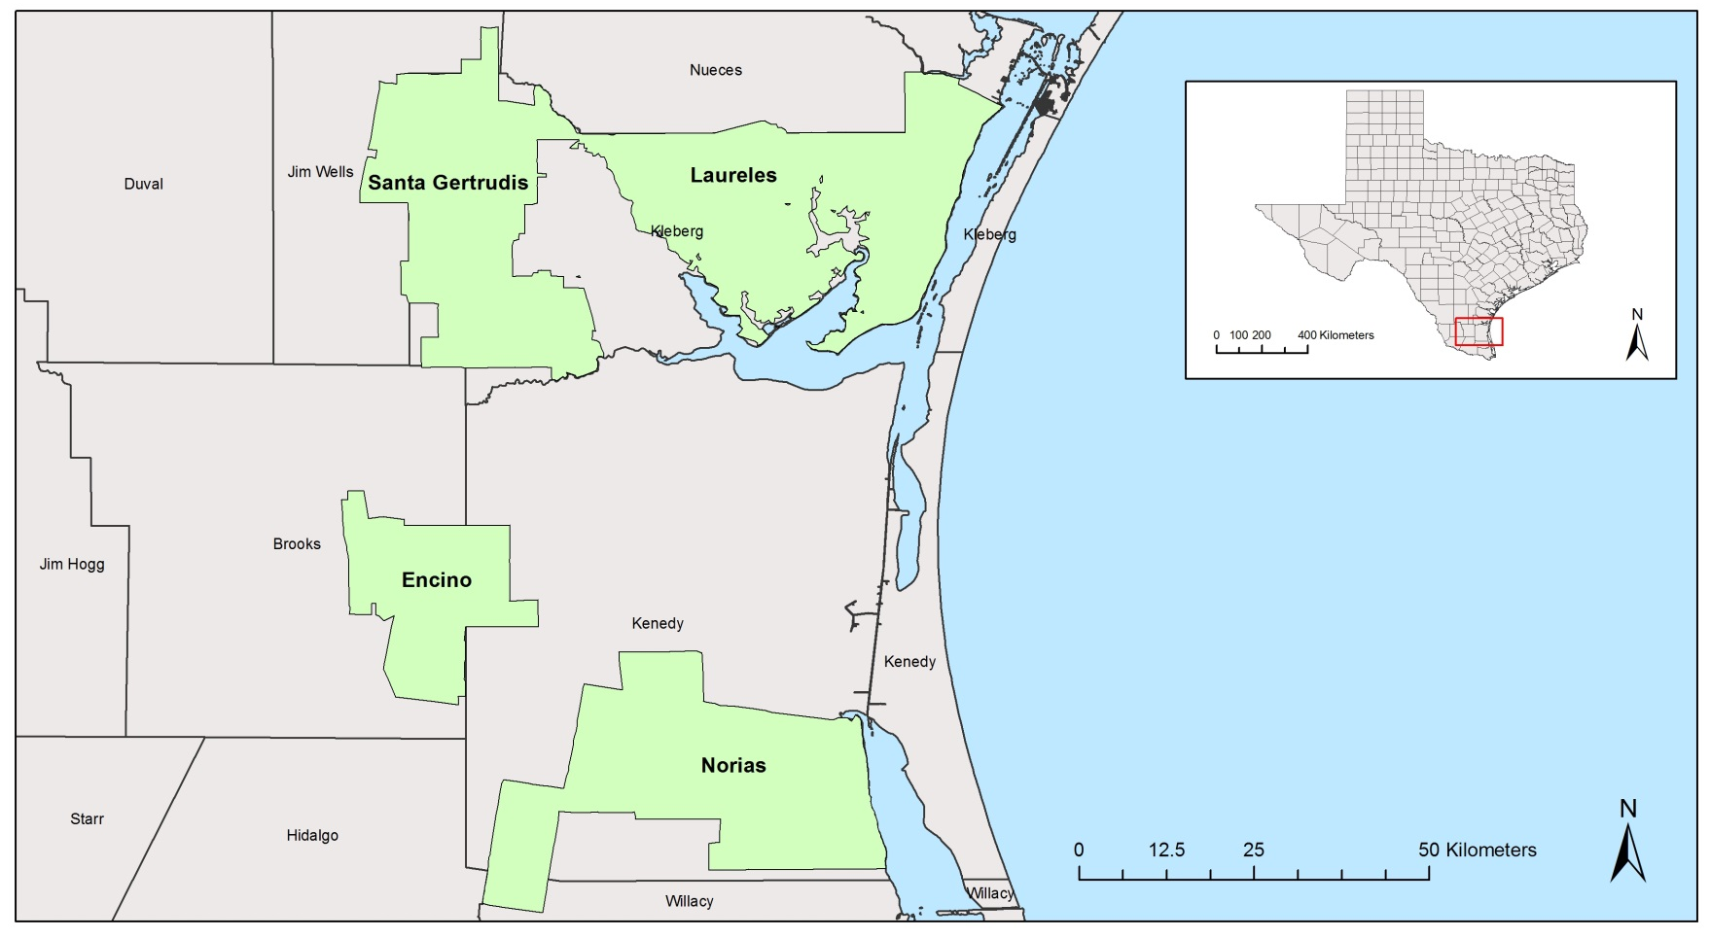
Figure 12. South Texas divisions of King Ranch surveyed for breeding birds 2005 – 2013.

Prosopis glandulosa (Honey Mesquite) and Celtis pallida (Spiny Hackberry) or Quercus virginiana (Live Oak) savannas and woodlands (TPWD 1984). The prairie communities are dominated by native grasses including Panicum virgatum (Switchgrass), Paspalum monostachyum (Gulfdune Paspalum), Paspalum setaceum var. ciliatifolium (Fringeleaf Paspalum), Schizachyrium scoparium var. littoralis (Seacoast Bluestem), and Trichloris pluriflora (Four-flowered Trichloris, Fulbright and Bryant 2003).
The amount and timing of rainfall in this region fluctuates dramatically, and decreases along an east-west gradient from an average of 71 cm/year to 51 cm/year (Western Regional Climatic Data Center 1990). Annual temperature fluctuations are typical of a subtropical climate, with summer temperatures averaging 27 – 32 ºC, and winter temperatures averaging 13 – 16 ºC (Fulbright and Bryant 1993, NOAA 2015). Dominant soil orders of the region included alfisols, vertisols, mollisols and inceptisols (NRCS 1990).
Encino is the smallest division, located southwest of the other divisions along the border between Brooks and Kenedy Counties. This division includes patchy live oak mottes and part of the Kenedy Sand prairie. The Laureles division is located northeast of the other divisions along the Gulf Coast in Kleberg County. The southern edge of the property borders Baffin Bay, and prior to wind farm development, was part of the longest stretch of undeveloped coastline in the United States (Fulbright and Bryant 2003). Two survey routes (north and south) were created on the Laureles division. This was the largest division at 103,439 ha, 22,840 ha of which are used for agriculture. The Laureles division also includes a portion of the Ingleside Prairie. Norias is located southeast of the other divisions and covers 97,601-ha along the Gulf Coast in Kenedy County. Two survey routes (north and south) were established on the Norias division. This division had the highest diversity of vegetation communities, with extensive Live Oak woodlands, Honey Mesquite savannas, and a portion of the Lower Coastal Prairie. A single survey route was located on the Santa Gertrudis division which covers 84,996 ha in Kleberg and Jim Wells Counties.

Methods

Breeding bird surveys
Six routes on 4 King Ranch properties were surveyed for breeding birds from 2005 – 2013, although all routes were not surveyed in all years (Table 10). Survey design was based on official United States Geological Survey breeding bird survey protocol, and described here (USGS 2001). Routes ran 39.2 km long, with survey points every 800 m, for a total of 50 points. Surveys started at the same point each year, and point locations did not change. A single observer conducted all surveys, which eliminated inter-observer variation. Using a vehicle to travel between points, a 3-minute count of all birds seen or heard within a 400-m radius was conducted at each point.
Surveys started 30 minutes before sunrise and were completed within 6.5 hours. Routes were not run in conditions of low visibility, with wind speeds greater than 4 on the Beaufort scale (20 – 29 km/h) as determined by environmental cues, or in constant precipitation. Surveys were conducted annually during the breeding season (May or June). Data from this type of survey is intended to serve as an index of abundance and diversity and was not considered a census of birds on these properties, nor was it used to estimated density (USGS 2001).

Table 10. Years in which individual breeding bird survey routes were run on King Ranch divisions in South Texas, 2005 – 2013.
 |  | Years Surveyed
Division | Survey Route | 2005 | 2006 | 2007 | 2008 | 2009 | 2010 | 2011 | 2012 | 2013
Encino |  |  |  | x | x | x | x | x | x | x
Laureles
 | North |  | x |  | x | x | x | x | x | x
 | South |  |  |  | x | x | x | x | x | x
Norias
 | North | x |  | x | x | x | x | x | x | x
 | South |  |  |  |  |  | x | x | x | x
Santa Gertrudis |  |  | x | x | x | x | x | x | x | x
x - route surveyed in this year

Analysis
Land birds were the focus of this study so observations of waterbirds were excluded from analysis. Observations of some species were grouped for analysis due to the number of species identified to group only. With the exception of Zenaida macroura (Mourning Dove), data on all other Doves species (Columbina passerina [Common Ground-dove], C. inca [Inca Dove], Leptotila verreauxi [White-tipped Dove], Streptopelia decaoto [Eurasian Collared-Dove], and Zenaida asiatica [White-winged Dove]) were combined. Data on the 2 locally common woodpecker species Melanerpes aurifrons (Golden-fronted Woodpecker) and Picoides scalaris (Ladder-backed Woodpecker) were combined. Data collected on the following species were grouped by genera: Cardinalis cardinalis (Northern Cardinal) and C. sinuatus (Pyrrhuloxia), Molothrus aeneus (Bronzed Cowbird) and M. ater (Brown-headed Cowbird), Myiarchus cineracens (Ash-throated Flycatcher) and M. tyrranulus (Brown-crested Flycatcher), and Toxostoma Longirostre (Long-billed Thrasher) and T. curvirostre (Curve-billed Thrasher).
Temporal Tends. Trends in abundance of 17 common species were calculated for each division. To account for variation in the number of points and surveys among years, the mean number of birds counted per point (birds/point) was used to calculate trends in abundance over time. For divisions having 2 survey routes, analysis was performed on the combined average birds/point. Trends were calculated for an additional 7 species of conservation interest on divisions where there was a sample size >10.
Trends in mean birds/point over time were modeled using linear and quadratic regression. The model with the highest r² value was considered the best-fit. Trends were considered significant at α = 0.05, and weakly significant at α = 0.10. Trends in birds/point of all species were calculated for each division individually, and all divisions combined. Trends in the abundance of individual species were only calculated for individual divisions. Trends and descriptive statistics were calculated using Microsoft Excel, the significance of trends was tested using R statistical software (R Core Team 2015).
Analysis on the effects of total May – April precipitation was calculated for each survey point individually. Readings came from rain gauges located throughout the divisions of King Ranch. Data on cattle stocking rates were reported as animal unit days/month for each pasture. An “Animal Unit” is a 500-kg bovine that is not lactating and not being fed for weight gain. Each 24 hours one “Animal Unit” spends on a pasture is equal to 1 “Animal Unit Day” (Allen et al. 2011). Grazing intensity in this study was quantified as the total animal unit days spent on a pasture from 1 May – 30 April, divided by the area of the pasture in hectares, hereafter aud/ha.
Both the individual and combined effect of precipitation and aud/ha on the number of birds observed birds/point were modeled using square root transformed count data. Transformed count data was regressed against precipitation and aud/ha individually to test for linear, quadratic, cubic, or quartic trends. Analysis of variance tests (ANOVAs) were performed on the transformed count data set by treating precipitation and aud/ha as class variables. Two pseudo-r² values were generated for these models. The first estimated variation due to the main effects (precipitation and aud/ha) only, the second estimated variation due to all effects included in the 'full model' (precipitation, aud/ha, and point location). The effects of precipitation and aud/ha on species richness and was not analyzed for the southern Norias survey route due to the small number of surveys. The effects of precipitation and aud/ha on the abundance of individual species or groups on the southern route of the Laureles and Norias divisions were not tested due to the small number of surveys of those routes (Table 10).

Results

Species richness and composition
A total 19,162 individuals of 87 different species were recorded during 40 breeding bird surveys on King Ranch properties between 2005 and 2013 (Table 11). Mourning Dove and Mimus polyglottis (Northern Mockingbird) were the 2 most abundant species and made up 13% and 8% of total observations, respectively. Combined with observations of the other 10 most common species (Northern Cardinal, Bronzed Cowbird, Colinus virginianus [Northern Bobwhite], Arremonops rufivirgatus [Olive Sparrow], Tyrannus forficatus [Scissor-tailed Flycatcher], Golden-fronted Woodpecker, Passerina ciris [Painted Bunting], and Brown-crested Flycatcher) they accounted for 57% of total observations (Fig. 13). Species composition varied among properties, but Northern Cardinals, Bronzed Cowbirds, and Northern Bobwhite were among the 10 most commonly observed species on all divisions.
Encino. On the Encino division a total of 2,812 individuals of 63 species were observed. The mean number of birds counted per survey was 402, the lowest of the 4 divisions. The 10

Table 11. Total individuals of all species observed during breeding bird surveys of King Ranch in South Texas, 2005 – 2013.
Name | Species | EN ^{i} | LA ^{ii} | NO ^{iii} | SG ^{iv} | Total
Ash-throated Flycatcher | Myiarchus cinerascens | 60 | 37 | 33 | 47 | 177
Audubon's Oriole | Icterus graduacauda | 0 | 0 | 34 | 1 | 35
Barn Swallow | Hirundo rustica | 2 | 9 | 0 | 0 | 11
Bewick's Wren | Thryomanes bewickii | 89 | 41 | 101 | 58 | 289
Black Vulture | Coragyps atratus | 21 | 28 | 32 | 28 | 109
Black-crested Titmouse | Baeolophus atricristatus | 54 | 8 | 178⁹ | 22 | 262
Blue Grosbeak | Passerina caerulea | 47 | 38 | 70 | 7 | 162
Blue-gray Gnatcatcher | Polioptila caerulea | 3 | 2 | 9 | 0 | 14
Botteri's Sparrow | Peucaea botterii | 0 | 73 | 6 | 0 | 79
Bronzed Cowbird⁴ | Molothrus aeneus | 123⁸ | 366 | 337³ | 298⁴ | 1124
Brown-crested Flycatcher¹⁰ | Myiarchus tyrannulus | 114⁹ | 97 | 284⁶ | 148¹⁰ | 643
Brown-headed Cowbird | Molothrus ater | 43 | 171 | 49 | 110 | 373
Buff-collared Nightjar | Antrostomus ridgwayi | 0 | 2 | 0 | 0 | 2
Buff-bellied Hummingbird | Amazalia yucatensis | 2 | 0 | 55 | 0 | 57
Bullock's Oriole | Icterus bullockii | 6 | 9 | 2 | 20 | 37
Cactus Wren | Campylorhynchus brunneicapillus | 3 | 0 | 0 | 0 | 3
Carolina Wren | Thryothorus ludovicianus | 3 | 0 | 28 | 1 | 32
Cassin's Sparrow | Peucaea cassinii | 4 | 12 | 7 | 25 | 48
Cattle Egret | Bubulcus ibis | 0 | 46 | 0 | 116 | 162
Cave Swallow | Petrochelidon fulva | 0 | 177 | 1 | 4 | 182
Chimney Swift | Chaetura pelagica | 0 | 2 | 0 | 0 | 2
Cliff Swallow | Petrochelidon pyrrhonota | 1 | 83 | 0 | 1 | 85
Common Ground-Dove | Columbina passerina | 61 | 109 | 92 | 121 | 383
Common Nighthawk | Chordeiles minor | 1 | 191¹⁰ | 20 | 14 | 226
Common Pauraque | Nyctidromus albicollis | 1 | 5 | 0 | 1 | 7
Cooper's Hawk | Accipiter cooperii | 1 | 1 | 2 | 0 | 4
Couch's Kingbird | Tyrannus couchii | 25 | 6 | 133 | 25 | 189
Crested Caracara | Caracara cheriway | 13 | 89 | 54 | 54 | 210
Curve-billed Thrasher | Toxostoma curvirostre | 0 | 0 | 1 | 0 | 1
Dickcissel | Spiza americana | 0 | 26 | 0 | 22 | 48
Eastern Bluebird | Sialia sialis | 3 | 0 | 22 | 1 | 4
Eastern Meadowlark | Sturnella magna | 4 | 103 | 1 | 7 | 136
Eastern Screech-Owl | Megascops asio | 0 | 0 | 0 | 0 | 1
Eurasian Collared-dove | Streptopelia decaoto | 1 | 3 | 1 | 6 | 11
European Starling | Sturnus vulgaris | 0 | 68 | 0 | 34 | 102
Ferruginous Pygmy-Owl | Glaucidium brasilianum | 0 | 0 | 4 | 0 | 4
Field Sparrow | Spizella pusilla | 0 | 0 | 7 | 0 | 7
Table 11. Continued
Name | Species | EN ^{i} | LA ^{ii} | NO ^{iii} | SG ^{iv} | Total
Golden-fronted Woodpecker⁸ | Melanerpes aurifrons | 150⁷ | 106 | 222⁸ | 219⁸ | 697
Great Horned Owl | Bubo virginianus | 2 | 17 | 6 | 14 | 39
Great Kiskadee | Pitangus sulphuratus | 10 | 11 | 18 | 18 | 57
Greater Roadrunner | Geococcyx californianus | 26 | 115 | 56 | 78 | 275
Great-tailed Grackle | Quiscalus mexicanus | 5 | 38 | 18 | 188⁹ | 249
Green Jay | Cyanocorax yncas | 12 | 17 | 83 | 19 | 131
Groove-billed Ani | Crotophaga sulcirostris | 0 | 24 | 5 | 10 | 39
Hooded Oriole | Icterus cucullatus | 1 | 1 | 109 | 0 | 111
Horned Lark | Eremophila alpestris | 0 | 11 | 0 | 0 | 11
House Sparrow | Passer domesticus | 1 | 3 | 0 | 9 | 13
Harris’ Hawk | Parabuteo unicinctus | 1 | 30 | 14 | 24 | 69
Inca Dove | Columbina inca | 0 | 1 | 4 | 5 | 10
Indigo Bunting | Passerina cyanea | 1 | 0 | 0 | 0 | 1
Killdeer | Charadrius vociferus | 0 | 13 | 0 | 0 | 0
Ladder-backed Woodpecker | Picoides scalaris | 54 | 28 | 119 | 51 | 252
Lark Sparrow | Chondestes grammacus | 60 | 48 | 42 | 33 | 183
Lesser Goldfinch | Spinus psaltria | 59 | 0 | 105 | 0 | 164
Lesser Nighthawk | Chordeiles acutipennis | 0 | 5 | 2 | 9 | 16
Loggerhead Shrike | Lanius ludovicianus | 2 | 2 | 0 | 3 | 7
Long-billed Curlew | Numenius americanus | 0 | 1 | 1 | 0 | 0
Long-billed Thrasher | Toxostoma longirostre | 26 | 39 | 141¹⁰ | 67 | 273
Mourning Dove¹ | Zenaida macroura | 360¹ | 805¹ | 806¹ | 524¹ | 2495
Northern Beardless Tyrranulet | Campostoma imberbe | 0 | 0 | 19 | 0 | 19
Northern Bobwhite⁵ | Colinus virginianus | 194⁴ | 308⁸ | 247⁷ | 309³ | 1058
Northern Cardinal³ | Cardinalis cardinalis | 214³ | 406⁴ | 337 | 250⁵ | 1207
Northern Mockingbird² | Mimus polyglottos | 232² | 422² | 416² | 416² | 1486
Olive Sparrow⁶ | Arremonops rufivirgatus | 108¹⁰ | 127 | 298⁵ | 235⁷ | 768
Painted Bunting⁹ | Passerina ciris | 159⁵ | 364⁶ | 60 | 111 | 694
Purple Martin | Progne subis | 0 | 1 | 0 | 2 | 3
Pyrrhuloxia | Cardinalis sinuatus | 9 | 45 | 27 | 88 | 169
Red-shouldered Hawk | Buteo lineatus | 1 | 0 | 0 | 0 | 1
Red-tailed Hawk | Buteo jamaicensis | 23 | 7 | 12 | 7 | 49
Red-winged Blackbird | Agelaius phoeniceus | 9 | 408³ | 18 | 114 | 549
Ruby-throated Hummingbird | Archilochus colubris | 0 | 2 | 1 | 0 | 3
Scissor-tailed Flycatcher⁷ | Tyrannus forficatus | 153⁶ | 336⁷ | 119 | 123 | 731
Summer Tanager | Piranga rubra | 30 | 3 | 74 | 1 | 108
Tree Swallow | Tachycineta bicolor | 0 | 0 | 0 | 1 | 1
Tropical Parula | Setophaga pitiayumi | 0 | 0 | 23 | 0 | 23

Table 11. Continued
Name | Species | EN ^{i} | LA ^{ii} | NO ^{iii} | SG ^{iv} | Total
Turkey Vulture | Cathartes aura | 45 | 220⁹ | 101 | 68 | 434
Verdin | Auriparus flaviceps | 15 | 0 | 14 | 17 | 46
Vermilion Flycatcher | Pyrocephalus rubinus | 33 | 1 | 21 | 3 | 58
Western Kingbird | Tyrannus verticalis | 3 | 0 | 0 | 3 | 6
White-eyed Vireo | Vireo griseus | 17 | 117 | 103 | 78 | 315
White-tailed Hawk | Buteo albicaudatus | 4 | 60 | 20 | 10 | 94
White-tailed Kite | Elanus leucurus | 1 | 0 | 0 | 0 | 1
White-tipped Dove | Leptotila verreauxi | 6 | 6 | 134 | 26 | 172
White-winged Dove | Zenaida asiatica | 1 | 1 | 0 | 13 | 15
Wild Turkey | Meleagris gallopavo | 61 | 34 | 122 | 44 | 261
Yellow-bellied Flycatcher | Empidonax flaviventris | 0 | 1 | 0 | 0 | 1
Yellow-billed Cuckoo | Coccyzus americanus | 39 | 188 | 88 | 247⁶ | 562
^{i} Encino Division ^{ii} Laureles Division ^{iii} Norias Division ^{iv} Santa Gertrudis Division
¹⁻¹⁰ Abundance rank for 10 most abundant species (1 – most abundant, 10 – tenth most abundance)

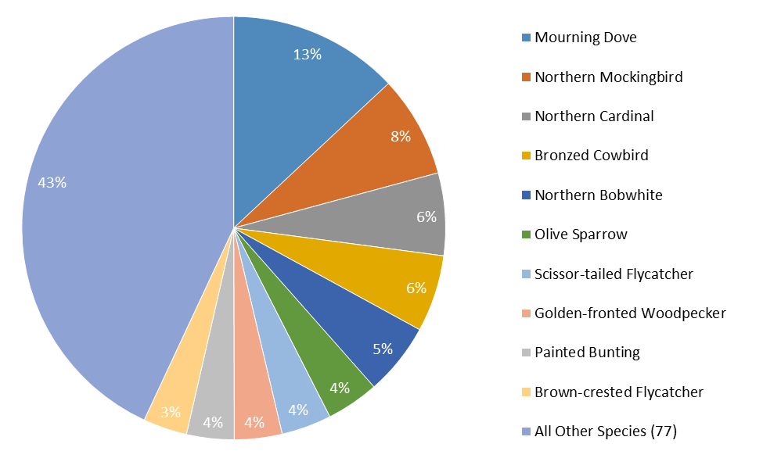

Figure 13. Percent of total observations accounted for by the 10 most common species observed during breeding bird surveys of King Ranch in South Texas, 2005 – 2013.

most commonly observed species accounted for 64% of total observations on the division. Of the 53 other species that made up the remaining 36%, 30 were observed only once, accounting for 0.03% of total observations. Four species were observed only on Encino: Campylorhynchus brunneicapillus (Cactus Wren), Passerina cyanea (Indigo Bunting), Buteo lineatus (Red-shouldered Hawk), and Elanus leucurus (White-tailed Kite; Table 11, pg. 77).
Laureles. A total of 6,174 individuals were observed on the Laureles division, averaging 475 birds counted per survey. At 68 total species, Laureles had the highest species richness of the 4 divisions. The 10 most common species on Laureles accounted for 62% of total observations on the division. Conversely 23 species were observed 10 times or fewer during the survey period, equal to 0.02% total of observations on the division. Four species were observed only on Laureles: Chaetura pelagica (Chimney Swift), Eremophila alpestris (Horned Lark), Killdeer, and Empidonax flaviventris (Yellow-bellied Flycatcher; Table 11, pg. 77).
Norias. Total observations from both routes combined came to 5,568 individuals of 65 species, with a mean of 464 birds counted per survey. The 10 most commonly observed species on Norias accounted for 59% of total observations on the division. Of the 65 species, 17 of them were observed 10 times or less and accounted for 0.01% of total observations on the division. Six species were observed only on Norias, 3 of which (Glaucidium brasilianum [Ferruginous Pygmy Owl], Camptostoma imberbe [Northern Beardless Tyrannulet], and Setophaga pitiayumi [Tropical Parula]), are listed as Threatened by the state of Texas. The other 3 species were Curve-billed Thrasher, Megascops asio (Eastern Screech-owl), and Spizella pusilla (Field Sparrow; Table 11, pg. 77).
Santa Gertrudis. A total of 4,608 individuals of 63 species were observed on the Santa Gertrudis division. The mean number of birds counted per survey was 576, the highest of all the divisions. The 10 most commonly observed species on Santa Gertrudis accounted for 61% of total observations on the division. Of the 63 species, 21 were observed 10 times or fewer accounting for 0.02% of total observations on the division. Only 1 species, Tachycineta bicolor (Tree Swallow), was observed only on Santa Gertrudis (Table 11, pg. 77).

Trends in abundance
A total of 86 models were analyzed for 26 species or groups on 1 or more divisions. Of the 86 models, 31 calculated trends significant at α = 0.10. Of the significant models, 26 species or groups increase in abundance, and 15 decreased during the study period. Significant trends were not calculated for any other species or groups and populations were considered stable. Linear models best fit trends in abundance of 55 species or groups, and quadratic models best fit trends in abundance of 31 species or groups.
Avian abundance on King Ranch during the study period remained stable. Trends in birds/point (of all species) were statistically equal among divisions (F_{calc 6, 22} 0.354 < F_{tab 6, 22} 2.549), meaning it was possible to calculate the trend in birds/point for all 4 divisions combined. This was best modeled as a stable linear trend (F_{1, 28} = 1.281, P = 0.267; Fig. 14a), but accounted for a small percentage of the variation in birds/point (r² = 0.11). Linear models best fit trends in total avian abundance on the Laureles and Norias divisions (Fig. 14b and c). Trends in birds/point calculated for the Encino and Santa Gertrudis divisions were best fit by quadratic models (Fig. 14d and e).
Encino. Mean birds/point (of all species) increased significantly during the study period, best modeled by a quadratic trend (Fig. 14d). Trends in birds/point were calculated for 19 individual species or groups on Encino (Table 12). Two species on Encino had significant
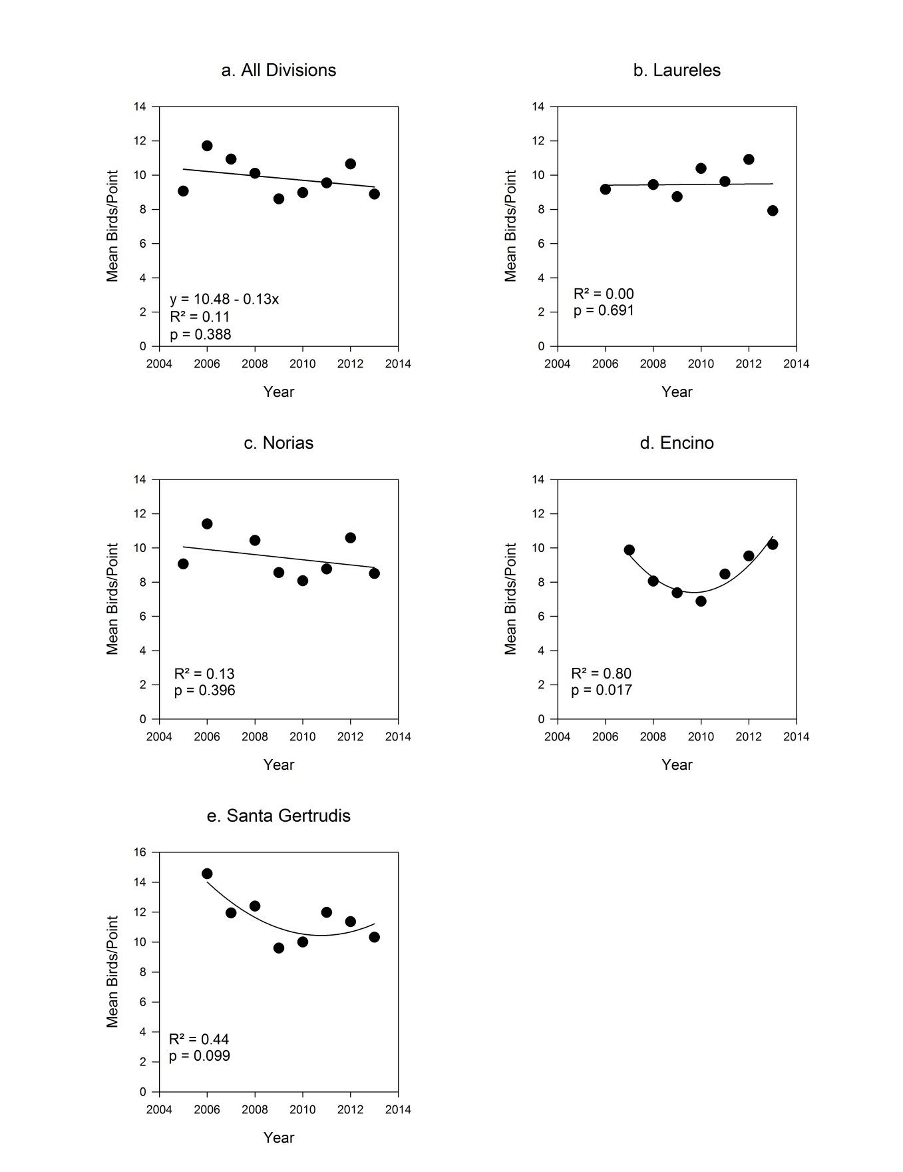
Figure 14. Trends in the mean number of birds (of all species) counted during breeding bird surveys of 4 King Ranch divisions in South Texas, 2005 – 2013.

Table 12. Trends in the mean number of birds counted per point during breeding bird surveys of the Encino division of King Ranch in Brooks County, Texas, 2007 – 2013.
Species | Nª | Model | Trend | F-statistic | DF ^{b} | P-value | r²
All | 2812 | yr + yr² | increase | 13.340 | 2,4 | 0.017** | 0.80
Bewick's Wren | 89 | yr | stable | 3.752 | 1,5 | 0.111 | 0.43
Black-crested Titmouse | 54 | yr | increase | 7.018 | 1,5 | 0.045** | 0.58
Cardinalis spp. | 223 | yr | stable | 0.183 | 1,5 | 0.687 | 0.03
Cowbird spp. | 166 | yr | stable | 0.066 | 1,5 | 0.807 | 0.01
Dove spp. | 69 | yr + yr² | weak increase | 5.672 | 2,4 | 0.068* | 0.61
Green Jay | 12 | yr + yr² | stable | 0.081 | 2,4 | 0.508 | 0.00
Lark Sparrow | 60 | yr + yr² | stable | 1.043 | 2,4 | 0.432 | 0.01
Mourning Dove | 360 | yr + yr² | stable | 1.776 | 2,4 | 0.281 | 0.21
Myiarchus spp. | 174 | yr + yr² | stable | 2.408 | 2,4 | 0.206 | 0.32
Northern Bobwhite | 194 | yr + yr² | increase | 19.260 | 2,4 | 0.009** | 0.86
Northern Mockingbird | 232 | yr + yr² | weak increase | 5.370 | 2,4 | 0.074* | 0.59
Olive Sparrow | 108 | yr + yr² | stable | 1.881 | 2,4 | 0.266 | 0.48
Painted Bunting | 159 | yr + yr² | weak increase | 5.677 | 2,4 | 0.068* | 0.61
Scissor-tailed Flycatcher | 153 | yr | stable | 2.205 | 1,5 | 0.198 | 0.31
Thrasher spp. | 26 | yr | stable | 0.008 | 1,5 | 0.932 | 0.00
White-eyed Vireo | 17 | yr | decrease | 19.080 | 1,5 | 0.007** | 0.79
Wild Turkey | 61 | yr | stable | 0.090 | 1,5 | 0.777 | 0.02
Woodpecker spp. | 204 | yr + yr² | stable | 0.471 | 2,4 | 0.655 | 0.00
Yellow-billed Cuckoo | 39 | yr + yr² | stable | 4.078 | 2,4 | 0.108 | 0.51
ª Number of individuals
^{b} degrees of freedom
**P < 0.05, *P < 0.10

positive trends (Northern Bobwhite, and Baeolophus atricristatus [Black-crested Titmouse], Fig. 15a and b). Weak increases in birds/point were calculated for 3 species or groups (Paserina ciris [Painted Bunting], Northern Mockingbird, and Dove spp., Fig. 15c, d, and e). White-eyed Vireo was the only species that declined significantly during the study period, with an estimated annual decrease of 0.025 birds/point (Fig. 15f). A greater number of species or groups on Encino fit quadratic trend models (9) than they did linear trend models (4; Table 12, pg. 84).
Laureles. Mean birds/point (of all species) remained stable during the study period, but both linear and quadratic models had low r² values indicating a poor fit (Table 13, Fig. 14b). Birds/point remained stable on the northern Laureles route, best modeled by a linear trend (Table 13). Birds/point decreased significantly on the southern Laureles route, best modeled by a negative quadratic trend (Table 13).
Trends in birds/point were calculated for 22 species or groups on Laureles (Table 13). A significant positive trend was calculated for Meleagris gallopavo (Wild Turkey), and was best fit by a positive quadratic model (Fig. 16a). A weak linear increase was calculated for Scissor-tailed Flycatcher (Fig. 16b). Three species or groups (Strurnella magna [Eastern Meadowlark], Northern Mockingbird, and Woodpecker spp.) declined significantly during the study period (Fig. 16c – e). A weakly decreasing trend was calculated for Mourning Doves (Fig. 16f). Of the trends in species/group abundance calculated, 13 were best modeled by quadratic trends and 9 were best modeled by linear trends (Table 13).
Norias. Mean birds/point (of all species) remained stable during the study period, but the low R² value indicated a poor model fit (Table 14, Fig. 14c). A weak decrease in birds/point was calculated for the northern Norias route, with an estimated decrease of 16 birds per survey per

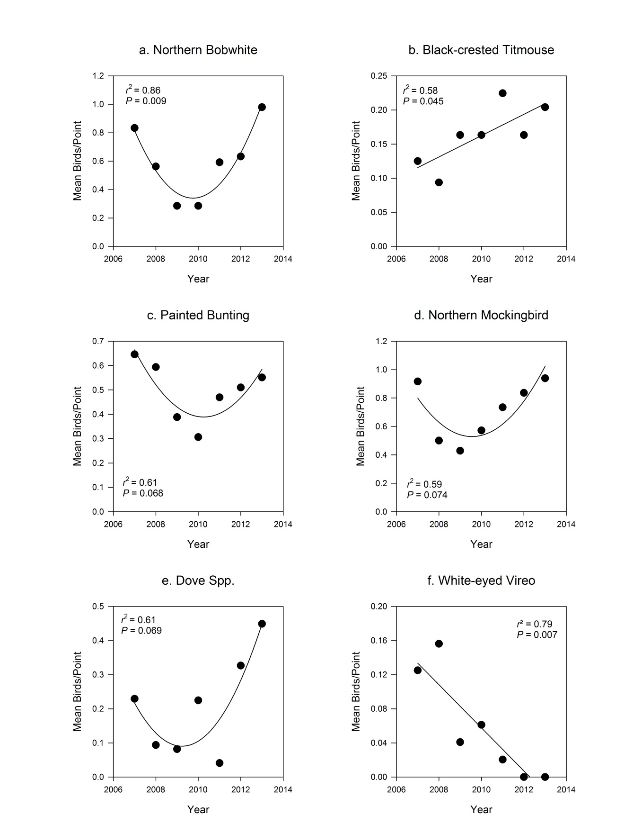
Figure 15. Trends in the mean number of birds counted per point during breeding bird surveys of the Encino division of King Ranch in Brooks County, Texas, 2007 - 2013.
Table 13. Trends in the mean number of birds counted per point during breeding bird surveys of the Laureles division of King Ranch in Kleberg County, Texas, 2005 – 2013.
Species | Nª | Model | Trend | F-statistic | DF ª | P-value | r²
All | 6160 | yr | stable | 0.406 | 2,4 | 0.691 | 0.00
North | 2716 | yr | stable | 0.228 | 2,4 | 0.833 | 0.04
South | 3444 | yr + yr² | decrease | 10.08 | 2,3 | 0.047** | 0.78
Bewick's Wren | 41 | yr | stable | 2.216 | 1,5 | 0.197 | 0.31
Botteri’s Sparrow | 73 | yr + yr² | stable | 2.197 | 2,4 | 0.229 | 0.28
Cardinalis spp. | 12 | yr | stable | 1.163 | 1,5 | 0.330 | 0.19
Cassin’s Sparrow | 451 | yr | stable | 2.188 | 1,5 | 0.199 | 0.30
Cowbird spp. | 537 | yr + yr² | stable | 2.445 | 2,4 | 0.203 | 0.33
Dove spp. | 120 | yr | stable | 2.059 | 1,5 | 0.211 | 0.29
Eastern Meadowlark | 103 | yr | decrease | 7.293 | 1,5 | 0.043** | 0.59
Green Jay | 17 | yr | stable | 1.064 | 1,5 | 0.350 | 0.17
Lark Sparrow | 48 | yr + yr² | stable | 3.969 | 2,4 | 0.112 | 0.50
Mourning Dove | 805 | yr + yr² | weak decrease | 4.381 | 2,4 | 0.098* | 0.53
Myiarchus spp. | 134 | yr + yr² | stable | 0.941 | 2,4 | 0.463 | 0.00
Northern Bobwhite | 308 | yr + yr² | stable | 1.629 | 2,4 | 0.304 | 0.17
Northern Mockingbird | 422 | yr + yr² | decrease | 8.57 | 2,4 | 0.036** | 0.72
Olive Sparrow | 127 | yr + yr² | stable | 1.92 | 2,4 | 0.260 | 0.23
Painted Bunting | 364 | yr + yr² | stable | 3.15 | 2,4 | 0.151 | 0.42
Red-winged Blackbird | 408 | yr + yr² | stable | 1.796 | 2,4 | 0.278 | 0.21
Scissor-tailed Flycatcher | 336 | yr | weak increase | 6.11 | 1,5 | 0.056* | 0.55
Thrasher spp. | 39 | yr + yr² | stable | 4.006 | 2,4 | 0.111 | 0.50
White-eyed Vireo | 117 | yr | stable | 3.25 | 1,5 | 0.131 | 0.39
Wild Turkey | 34 | yr + yr² | increase | 20.63 | 2,4 | 0.008** | 0.87
Woodpecker spp. | 134 | yr + yr² | decrease | 9.697 | 2,4 | 0.029** | 0.74
Yellow-billed Cuckoo | 188 | yr | stable | 1.098 | 1,5 | 0.343 | 0.18
ª Number of individuals
^{b} degrees of freedom
**P < 0.05, * P < 0.10

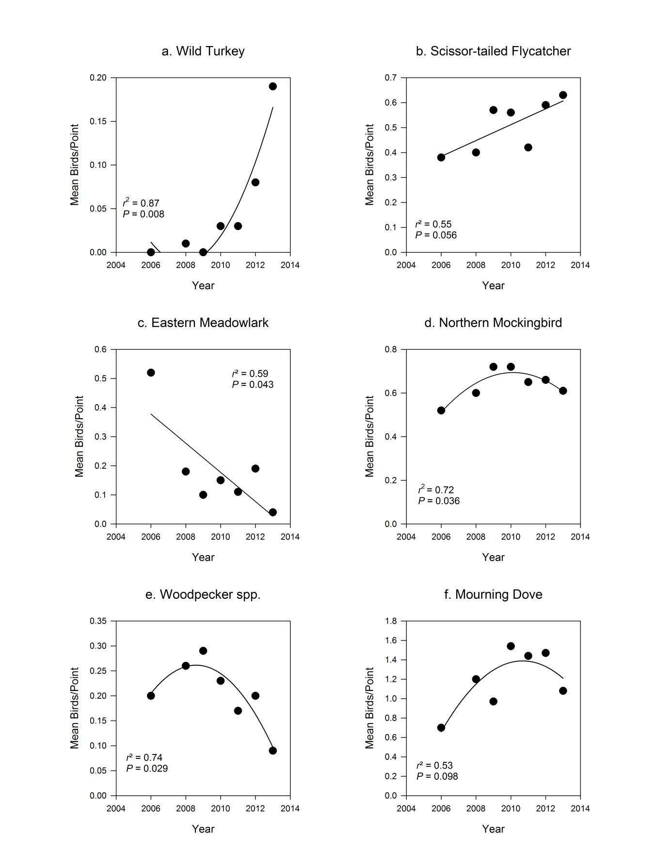
Figure 16. Trends in the mean number of birds counted per point during breeding bird surveys of the Laureles division of King Ranch in Kleberg County, Texas, 2006 – 2013.
Table 14. Trends in the mean number of birds counted per point during breeding bird surveys of the Norias division of King Ranch in Kenedy County, Texas, 2005 – 2013.
Species | Nª | Model | Trend | F-statistic | DF ^{b} | P-value | r²
All | 5567 | yr | stable | 0.835 | 1,6 | 0.396 | 0.13
North | 3563 | yr | weak decrease | 3.772 | 1,6 | 0.100* | 0.40
South | 2004 | yr | stable | 0.060 | 1,2 | 0.824 | 0.02
Bewick's Wren | 101 | yr | decrease | 13.01 | 1,6 | 0.011** | 0.68
Black-crested Titmouse | 178 | yr | decrease | 14.26 | 1,6 | 0.009** | 0.71
Cardinalis spp. | 364 | yr | stable | 2.333 | 1,6 | 0.178 | 0.28
Cowbird spp. | 386 | yr | stable | 1.472 | 1,6 | 0.271 | 0.20
Dove spp. | 231 | yr | stable | 0.744 | 1,6 | 0.422 | 0.11
Eastern Meadowlark | 22 | yr | stable | 0.172 | 1,6 | 0.692 | 0.03
Green Jay | 83 | yr | stable | 0.033 | 1,6 | 0.862 | 0.00
Lark Sparrow | 42 | yr | weak increase | 4.828 | 1,6 | 0.070* | 0.44
Mourning Dove | 806 | yr | stable | 0.320 | 1,6 | 0.592 | 0.05
Myiarchus spp. | 317 | yr | stable | 2.268 | 1,6 | 0.183 | 0.27
Northern Bobwhite | 247 | yr | stable | 0.889 | 1,6 | 0.382 | 0.13
Northern Mockingbird | 416 | yr + yr² | stable | 1.489 | 2,5 | 0.311 | 0.12
Olive Sparrow | 298 | yr | stable | 0.151 | 1,6 | 0.711 | 0.02
Painted Bunting | 60 | yr | stable | 2.293 | 1,6 | 0.181 | 0.28
Scissor-tailed Flycatcher | 119 | yr + yr² | increase | 9.076 | 2,5 | 0.022** | 0.70
Thrasher spp. | 142 | yr | stable | 2.897 | 1,6 | 0.140 | 0.32
White-eyed Vireo | 103 | yr | decrease | 6.946 | 1,6 | 0.039** | 0.53
Wild Turkey | 122 | yr | stable | 0.503 | 1,6 | 0.500 | 0.08
Woodpecker spp. | 341 | yr | stable | 0.310 | 1,6 | 0.598 | 0.05
Yellow-billed Cuckoo | 88 | yr + yr² | stable | 1.592 | 2,5 | 0.292 | 0.14
ª Number of individuals
^{b}degrees of freedom
**P < 0.05, * P < 0.10

year (Table 14, pg. 89). Birds/point on the southern Norias route remained stable, although the low r² value indicated a poor model fit (Table 14, pg. 89).
Trends were calculated for 20 species or groups on Norias (Table 14, pg. 89). Scissor-tailed Flycatchers increased significantly during the study period, best modeled by a positive quadratic trend (Fig. 17a). The trend in the number of Lark Sparrows showed a weak linear increase during the study period (Fig. 17b). Three species (Thryomanes bewickii [Bewick’s Wren], Black-crested Titmouse, and White-eyed Vireo) decreased significantly during the study period, best modeled by linear trends (Fig. 17c – e). Of the trends in species/group abundance calculated, 17 were best fit by linear models, 3 were best fit by quadratic models.
Santa Gertrudis. The trend in birds/point (of all species) calculated for Santa Gertrudis was weakly significant, and was best modeled by a positive quadratic trend (Table 15, Fig. 14e). Trends in the abundance of 20 species or groups were modeled for Santa Gertrudis (Table 15). Mourning Doves increased significantly during the study period, best modeled by a positive quadratic trend (Fig. 18a). Three species or groups (Bewick's Wren, Cardinalis spp., and Painted Bunting) declined significantly, best modeled by linear trends (Fig. 18b – d). Three species (Cassin’s Sparrows, Northern Bobwhite, and White-eyed Vireo) had weak declines, best modeled by linear trends (Fig. 18e – g). Trends calculated for 6 species or groups were best modeled by quadratic trends, and 14 were best modeled by linear trends (Table 15).

Precipitation
The 100-year average annual rainfall for Texas Climate Division 7 between 1900 and 2000 was 84.3 cm. From 2006 to 2013 this Climate Division experienced 5 years of below average precipitation and 3 years of above average precipitation. The wettest years for the Climate Division were 2007 and 2008, followed by the driest year in 2009. The average total
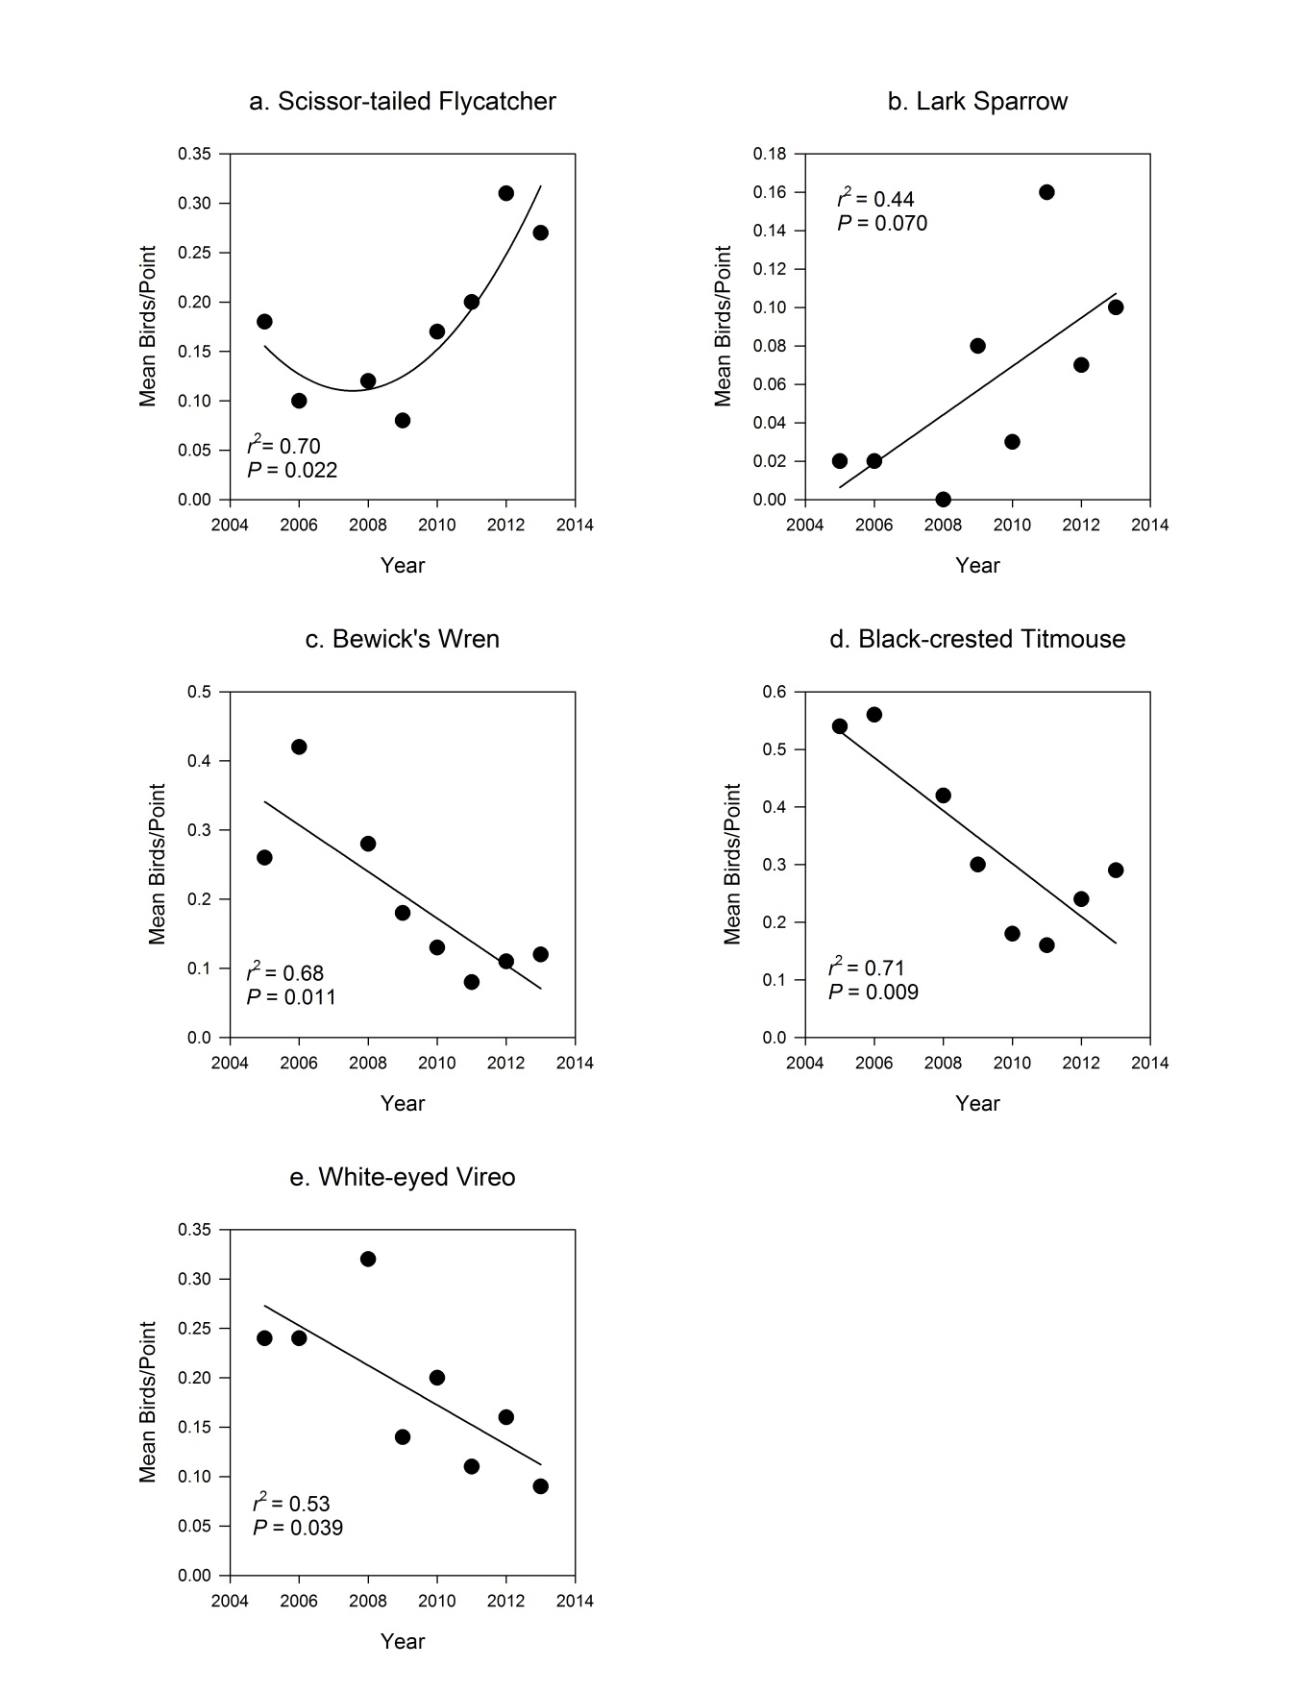
Figure 17. Trends in the mean number of birds counted per point during breeding bird surveys of the Norias division of King Ranch in Kenedy County, Texas, 2005 – 2013.
Table 15. Trends in the mean number of birds counted per point during breeding bird surveys of the Santa Gertrudis division of King Ranch in Kleberg County, Texas, 2006 – 2013.
Species | Nª | Model | Trend | F-statistic | DF ^{b} | P-value | r²
All | 4608 | yr + yr² | weak increase | 3.803 | 2,5 | 0.099* | 0.44
Bewick's Wren | 58 | yr | decrease | 7.910 | 1,6 | 0.030** | 0.57
Black-crested Titmouse | 22 | yr | stable | 1.551 | 1,6 | 0.259 | 0.21
Cardinalis spp. | 338 | yr | decrease | 7.483 | 1,6 | 0.034** | 0.55
Cassin’s Sparrow | 25 | yr | weak decrease | 5.597 | 1,6 | 0.056* | 0.48
Cowbird spp. | 408 | yr + yr² | stable | 1.108 | 2,5 | 0.400 | 0.03
Dove spp. | 171 | yr + yr² | stable | 3.311 | 2,5 | 0.121 | 0.40
Lark Sparrow | 33 | yr | stable | 2.708 | 1,6 | 0.151 | 0.31
Mourning Dove | 524 | yr + yr² | increase | 5.496 | 2,5 | 0.050** | 0.56
Myiarchus spp. | 195 | yr | stable | 1.372 | 1,6 | 0.286 | 0.19
Northern Bobwhite | 309 | yr | weak decrease | 4.144 | 1,6 | 0.087* | 0.41
Northern Mockingbird | 416 | yr + yr² | stable | 2.923 | 2,5 | 0.144 | 0.35
Olive Sparrow | 235 | yr + yr² | stable | 0.256 | 2,5 | 0.784 | 0.00
Painted Bunting | 111 | yr | decrease | 20.02 | 1,6 | 0.004** | 0.77
Red-winged Blackbird | 114 | yr | stable | 2.288 | 1,6 | 0.181 | 0.28
Scissor-tailed Flycatcher | 123 | yr + yr² | stable | 1.575 | 2,5 | 0.295 | 0.14
Thrasher spp. | 67 | yr | stable | 0.861 | 1,6 | 0.389 | 0.13
White-eyed Vireo | 78 | yr | weak decrease | 4.817 | 1,6 | 0.071* | 0.44
Wild Turkey | 44 | yr | stable | 1.727 | 1,6 | 0.237 | 0.22
Woodpecker spp. | 270 | yr | stable | 0.134 | 1,6 | 0.727 | 0.02
Yellow-billed Cuckoo | 247 | yr | stable | 0.057 | 1,6 | 0.819 | 0.00
ª Number of individuals
^{b} degrees of freedom
**p < 0.05, *p< 0.10

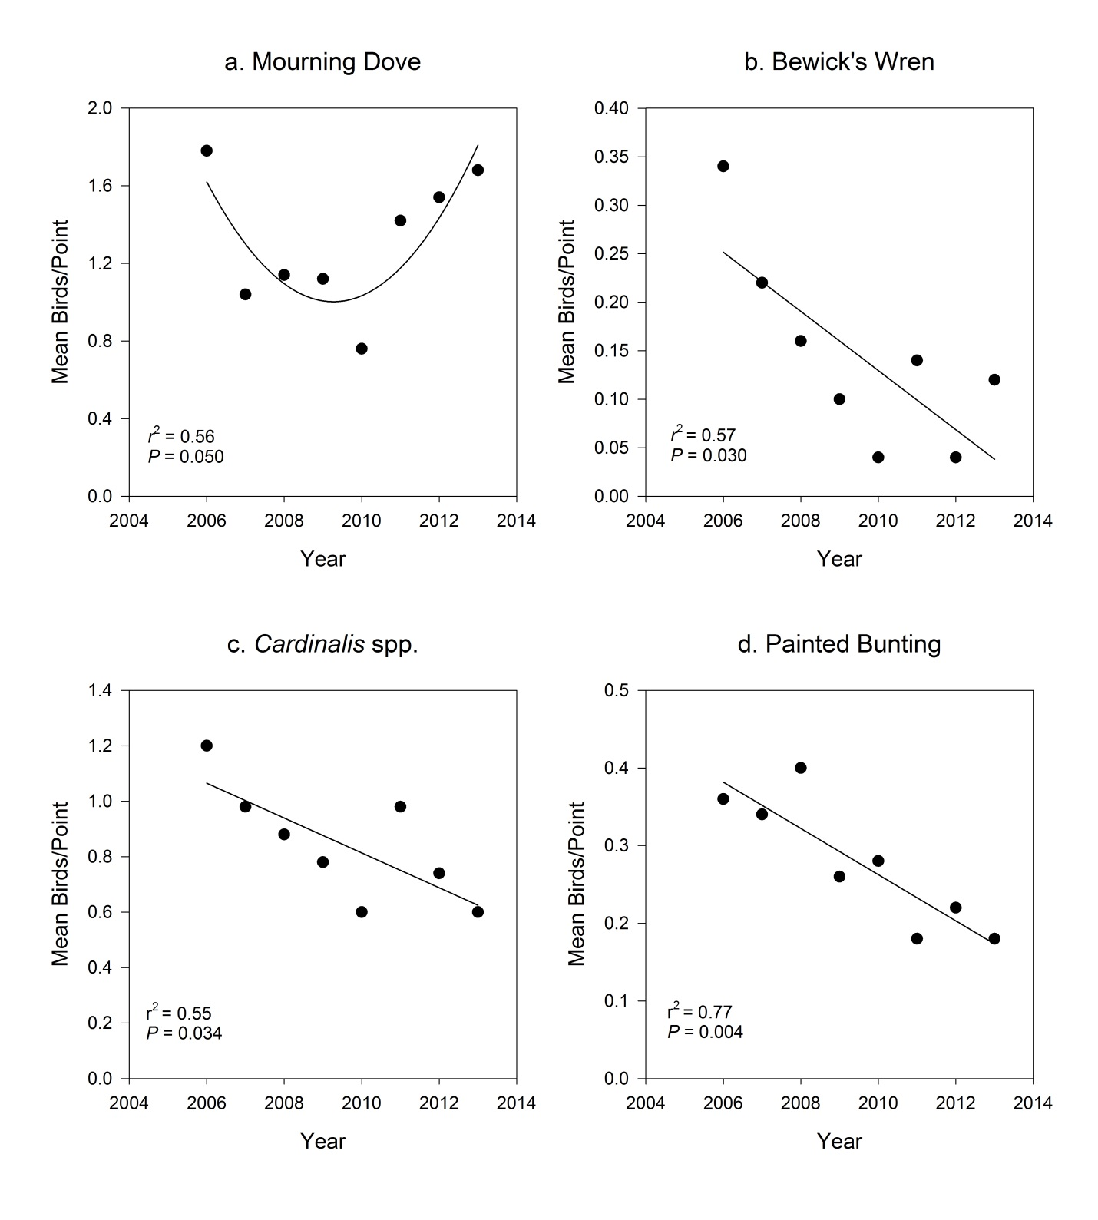
Figure 18. Trends in the mean number of birds counted per point during breeding bird surveys of the Santa Gertrudis division of King Ranch in Kleberg County, Texas, 2006 – 2013.

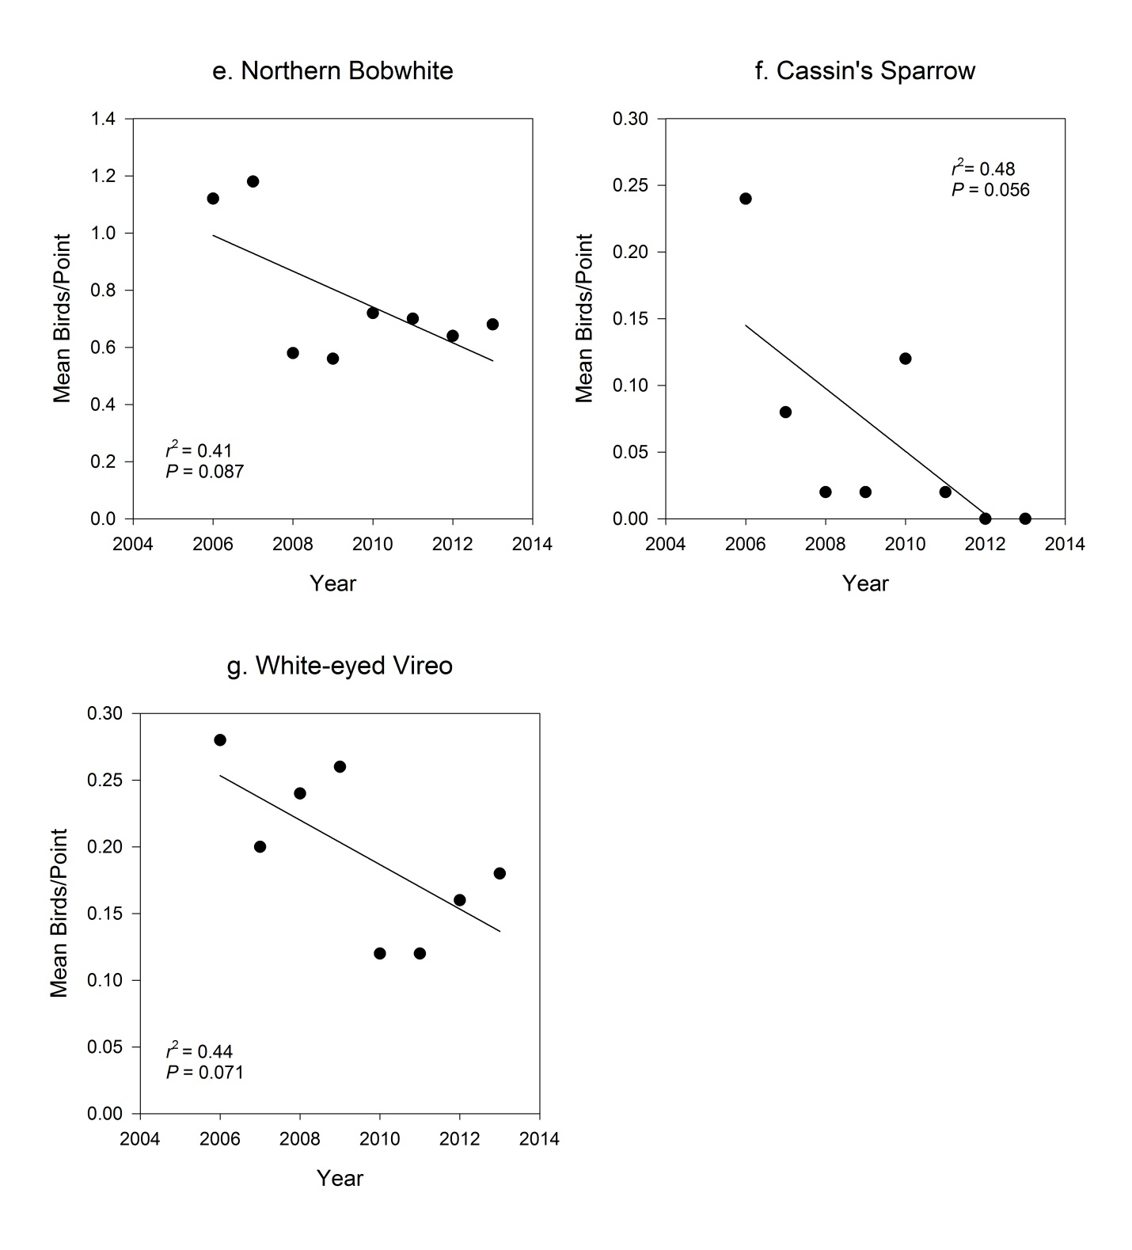
Figure 18. Continued
May – April precipitation for the study period did not vary >6 cm among divisions, however the total May – April precipitation received on each division within a given year varied. In the wettest year (2007) rainfall on Laureles was >20 cm greater than that received on Norias (Fig. 19). The greatest difference in total May – April precipitation was 40 cm in 2008. That year Santa Gertrudis received 93.7 cm of total May – April precipitation while Encino received only 52.8 cm (Fig. 19). Precipitation data was not available for 2005, so that year was excluded from analysis.
Average total May – April rainfall during the study period was lowest on Encino at 60.5 cm, and highest on Laureles at 67.0 cm. Encino received a high of 87.3 cm of precipitation in 2007, and a low of 27.6 cm in 2013 (Fig. 19). Precipitation on Laureles was highest in 2007 (105.4 cm) and lowest in 2013 (34.0 cm, Fig. 19). Norias received an average of 62.4 cm of total May – April precipitation, with a high of 84.3 cm in 2010 and a low of 34.0 cm in 2013 (Fig. 19). The average total May – April precipitation on Santa Gertrudis was 66.2 cm, with a high of 94.8 cm in 2007 and a low of 34.0 cm in 2013 (Fig. 19).

Animal unit days
The total number of animal unit days per hectare between May – April (aud/ha) were lower on all divisions at the end of the study in 2013 than at the start in 2006 (Fig. 20). The lowest average aud/ha was on Encino at 18.2, with a high of 21.9 in 2008 and a low of 13.2 in 2013 (Fig. 20). Average aud/ha on Laureles was 25.7, the highest in 2005 (34.9 aud/ha) and the lowest in 2011 (20.3 aud/ha, Fig. 20). Average aud/ha was relatively low at 19.5 on Norias, with a high of 21.9 in 2008 and a low of 16.7 in 2012 (Fig. 20). The highest average aud/ha was on Santa Gertrudis at 29.4, with a high of 37.8 in 2006 to a low of 25.0 aud/ha in 2009 (Fig. 20).

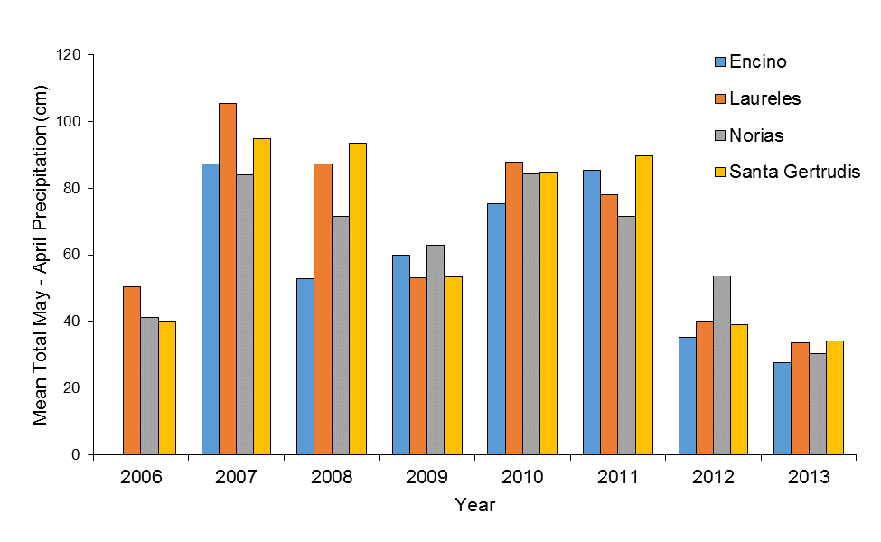
Figure 19. Mean total May – April precipitation (in cm) on King Ranch divisions in South Texas, 2006 - 2013.

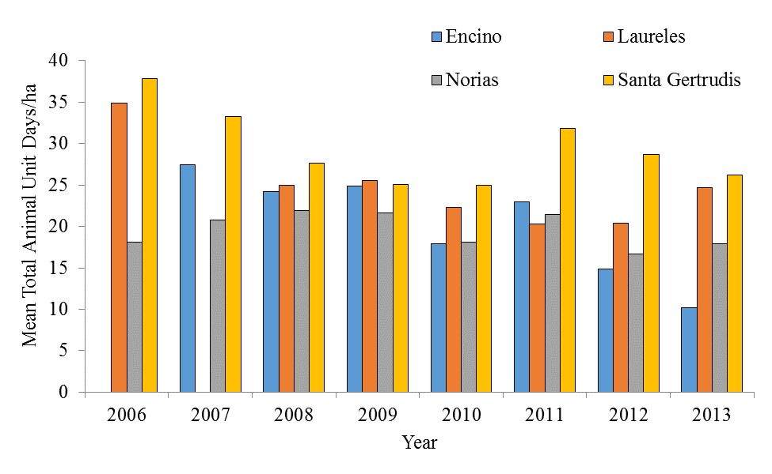
Figure 20. Mean total May – April animal unit days per hectare on King Ranch divisions in South Texas, 2006 – 2013.

Effects of Precipitation and Grazing
It was not possible to separately calculate the effects of precipitation and grazing on the number of birds/point due to extreme multicollinearity between these variables. Attempts to simultaneously model the effects of precipitation and aud/ha on birds/point produced models in which the interaction term had very limited (0 – 1) degrees of freedom (Table 16). The notable exception was the northern Norias survey route for which 9 degrees of freedom were calculated for the interaction term. This still indicated a high degree of collinearity between effects, but allowed me to test if there were significant interactions between precipitation and aud/ha. Tests for correlations between total May – April precipitation and total May – April aud/ha were significant on just 2 of the 6 survey routes. Because of this, the model of precipitation or aud/ha with the lowest AICc value was considered to best represent the combined effect of precipitation and aud/ha on birds/point.
Linear, quadratic, cubic, and quartic regression models of the combined effect of precipitation and aud/ha on total avian abundance were statistically significant in several cases, but did not provide biologically relevant estimates of the effects, as indicated by extremely low model r² values. However, analysis of variance tests (ANOVAs) in which the main effects were treated as a class variables were statistically significant, and explained a biologically relevant amount of variation in total landbird abundance.
Variation in avian abundance explained by the combined effect of precipitation and aud/ha was significant on all survey routes. The combined effect of precipitation and aud/ha had a significant effect on mean birds/point on all divisions. The combined effect of precipitation and aud/ha was significant for some species or groups, but varied among divisions.
Encino. The combined effect of precipitation and aud/ha on total avian abundance was statistically significant, but did not explain a large amount of variation (r² = 0.13, Table 17).
Table 16. Models of the effect of precipitation and animal unit days/ha on the number of birds counted per point during breeding bird surveys of King Ranch, 2005–2013.
Survey Route | Effect | DF ª | AICc ^{b} | Δ AICc ^{c} | Single effect r^{2 d} | Full Model r² ^{e} | P-value
Encino | ppt ^{f} | 40 | 595.7 | 50.7 | 0.14 | 0.67 | <0.0001
 | aud/ha^{1,g} | 62 | 579.0 | 34.0 | 0.13 | 0.69 | 0.0444
 | both | 1 | 545.0 | 0.0 | . | . | 0.7331
Laureles North | ppt¹ | 34 | 741.6 | 38.0 | 0.44 | 0.82 | <0.0001
 | aud/ha | 41 | 792.2 | 88.6 | 0.42 | 0.82 | <0.0001
 | both | 0 | 703.6 | 0.0 | . | . | .
Laureles South | ppt | 46 | 537.6 | 75 | 0.30 | 0.75 | <0.0001
 | aud/ha¹ | 54 | 522.6 | 60 | 0.31 | 0.76 | <0.0001
 | both | 0 | 462.6 | 0.00 | . | . | .
Norias North | ppt¹ | 34 | 617.1 | 79.5 | 0.42 | 0.77 | <0.0001
 | aud/ha | 46 | 675.1 | 137.5 | 0.10 | 0.78 | 0.0002
 | both | 9 | 537.6 | 0.0 | . | . | 0.8686
Norias South | ppt | 22 | 347.2 | 9.5 | 0.48 | 0.80 | <0.0001
 | aud/ha¹ | 25 | 339.3 | 1.6 | 0.48 | 0.81 | <0.0001
 | both | 0 | 337.7 | 0.00 | . | . | .
Santa Gertrudis | ppt | 47 | 709.1 | 92.8 | 0.18 | 0.65 | <0.0001
 | aud/ha¹ | 100 | 616.3 | 49.1 | 0.21 | 0.68 | 0.0003
 | both | 0 | 567.2 | 0 | . | . | .
ª degrees of freedom
^{b} measure of model fit
^{c} difference in AICc value between the best model (Δ AICc = 0), and the current model
^{d} variation in bird numbers explained by the main effects included in the model
^{e} variation in bird numbers explained by all effects included in the model
^{f} total annual May - April precipitation (cm)
^{g} total annual May - April animal unit days per hectare
¹best model (lowest ΔAICc value between precipitation and aud/ha)

Table 17. Models of the effect of precipitation and animal unit days/ha on the number of birds counted per point during breeding bird surveys of the Encino division of King Ranch in Brooks County, Texas, 2007–2013.
Survey Route | Effect | DF ª | AICc ^{b} | Δ AICc ^{c} | Single effect r^{2 d} | Full Model r² ^{e} | P-value
All Spp. | ppt ^{f} | 40 | 595.7 | 50.7 | 0.14 | 0.67 | <0.0001
 | aud/ha^{1, g} | 62 | 579.0 | 34.0 | 0.13 | 0.69 | 0.0444
 | both | 1 | 545.0 | 0.0 | . | . | 0.7331
Species Richness | ppt | 40 | 399.4 | 13.3 | 0.09 | 0.48 | 0.0010
 | aud/ha¹ | 62 | 392.8 | 6.7 | 0.09 | 0.50 | 0.1063
 | both | 1 | 386.1 | 0.0 | . | . | 0.7786
Cowbird spp. | ppt | 40 | 586.7 | 64.1 | 0.08 | 0.61 | 0.2437
 | aud/ha¹ | 62 | 544.6 | 22.0 | 0.12 | 0.62 | 0.1772
 | both | 1 | 522.6 | 0.0 | . | . | 0.9028
Golden-Fronted Woodpecker | ppt | 40 | 498.5 | 43.1 | 0.10 | 0.58 | 0.0632
Golden-Fronted Woodpecker | aud/ha¹ | 62 | 464.0 | 8.6 | 0.12 | 0.59 | 0.0663
Golden-Fronted Woodpecker | both | 1 | 455.4 | 0.0 | . | . | 0.6117
Mourning Dove | ppt | 40 | 687.8 | 65.5 | 0.14 | 0.71 | 0.0014
 | aud/ha¹ | 62 | 655.1 | 32.8 | 0.16 | 0.72 | 0.0501
 | both | 1 | 622.3 | 0.0 | . | . | 0.9369
Myiarchus spp. | ppt | 40 | 553.0 | 39.0 | 0.08 | 0.58 | 0.1075
 | aud/ha¹ | 62 | 528.7 | 14.7 | 0.09 | 0.60 | 0.5165
 | both | 1 | 514.0 | 0.0 | . | . | 0.1300
Northern Bobwhite | ppt | 40 | 551.5 | 56.2 | 0.13 | 0.62 | <.0001
 | aud/ha¹ | 62 | 517.2 | 21.9 | 0.15 | 0.63 | 0.0008
 | both | 1 | 495.3 | 0.0 | . | . | 0.1175
Northern Cardinal | ppt | 40 | 517.9 | 50.3 | 0.18 | 0.61 | <0.0001
 | aud/ha¹ | 62 | 491.2 | 23.6 | 0.19 | 0.62 | 0.0005
 | both | 1 | 467.6 | 0.0 | . | . | 0.6476
Northern Mockingbird | ppt | 40 | 565.1 | 57.5 | 0.11 | 0.64 | 0.0092
Northern Mockingbird | aud/ha¹ | 62 | 530.5 | 22.9 | 0.14 | 0.65 | 0.0343
Northern Mockingbird | both | 1 | 507.6 | 0.0 | . | . | 0.9644
Olive Sparrow | ppt¹ | 40 | 389.5 | 27.0 | 0.12 | 0.51 | 0.0017
 | aud/ha | 62 | 388.9 | 26.4 | 0.11 | 0.52 | 0.2732
 | both | 1 | 362.5 | 0.0 | . | . | 0.7900
Painted Bunting | ppt | 40 | 526.2 | 18.6 | 0.08 | 0.56 | 0.1183
 | aud/ha¹ | 62 | 507.6 | 12.7 | 0.09 | 0.58 | 0.6106
 | both | 1 | 494.9 | 0.0 | . | . | 0.8684

Table 17. Continued
Survey Route | Effect | DF ª | AICc ^{b} | Δ AICc ^{c} | Single effect r^{2 d} | Full Model r² ^{e} | P-value
Scissor-tailed Flycatcher | ppt | 40 | 534.8 | 40.3 | 0.10 | 0.60 | 0.0142
Scissor-tailed Flycatcher | aud/ha¹ | 62 | 494.9 | 0.4 | 0.13 | 0.61 | 0.0119
Scissor-tailed Flycatcher | both | 1 | 494.5 | 0.0 | . | . | 0.6361
ª degrees of freedom
^{b} measure of model fit
^{c} difference in AICc value between the best model (Δ AICc = 0), and the current model
^{d} variation in bird numbers explained by the main effects included in the model
^{e} variation in bird numbers explained by all effects included in the model
^{f} total annual May - April precipitation (cm)
^{g} total annual May - April animal unit days per hectare
¹best model (lowest ΔAICc value between precipitation and aud/ha)

The combined effect of precipitation and aud/ha on species richness/point was statistically significant, but only accounted for 9% of variation (Table 17, pg. 100). The combined effect of precipitation and aud/ha had a significant effect on birds/point of 6 species, and the aud/ha model had the lowest AICc value for 9 out of 10 species or groups (Table 17, pg. 100).
Laureles. The combined effect of precipitation and aud/ha on total avian abundance and species richness was significant on both the north and south survey routes of Laureles (Table 18). The effect was greater on the northern survey route than the southern route (Table 18). Variation in abundance due to precipitation and aud/ha was modeled for 11 species or groups on the northern survey route of the Laureles division. Precipitation models had the lowest AICc value for 7 species, and aud/ha models were lowest for 4 species (Table 18). The combined effect of precipitation and aud/ha was significant for 9 species (Table 18).
Norias. The combined effect of precipitation and aud/ha did not have complete multicollinearity on the northern route of the Norias division. Both effects were significant, but precipitation accounted for a greater amount of variation in both total avian abundance (r² = 0.42) and species richness (r² = 0.36) than aud/ha (r² = 0.10 and r² = 0.08, Table 19). Variation in abundance due to precipitation and aud/ha was modeled for 10 species or groups on the northern survey route of the Norias division. The effect of precipitation, aud/ha, or both, was significant for 9 species, and the interaction between precipitation and aud/ha was significant for 3 species (Table 19). Of 7 species for which the interaction between precipitation and aud/ha was not significant, precipitation models had the lowest AICc value for 4 species, and aud/ha had the lowest AICc value for 3 (Table 19).

Table 18. Models of the effect of precipitation and animal unit days/ha on the number of birds counted per point during breeding bird surveys of the Laureles division of King Ranch in Kleberg County, Texas, 2006 – 2013.
Survey Route | Effect | DF ª | AICc ^{b} | Δ AICc ^{c} | Single effect r^{2 d} | Full Model r² ^{e} | P-value
All spp. | ppt^{1, f} | 34 | 741.6 | 38.0 | 0.44 | 0.82 | <0.0001
All spp. | aud/ha ^{g} | 41 | 792.2 | 88.6 | 0.42 | 0.82 | <0.0001
All spp. | both | 0 | 703.6 | 0.0 | . | . | .
Species Richness | ppt | 34 | 470.9 | 14.6 | 0.40 | 0.67 | <0.0001
Species Richness | aud/ha¹ | 41 | 464.4 | 8.1 | 0.40 | 0.67 | <0.0001
Species Richness | both | 0 | 456.3 | 0.0 | . | . | .
Eastern Meadowlark | ppt | 34 | 275.4 | 35.4 | 0.08 | 0.36 | <0.0001
Eastern Meadowlark | aud/ha¹ | 41 | 240.0 | 0.0 | 0.11 | 0.37 | <0.0001
Eastern Meadowlark | both | 0 | 249.4 | 9.4 | . | . | .
Greater Road Runner | ppt | 34 | 423.1 | 20.0 | 0.07 | 0.45 | 0.0029
Greater Road Runner | aud/ha¹ | 41 | 422.7 | 19.6 | 0.07 | 0.46 | 0.0256
Greater Road Runner | both | 0 | 403.1 | 0.0 | . | . | .
Mourning Dove | ppt | 34 | 627.5 | 30.7 | 0.20 | 0.65 | <0.0001
Mourning Dove | aud/ha¹ | 41 | 624.4 | 27.6 | 0.19 | 0.66 | <0.0001
Mourning Dove | both | 0 | 596.8 | 0.0 | . | . | .
Northern Bobwhite | ppt¹ | 34 | 611.0 | 26.8 | 0.11 | 0.61 | 0.0002
Northern Bobwhite | aud/ha | 41 | 598.2 | 14.0 | 0.12 | 0.61 | 0.0005
Northern Bobwhite | both | 0 | 584.2 | 0.0 | . | . | .
Northern Cardinal | ppt | 34 | 582.6 | 20.7 | 0.19 | 0.64 | <0.0001
Northern Cardinal | aud/ha¹ | 41 | 576.7 | 14.8 | 0.18 | 0.64 | <0.0001
Northern Cardinal | both | 0 | 561.9 | 0.0 | . | . | .
Northern Mockingbird | ppt | 34 | 352.9 | 21.1 | 0.21 | 0.52 | <0.0001
Northern Mockingbird | aud/ha¹ | 41 | 331.8 | 0.0 | 0.25 | 0.52 | <0.0001
Northern Mockingbird | both | 0 | 334.9 | 3.1 | . | . | .
Olive Sparrow | ppt¹ | 34 | 215.1 | 0.0 | 0.05 | 0.32 | 0.0902
Olive Sparrow | aud/ha | 41 | 224.2 | 9.1 | 0.04 | 0.33 | 0.5461
Olive Sparrow | both | 0 | 221.3 | 6.2 | . | . | .
Painted Bunting | ppt | 34 | 564.2 | 19.3 | 0.15 | 0.60 | <0.0001
Painted Bunting | aud/ha¹ | 41 | 554.7 | 9.8 | 0.16 | 0.60 | <0.0001
Painted Bunting | both | 0 | 544.9 | 0.0 | . | . | .
White-eyed Vireo | ppt¹ | 34 | 399.1 | 15.3 | 0.09 | 0.45 | <0.0001
White-eyed Vireo | aud/ha | 41 | 415.8 | 32.0 | 0.07 | 0.46 | 0.0225
White-eyed Vireo | both | 0 | 383.8 | 0.0 | . | . | .

Table 18. Continued
Survey Route | Effect | DF ª | AICc ^{b} | Δ AICc ^{c} | Single effect r^{2 d} | Full Model r² ^{e} | P-value
White-tailed Hawk | ppt | 34 | 231.7 | 11.7 | 0.03 | 0.30 | 0.3525
White-tailed Hawk | aud/ha¹ | 41 | 220.0 | 0.0 | 0.04 | 0.30 | 0.1017
White-tailed Hawk | both | 0 | 239.0 | 7.3 | . | . | .
Yellow-billed Cuckoo | ppt¹ | 34 | 260.8 | 3.3 | 0.09 | 0.35 | <0.0001
Yellow-billed Cuckoo | aud/ha | 41 | 286.3 | 28.8 | 0.07 | 0.36 | 0.0013
Yellow-billed Cuckoo | both | 0 | 257.5 | 0.0 | . | . | .
ª degrees of freedom
^{b} measure of model fit
^{c} difference in AICc value between the best model (Δ AICc = 0), and the current model
^{d} variation in bird numbers explained by the main effects included in the model
^{e} variation in bird numbers explained by all effects included in the model
^{f} total annual May - April precipitation (cm)
^{g} total annual May - April animal unit days per hectare
¹best model (lowest ΔAICc value between precipitation and aud/ha models)

Table 19. Models of the effect of precipitation and animal unit days/ha on the number of birds observed during breeding bird surveys of the Norias division of King Ranch in Kenedy County, Texas, 2006 – 2013.
Survey Route | Effect | DF ª | AICc ^{b} | Δ AICc ^{c} | Single effect r^{2 d} | Full Model r² ^{e} | P-value
All spp. | ppt^{1, f} | 34 | 617.1 | 79.5 | 0.42 | 0.77 | <0.0001
All spp. | aud/ha ^{g} | 46 | 675.1 | 137.5 | 0.10 | 0.78 | 0.0002
All spp. | both | 9 | 537.6 | 0.0 | . | . | 0.8686
Species Richness | ppt¹ | 34 | 491.4 | 65.0 | 0.36 | 0.68 | <0.0001
Species Richness | aud/ha | 46 | 549.7 | 123.3 | 0.08 | 0.69 | 0.0004
Species Richness | both | 9 | 426.4 | 0.0 | . | . | 0.6940
Black-crested Titmouse | ppt¹ | 34 | 495.5 | 36.3 | 0.12 | 0.53 | <0.0001
Black-crested Titmouse | aud/ha | 46 | 509.4 | 50.2 | 0.08 | 0.53 | 0.1111
Black-crested Titmouse | both | 9 | 459.2 | 0.0 | . | . | 0.7035
Bewick's Wren | ppt¹ | 34 | 352.4 | 13.1 | 0.10 | 0.42 | <0.0001
Bewick's Wren | aud/ha | 46 | 382.4 | 43.1 | 0.06 | 0.43 | 0.0611
Bewick's Wren | both | 9 | 339.3 | 0.0 | . | . | 0.8875
Couch's Kingbird | ppt | 34 | 388.4 | 30.9 | 0.05 | 0.41 | 0.2339
Couch's Kingbird | aud/ha¹ | 46 | 366.4 | 8.9 | 0.06 | 0.42 | 0.1573
Couch's Kingbird | both | 9 | 357.5 | 0.0 | . | . | 0.5181
Mourning Dove | ppt¹ | 34 | 653.4 | 93.9 | 0.22 | 0.69 | <0.0001
Mourning Dove | aud/ha | 46 | 671.9 | 112.4 | 0.13 | 0.69 | 0.0042
Mourning Dove | both | 9 | 559.5 | 0.0 | . | . | 0.1322
Northern Bobwhite | ppt | 34 | 428.5 | 28.4 | 0.24 | 0.57 | <0.0001
Northern Bobwhite | aud/ha | 46 | 456.2 | 56.1 | 0.11 | 0.59 | 0.0060
Northern Bobwhite | both¹ | 9 | 400.1 | 0.0 | . | . | 0.0476
Northern Cardinal | ppt | 34 | 623.7 | 76.8 | 0.11 | 0.61 | 0.0001
Northern Cardinal | aud/ha¹ | 46 | 609.4 | 62.5 | 0.10 | 0.62 | 0.0538
Northern Cardinal | both | 9 | 546.9 | 0.0 | . | . | 0.4737
Northern Mockingbird | ppt | 34 | 537.8 | 31.2 | 0.12 | 0.60 | 0.0001
Northern Mockingbird | aud/ha¹ | 46 | 530.8 | 24.2 | 0.11 | 0.60 | 0.0240
Northern Mockingbird | both | 9 | 506.6 | 0.0 | . | . | 0.9897
Olive Sparrow | ppt¹ | 34 | 507.0 | 52.5 | 0.17 | 0.58 | <0.0001
Olive Sparrow | aud/ha | 46 | 526.3 | 71.8 | 0.05 | 0.60 | 0.4449
Olive Sparrow | both | 9 | 454.5 | 0.0 | . | . | 0.9820
White-eyed Vireo | ppt | 34 | 348.1 | 31.7 | 0.05 | 0.38 | 0.0256
White-eyed Vireo | aud/ha | 46 | 324.3 | 7.9 | 0.07 | 0.39 | 0.0099
White-eyed Vireo | both¹ | 9 | 316.4 | 0.0 | . | . | 0.0457

Table 19. Continued
Survey Route | Effect | DF ª | AICc ^{b} | Δ AICc ^{c} | Single effect r^{2 d} | Full Model r² ^{e} | P-value
White-tipped Dove | ppt | 34 | 395.9 | 29.1 | 0.12 | 0.46 | <0.0001
White-tipped Dove | aud/ha | 46 | 388.9 | 22.1 | 0.10 | 0.47 | 0.0182
White-tipped Dove | both¹ | 9 | 366.8 | 0.0 | . | . | 0.0116
ª degrees of freedom
^{b} measure of model fit
^{c} difference in AICc value between the best model (Δ AICc = 0), and the current model
^{d} variation in bird numbers explained by the main effects included in the model
^{e} variation in bird numbers explained by all effects included in the model
^{f} total annual May - April precipitation (cm)
^{g} total annual May - April animal unit days per hectare
¹best model (lowest ΔAICc value between precipitation and aud/ha models)

Santa Gertrudis. The effect of precipitation and aud/ha was modeled for 12 species or groups on the Santa Gertrudis division. The combined effect of precipitation and aud/ha was significant for 9 of the 12 species (Table 20). Precipitation models had the lowest AICc values for all species or groups on Santa Gertrudis.

Discussion
Total avian abundance remained stable during the study period, although there was some oscillation in total bird numbers. In addition, the trends in abundance calculated for individual species were stable. The 3 most abundant species observed during my study were Mourning Dove, Northern Cardinal, and Northern Mockingbird. These species are habitat generalists that are common and abundant throughout most of the U.S. (Alsop 2002).
King Ranch pastures are managed simultaneously for cattle, White-tailed Deer (Odocoileus virginianus), and quail, in order to balance income streams from both cattle and hunting (Genho et al. 2003). Circa 2003 brush management involved strips of brush approximately 100-m wide with open corridors 200-m wide, within the open corridors occasional mottes are left as escape cover (Forgason and Fulbright 2003). The avian species that benefits most from this structure is Northern Bobwhite, a highly adaptable grassland edge species (Guthery 1999). It appears that the result of this type of land management is an avian community dominated by species that prefer woody and brushy edges.
Robust populations of Mourning Doves can be economically beneficial to King Ranch as another game species available on areas leased for hunting. Mourning Doves can have 5 – 6 broods per year in tropical climates (Rappole and Blacklock 1985). This extreme fecundity
Table 20. Models of the effect of precipitation and animal unit days/ha on the number of birds counted per point during breeding bird surveys of Santa Gertrudis division of King Ranch in Kleberg County, Texas, 2006 – 2013.
Survey Route | Effect | DF ª | AICc ^{b} | Δ AICc ^{c} | Single effect r^{2d} | Full Model r^{2e} | P-value
All spp. | ppt ^{f} | 47 | 709.1 | 141.9 | 0.18 | 0.65 | <0.0001
All spp. | aud/ha ^{1, g} | 100 | 616.3 | 49.1 | 0.21 | 0.68 | 0.0003
All spp. | both | 0 | 567.2 | 0 | . | . | .
Species Richness | ppt | 47 | 492.5 | 61.9 | 0.11 | 0.50 | <0.0001
Species Richness | aud/ha ¹ | 100 | 435.4 | 4.8 | 0.15 | 0.53 | 0.0228
Species Richness | both | 0 | 430.6 | 0 | . | . | .
Bewick's Wren | ppt | 47 | 345.2 | 67.2 | 0.06 | 0.36 | 0.0025
Bewick's Wren | aud/ha ¹ | 100 | 313.8 | 35.8 | 0.08 | 0.39 | 0.3709
Bewick's Wren | both | 0 | 278.0 | 0.0 | . | . | .
Dove spp. | ppt | 47 | 638.2 | 113.3 | 0.12 | 0.58 | <0.0001
Dove spp. | aud/ha ¹ | 100 | 568.3 | 43.4 | 0.14 | 0.61 | 0.1601
Dove spp. | both | 0 | 524.9 | 0.0 | . | . | .
Golden-fronted Woodpecker | ppt | 47 | 691.6 | 132.8 | 0.06 | 0.59 | 0.3367
Golden-fronted Woodpecker | aud/ha ¹ | 100 | 591.5 | 32.7 | 0.12 | 0.62 | 0.5212
Golden-fronted Woodpecker | both | 0 | 558.8 | 0.0 | . | . | .
Mourning Dove | ppt | 47 | 801.0 | 160.6 | 0.14 | 0.69 | <.0001
Mourning Dove | aud/ha ¹ | 100 | 691.0 | 50.6 | 0.19 | 0.71 | 0.0235
Mourning Dove | both | 0 | 640.4 | 0.0 | . | . | .
Northern Bobwhite | ppt | 47 | 715.2 | 157.1 | 0.15 | 0.65 | <.0001
Northern Bobwhite | aud/ha ¹ | 100 | 607.6 | 49.5 | 0.21 | 0.67 | 0.0005
Northern Bobwhite | both | 0 | 558.1 | 0.0 | . | . | .
Northern Cardinal | ppt | 47 | 656.7 | 138.0 | 0.14 | 0.60 | <.0001
Northern Cardinal | aud/ha ¹ | 100 | 563.4 | 44.7 | 0.17 | 0.62 | 0.0044
Northern Cardinal | both | 0 | 518.7 | 0.0 | . | . | .
Northern Mockingbird | ppt | 47 | 760.9 | 163.4 | 0.13 | 0.67 | 0.0003
Northern Mockingbird | aud/ha ¹ | 100 | 658.3 | 60.8 | 0.17 | 0.69 | 0.0527
Northern Mockingbird | both | 0 | 597.5 | 0.0 | . | . | .
Olive Sparrow | ppt | 47 | 634.1 | 132.5 | 0.16 | 0.60 | <0.0001
Olive Sparrow | aud/ha ¹ | 100 | 554.6 | 53.0 | 0.16 | 0.62 | 0.059
Olive Sparrow | both | 0 | 501.6 | 0.0 | . | . | .
Painted Bunting | ppt | 47 | 545.8 | 97.8 | 0.05 | 0.48 | 0.377
Painted Bunting | aud/ha ¹ | 100 | 448.0 | 11.2 | 0.12 | 0.51 | 0.08
Painted Bunting | both | 0 | 436.8 | 0.0 | . | . | .

Table 20. Continued
Survey Route | Effect | DF ª | AICc ^{b} | Δ AICc ^{c} | Single effect r^{2d} | Full Model r^{2e} | P-value
Pyrrhuloxia | ppt | 47 | 474.9 | 99.4 | 0.06 | 0.44 | 0.1366
 | aud/ha* | 100 | 365.4 | 0.0 | 0.14 | 0.46 | 0.0006
 | both | 0 | 375.5 | 10.1 | . | . | .
Scissor-tailed Flycatcher | ppt | 47 | 575.2 | 105.8 | 0.06 | 0.52 | 0.4739
Scissor-tailed Flycatcher | aud/ha ¹ | 100 | 477.4 | 8.0 | 0.11 | 0.54 | 0.1708
Scissor-tailed Flycatcher | both | 0 | 469.4 | 0.0 | . | . | .
Yellow-billed Cuckoo | ppt | 47 | 599.6 | 105.7 | 0.19 | 0.59 | <0.0001
Yellow-billed Cuckoo | aud/ha ¹ | 100 | 538.7 | 44.8 | 0.20 | 0.62 | 0.001
Yellow-billed Cuckoo | both | 0 | 493.9 | 0.0 | . | . | .
ª degrees of freedom
^{b} measure of model fit
^{c} difference in AICc value between the best model (Δ AICc = 0), and the current model
^{d} variation in bird numbers explained by the main effects included in the model
^{e} variation in bird numbers explained by all effects included in the model
^{f} total annual May - April precipitation (cm)
^{g} total annual May - April animal unit days per hectare
¹best model (lowest ΔAICc value between precipitation and aud/ha models)

means that populations can increase or rebound from poor years much faster than other bird species.
Bronzed Cowbirds and Brown-headed Cowbirds were abundant and had stable populations on King Ranch during my study. Current rangeland management practices on King Ranch may have inadvertently created ideal cowbird habitat. Although not detected by this study, Bronzed Cowbirds have expanded their range and increased in number since the 1950s (Rappole and Blacklock 1985, Sibley 2001). In surveys of King Ranch during 1992-93 Bronzed Cowbirds accounted for just 0.2% of total observations (Langschied 1994), compared to 6% of total observations during my study. Bronzed Cowbirds forage near cattle, eating insects that are disturbed by grazing and movement (Alsop 2002). On King Ranch, cattle graze in close proximity to brushy strips and mottes which are attractive breeding sites for cowbird host species.
White-eyed Vireos declined on 3 of the 4 divisions. This was surprising considering that this species is associated with dense brush (Rappole and Blacklock 1985). Many vireo species are victims of nest parasitism by cowbirds, which may also affect White-eyed Vireos (Sibley 2001). A closely related vireo species, Vireo bellii (Bell’s Vireo), used to breed in this region and is now only seen during migration (Rappole and Blacklock 1985).
Aridland and Grassland species. Compared to a 1992-93 study (Langschied 1994), the number of grassland and aridland associate bird species appear to have declined on King Ranch. Cassin’s Sparrow is considered a grassland indicator species by the North American Breeding Bird Initiative (NABCI 2014). In South Texas Cassin’s Sparrow uses bunch-grass habitats (Rising and Beadle 1996). In wet years this species breeding range may decrease when sufficient grass in available in a smaller geographic area (Rising and Beadle 1996). This behavior complicates analysis of the relationship between Cassin’s Sparrow abundance and precipitation. This species may appear to decline numerically during wet years when it has in fact merely constricted its range.
Olive Sparrows are generally associated with brushy habitats, and habitat loss is considered the leading cause of declines in this species (Alsop 2002). The number of Olive Sparrows on King Ranch remained stable during my study, and appears to have increased on King Ranch since a 1992-93 study (Langschied 1994).
Botteri’s Sparrow was the second most commonly recorded threatened species observed during my study, and has been the focus of several studies on King Ranch. This species prefers large patches of Spartina or bunch grasses taller than 20 cm, interspersed with shrubs or trees (Rising and Beadle 1996). Habitat modification after World War II is blamed for this species decline in Texas (Rising and Beadle 1996). Botteri’s Sparrow has been found to respond negatively to grazing in other studies (Bock et al. 1993). Based on my study the number of Botteri’s sparrow on King Ranch is low but stable. I do not have enough data to conclude that grazing does not affect Botteri’s Sparrows on King Ranch, but my study found no evidence of a negative relationship.
Species Richness. Species richness and composition among the 4 divisions was primarily dependent upon geographic location. As predicted the coastal divisions did have a greater number of species observed compared to the inland divisions. South Texas has a remarkable diversity of avian species due to its unique geography and climate (Forgason and Fulbright 2003). The gulf coast of South Texas serves as a migratory corridor for up to 80% of all migratory North American bird species (Rappole and Blacklock 1985). The Gulf of Mexico in the east and arid plains and thornscrub in the west create a bottleneck for migrating birds passing through the Coastal Bend region (Rappole et al. 1979). Oak mottes and woodlands, found on sandy soils in this region, are attractive stop-over sites for birds migrating through this corridor (Williges 1989, Schmidly 2003). Higher species richness on the eastern (coastal) divisions of King Ranch may in part be due to observations of late migrants using the area as a stop-over. Many predominantly Mexican species can be found in South Texas, that are not found elsewhere in the U.S. (Alsop 2002).
Arid sub-tropical climates are uncommon, and the dramatic change in average annual precipitation as one moves east to west or north to south through South Texas result in abrupt changes in vegetation within fairly short distances (Forgason and Fulbright 2003). I observed a change in species composition as vegetation and climate changed along east-west and north-south gradients. The change in species composition included changes in the ratios of individuals of different species within the same genera, such as Ash-throated and Brown-crested Flycatcher, Bronzed and Brown-headed Cowbird, and Northern Cardinal and Pyrrhuloxia. Multiple genera contain species that have geographically distinct ranges throughout most of the U.S., but have overlapping ranges in South Texas (Alsop 2002). This extreme diversity results in rapid changes in species composition based upon geographic location.
Precipitation and Animal Unit Days/ha. It was not possible to model the effects of precipitation or grazing on avian abundance due to extreme multicollinearity. Even without multicollinearity grazing intensity can be difficult to quantify which has resulted in inconsistent metrics and definitions in the literature (Flieschner 1994). For most avian species the composition of vegetation and bare ground on the landscape is more important than the presence or absence of cattle (Bleho 2013). The intensity of grazing can affect the structure and composition of vegetation, but what effect it has is dependent upon the timing and duration of grazing (Derner et al. 2014). Responsible range managers will stock cattle with soil type and potential pasture productivity in mind. In drought prone regions additional management is recommended so that quick herd reduction is possible (Genho et al. 2003). If these management practices are followed, stocking rates should be dependent upon rainfall and the potential productivity of a pasture.
My prediction that birds/point would be positively correlated with precipitation in my study was not supported by this data. This was unexpected as multiple studies on birds in South Texas have found strong positive relationships between precipitation and avian abundance or survival (Dunning and Brown 1982, DeSante and Geupel 1987, Bridges et al. 2001, Hernandez 2005). However, many of these studies tested the effects of precipitation received during specific months or seasons, in addition to a single annual total like the one used in this study (Bridges et al. 2001, Lusk et al. 2007, Cooper et al. 2009). Other studies have found that alternative measures of available moisture, such as the Palmer Drought severity index, are better predictors of avian abundance and survival (Bridges et al. 2001). In general, the best predictor of avian abundance appears to be total precipitation received during the growing season prior to the time when surveys are conducted (Dunning and Brown 1982, Cooper et al. 2009).

Management Implications
The type of analyses I ultimately used have a limited scope of inference; precipitation and aud/ha did effect avian abundance and species richness during my study, but not in a predictable manner. Because the direction of the effect is variable or unknown, changes in land bird abundance with a given change in grazing intensity or precipitation cannot be estimated. Interpretation was further complicated by the multicollinearity between precipitation and aud/ha. This degree of multicoliearity meant that I was unable to determine what amount of variation in avian abundance or species richness due to precipitation versus that due to grazing pressure (aud/ha).
Habitat Management and Conservation. Most importantly, and most difficult to address is an apparent trend towards homogeneity in the structure of vegetation. This is counter-intuitive considering that current brush management is designed to create brush strips and mottes while still providing open areas for grazing. However, any single management prescription, when applied at a large scale can result in homogeneity in vegetation. In this case management practices have restricted the range of percent cover on the landscape by reducing or eliminating the extremes.
The best way to increase overall avian diversity is to create a true patchwork of habitat types within each division. This may appear to have little to no economic benefit, but many species of grassland birds can and will cohabitate with cattle. Although cattle generally do best with no brush cover and “improved” grasses, native warm season bunch grasses can provide good cattle forage in favorable conditions. Native bunch grasses have the added benefit of providing grassland bird habitat. This type of habitat management could be implemented slowly and on parts of the ranch that are less productive or already support native grasslands and oak mottes. It is possible that cattle could be used diversify vegetation structure using strategic timing and intensity of grazing.
The remnant coastal prairies that exist on the Laureles and Norias divisions should be conserved. Native bunchgrasses should be restored, especially in areas that are less productive for cattle and White-tailed Deer. Allowing the holders of hunting leases flexibility in brush management plans on their leased on the desired game is encouraged. Oak habitats, especially on the Norias division, should be conserved to the extent possible, as these act as stop-over points for migrants and support multiple species of conservation concern.
Threatened and Endangered Species. Conduct or continue target surveys for Threatened and Endangered (T&E) species. Surveys that collect ancillary information that can be used to calculate rates of detection or relative density are strongly recommended due to the cryptic nature of several Threatened species that occur on King Ranch. Regular delineation of areas known to be used by T&E species is crucial if ranch managers do not want these species and their habitat to be negatively impacted by management and development activities. Bird and wildlife tours would also benefit from knowledge of the exact areas used by T&E species by increasing the likelihood of seeing rare and cryptic species.
Future Studies. In the future I would recommend using manipulative as opposed to observational experiments to address questions about the effects of grazing on land bird abundance and composition. King Ranch already supports many studies in cooperation with Texas Universities. This has included studies on non-game species, but the majority of studies have focused on game management. This is practical from a financial standpoint, but there is a great deal of unfulfilled potential when it comes to the study on non-game birds. Green Jays are cooperative breeders, a behavior that has interested biologists for decades. The presence of multiple Threatened species provides an excellent opportunity to develop survey and census methods for rare and cryptic T&E species. On King Ranch researchers can study tropical species within the U.S. Working within-country is considerably safer, more cost effective, and generally requires fewer permits than working abroad. The presence of tropical species is also an opportunity for collaboration between wildlife biologists from King Ranch and Mexico.

LITERATURE CITED
Allen, V.G., C. Batello, E.J. Berretta, J. Hodgson, M. Kothmann, X. Li, J. McIvor, J. Milne, C. Morris, A. Peeters, and M. Sanderson. 2011. An international terminology for grazing lands and grazing animals. Grass and Forage Science 66: 2–28.
Alsop, F. 2002. Birds of Texas. DK Publishing, New York, NY. 575 pp.
Ammon, A.M., and P.B. Stacey. 1997. Avian nest success in relation to past grazing regimes in a montane riparian system. The Condor 99:7–13.
Askins, R.A. 1993. Population trends in grassland, shrubland, and forest birds in eastern North America. Pp. 1–34, In D.M. Power (Ed.). Current Ornithology. Vol. 11. Plenum Press New York, NY. 295 pp.
Brennan, L.A., and W.P. Kuvlesky Jr. 2005. North American grassland birds: an unfolding conservation crisis? The Journal of Wildlife Management 69:1–13.
Baker, D.L., and F.S. Guthrey. 1990. Effects of continuous grazing on habitat and density of ground-foraging birds in South Texas. Journal or Range Management 43:2–5.
Bareiss, L.J., P. Schulz, and F.S. Guthrey. 1986. Effects of short-duration and continuous grazing on Bobwhite and Wild Turkey nesting. Journal of Range Management 39:259–260.
Bleho, B.I., N. Koper, and C.S. Machtans. 2013. Direct effects of cattle on grassland birds in Canada. Conservation Biology 28:724–734.
Bock, C.E., J.H. Bock, W.R. Kenney, and V.M. Hawthorne. 1984. Responses of birds, rodents, and vegetation to livestock exclosure in a semidesert grassland site. Journal of Range Management 37:239–242.
Bock, C.E., V.A. Saab, T.D. Rich, and D.S. Dobkin. 1993. Effects of livestock grazing on neotropical migratory landbirds in western North America. General Technical Report. Rocky Mountain Forest and Range Experiment Station, U.S. Department of Agriculture, Fort Collins, CO. 14 pp.
Bridges, A.S., M.J. Peterson, N.J. Silvy, F.E. Smeins, and X.B. Wu. 2001. Differential influence of weather on regional quail abundance in Texas. Journal of Wildlife Management 65:10–18.
Cooper, S.M., J.C. Cathey, D.L. Alford, and S.S. Sieckenius. 2009. Influence of rainfall, type of range, and brush management on abundance of Northern Bobwhites (Colinus virginianus) in Southern Texas. The Southwestern Naturalist 54:13–18.
Derner, J.D., D.J. Augustine, and E.J. Kachurgis. 2014. Cattle as ecosystem engineers: New grazing management enhances rangeland biodiversity. Western Confluence: Natural Resource Science and Management in the West 1:10–13.
DeSante, D.F. and G.R. Geupel. 1987. Landbird productivity in central coastal California: the relationship to annual rainfall, and a reproductive failure in 1986. The Condor 89: 636 – 653.
Dunning Jr., J.B. and J.H. Brown. 1982. Summer rainfall and winter sparrow densities: a test of the food limitation hypothesis. The Auk 99:123 – 129.
Dobkin, D.S., A.C. Rich, and W.H. Pyle. 1998. Habitat and avifaunal recovery from livestock grazing in a riparian meadow system of the northwestern Great Basin. Conservation Biology 12:209–221.
Fleischner, T.L. 1994. Ecological costs of livestock grazing in western North America. Conservation Biology 8:629–644.
Forgason, C.A., and T.E. Fulbright. 2003. Cattle, wildlife and range management on King Ranch over the years. Pp. 9–21, In C. A. Forgason, F.C. Bryant, and P. C. Genho (Eds.) Ranch Management: Integrating Cattle, Wildlife, and Range. King Ranch, Kingsville, TX. 295 pp.
Fulbright, T.E. and F.C. Bryant. 2003. The Wild Horse Desert: climate and ecology Pp. 35–58, In C. A. Forgason, F. C. Bryant, and P. C. Genho (Eds.). Ranch management: integrating cattle, wildlife, and range. King Ranch, Kingsville, TX. 295 pp.
Genho, P., J. Hunt, and M. Rhyne. 2003. Managing for the long term while surviving the short term Pp. 81–107, In C. A. Forgason, F. C. Bryant, and P. C. Genho (Eds.). Ranch management: integrating cattle, wildlife, and range. King Ranch, Kingsville, TX. 295 pp.
Guthery, F.S. 1999. Slack in the configuration of habitat patches for Northern Bobwhites. Journal of Wildlife Management 63: 245 – 250.
Hernandez, F., F. Hernandez, J.A. Arredondo, F.C. Bryant, L.A. Brennan and R.L. Bingham. 2005. Influence of precipitation on demographics of northern bobwhites in southern Texas. Wildlife Society Bulletin 33:1071 – 1079.
Langschied, T.M. 1994. Temporal variation in avian communities in southern Texas. M.S. Thesis. Texas A&M University – Kingsville, Kingsville, TX. 120 pp.
Lusk, J.J., F.S. Guthery, M.J. Peterson, S.J. Demaso. 2007. Evidence for regionally synchronized cycles in Texas quail population dynamics. Journal of Wildlife Management 17:837–843.
National Oceanic and Atmospheric Administrator (NOAA). 2015. National Climate Data Center: U.S. Climate Divisions. Available online at http://www.ncdc.noaa.gov/monitoring-references/maps/us-climate-divisions.php. Accessed 21 April 2014.
Natural Resources Conservation Service (NRCS). 1990. Dominant soil orders of Texas (map). National Cartography and Geospatial Center. Fort Worth, TX.
North American Bird Conservation Initiative, U.S. Committee (NABCI). 2014. The state of the birds 2014 report. U.S. Department of the Interior, Washington, D.C.
Niemuth, N.D., J.W. Solberg, and T.L. Shaffer. 2008. Influence of moisture on density and distribution of grassland birds in North Dakota. The Condor 110:211–222.
R Core Team. 2015. R: A language and environment for statistical computing. R Foundation for Statistical Computing, Vienna, Austria. Available online at http://www.R-project.org/.
Rappole J.H., M.A. Ramos, R.J. Oehlenschlager, D.W. Warner, and C.P. Barkan. 1979. Timing of migration and route selection in North American songbirds. Proceedings of the Welder Wildlife Foundation Symposium 1:199–214.
Rappole, J.H., and G.W. Blacklock. 1985. Birds of the Texas Coastal Bend Abundance and Distribution. The W.L. Moody Jr., natural history series; no. 7. Texas A&M University Press, College Station, TX. 126 pp.
Rising, J.D., and D.D. Beadle. 1996. A Guide to the Identification and Natural History of the Sparrows of the United States and Canada. Academic Press, San Diego, CA. 365 pp.
Sauer, J.R., J.E. Fallon, and R. Johnson. 2003. Use of North American breeding bird survey data to estimate population change for bird conservation regions. Journal of Wildlife Management 67:372–389.
Schmidly, D.J. 2003. Wildlife legacy: changes during the 20th century. Pages 9–21, In C. A. Forgason, F. C. Bryant, and P. C. Genho, eds. Ranch management: integrating cattle, wildlife, and range. King Ranch, Kingsville, TX.
Schulz, P.A., and F.S. Guthery. 1987. Effects of short duration grazing on Wild Turkey home ranges. Wildlife Society Bulletin 15:239–241.
Schulz, P.A., and F.S. Guthery. 1988. Effects of short duration grazing on Northern Bobwhites: a pilot study. Wildlife Society Bulletin 16:18–24.
Scifres, C.J., and W.T. Hamilton. 2003. Range habitat management: The tools. Pp 109–132 In C.A. Forgason, F.C. Bryant, and P.C. Genho (Eds). Ranch Management; Integrating Cattle, Wildlife, and Range. King Ranch, Kingsville. 295 pp.
Sibley, D.A. 2001. The Sibley guide to bird life and behavior. Andrew Stewart Publishing Inc, USA. 587 pp.
Texas Parks & Wildlife Department Wildlife Division (TPWD). 1984. The vegetation types of Texas: An illustrated synopsis to accompany the map by Craig A. McMahan, Roy G. Frye and Kirby L. Brown. Available Online at http://www.tpwd.texas.gov/publications/pwdpubs_bn_w7000_0120/. Accessed 21 April 2014.
United States Geological Survey, Patuxent Wildlife Research Center (USGS). 2001. North American Breeding Bird Survey. Available online at http://www.pwrc.usgs.gov/bbs/. Accessed 15 January 2014.
Vickery, P.D., and J.R. Herkert. 2001. Recent advances in grassland bird research: where do we go from here? The Auk 118:11–15.
Western Regional Climatic Data Center. 1990. PRISM precipitation maps 1961–1990. Available Online at http://www.wrcc.dri.edu/precip.html. Accessed 12 January 2014.
Wilkins, R.N., and W.G. Swank. 1992. Bobwhite habitat use under short duration and deferred-rotation grazing. Journal of Range Management 45:549–553.
Williges, K. 1989. The avian fauna of two oak mottes on the sand sheet of South Texas. M.S. Thesis. Texas A&M University – Kingsville, Kingsville, TX. 95 pp.

VITA

MAIA LYNN LIPSCHUTZ
213 Dickens Way, Santa Cruz CA 95064
Maia.lipschutz@gmail.com

Education

Humboldt State University, Arcata CA
B.S. in Wildlife Management and Conservation, December 2010

Santa Cruz High School, Santa Cruz CA
Diploma, June 2004

Work Experience

Biologist, HDR environmental Operations and Consulting
San Diego, CA May – Aug 2013

Banding Intern, USGS Avian Disease Project
Volcanoes, HI Jan – April 2013

Rangeland Health Technician, Ecosystems Inc.
Roswell, NM Oct – Nov 2012

Technician, USGS Bird Lab
San Diego, CA March – Aug 2012

Biologist, HDR environmental Operations and Consulting
San Diego, CA Aug 2011 – Feb 2012

This thesis follows the style and format of the journal Southeastern Naturalist

